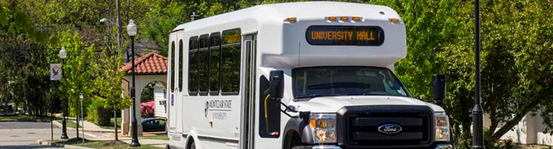
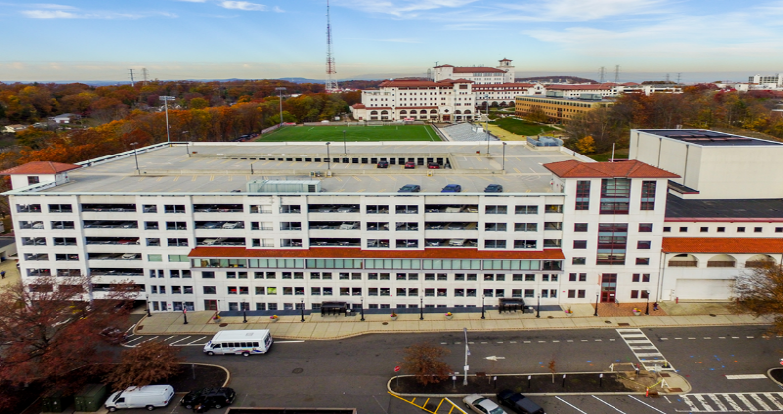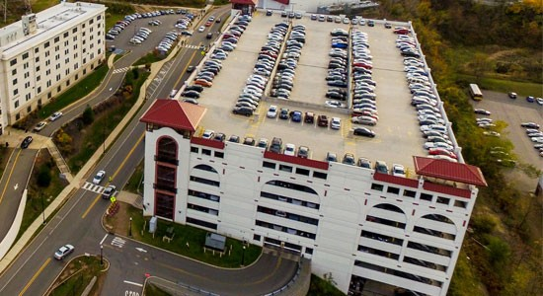

fACILITIES LOGISTICS
ANNUAL TRANSPORTATION & Parking REPORT
Annual Report
Fiscal Year 2017

Montclair State University
1 Normal Avenue
Montclair, New Jersey 07043
973-655-4000

[You can add an abstract or other key statement here. An abstract is typically a short summary of the document content.]

From The Assistant VP
This first annual Transportation and Parking report highlights accomplishments, changes and statistical information for the fiscal year that ended on June 30th. This document was created in an effort to provide the MSU community a better understanding of the mission, scope of services and financial challenges of Transportation and Parking Services.
The Office of Transportation and Parking Services is dedicated to working continuously to improve the quality of the services we provide. Our department has and will continue aggressively managing the demands associated with the ever-growing and changing environment on our campus.
Over the past few years, the department has faced challenges as a result of extensive construction affecting parking resources and the continual enrollment growth, which affects the demand for all of our services. Some of the highlights from the past few years include:
- Significantly altering parking plans which added several parking options to commuter students. MSU bought 900 NJ Transit permits and resold them to resident students. This enabled Parking Services to re-purpose 742 resident surface lot spaces to accommodate commuter students.
- Added more than 250 spaces to the parking inventory by expanding lot 60
- Integration of technology to provide information so that parking decisions can be made before students come to campus. This includes the Parker App that shows space are available on campus. Utilizing Twitter, we let students know what areas of campus to avoid in order to detour away from heavily congested areas.
- Introduction of virtual permits thus eliminating the need for physical permits.
- The five-year bus fleet replacement plan was completed with 16 new clean-running diesel buses being added to the Shuttle Operation.
- Shuttle Services has expanded operations to the Overlook Corporate Center and 1515 Broad Street while overall campus ridership is up 4% over the previous academic year.
Of course, we will continue to rely on our community’s feedback for new initiatives as we honor our commitment to provide the services the MSU community wants and needs. We look forward to hearing from you!
Sincerely,

William Fitzpatrick
Assistant Vice President, Facilities Logistic Support
Montclair State University

Mission
To provide efficient and responsive customer services by effectively and efficiently providing transportation and parking on campus to support the academic, research and service goals of the University.
Responsibilities
- Manage campus parking supply: Allocate the 6, 723 parking spaces on campus to best serve the University community which includes faculty, students, staff, visitors, contractors and service vehicles while ensuring adequate, accessible and well-maintained parking facilities.
- Administer permit and pay-to-park programs: This involves issuing faculty, student and staff parking permits as well as managing the visitor parking program which includes issuing visitor permits along with overseeing the pay-to-park locations in parking decks and commuter lots.
- Coordinate special event parking: The large number of events held across campus highlights the need for close management of parking resources to ensure reasonable parking availability for all user groups.
- Enforce parking regulations: Our enforcement efforts include automated systems such as Automatic License Plate Recognition, Pay on Foot machines and gate controlled entrances/exits as well as our enforcement staff members who patrol lots, provide customer assistance (i.e., jump starts) and issue citations to those that violate parking regulations.
- Manage citation adjudication and appeals process: This involves collections of parking citations and operating the appeals process which includes administrative review and Director’s Appeals.
- Develop/update parking regulations: This involves a regular review of policies and recommend revisions, additions, deletions, etc., to better serve the needs of the University community.
- Operate MSU Shuttle bus system: The MSU Shuttle bus system is the primary means of campus transportation for students & staff and also serves limited off-campus residential destinations.
- Operate PWD Transport services: In partnership with Disability Resources Center, MSU PWD Services provides transportation service to those students requiring long or short-term assistance moving around campus, as approved by the Office of Disability Support Services or Student Health Services.
- Provide/coordinate charter bus service for University use: Many MSU departments, athletics teams, student organizations, etc. require special charter service which is provided by MSU buses.

MSU Parking & Transportation Services • FY 2016–2017 Statistics
Parking Spaces | 6,723
Permits Sold | 13,061
Citations Issued | 19,929
Citations Waived | 5,875
Shuttle Buses | 18
Passengers Transported | 1,600,000
Person w/ Disability Transports | 34,000

MSU Parking Services • Financial Summary
FY 2017 (July 1, 2016 – June 30, 2017)

REVENUE
Actual
Parking (Daily and Visitor Parking) | $ 1,275,631
Parking Permit Income | $ 2,864,801
Parking Citation Income | $ 455,936
Parking Meter Income | $ 180,406
Events Income | $ 55,810
Total Revenue | $ 4,832,584
EXPENSES
Parking Operating Expenses | $ 1,694,348
Garage Debt Service | $ 2,728,000
General Fund Reserve | $ 410,236
Total Expense | $ 4,832,584
Net Margin | $ 0

MSU Transportation Services • Financial Summary
FY 2017 (July 1, 2016 – June 30, 2017)

REVENUE
Actual
Transportation Fee | $ 2,590,428
Other Revenue | $ 1,298
Grants | $ 1,416
Total Revenue | $ 2,593,142
EXPENSES
Transportation Operating Expenses | $ 2,348,563
General Fund Reserve | $ 241,865
Total Expense | $ 2,593,142
Net Margin | $0

