Internal Special Event Parking Payment Process
Per the Division of Treasury and Finance, parking events must be paid utilizing Workday as follows:

Create an Internal Service Delivery Event
- Enter Create Internal Service Delivery into the Search bar and select Create Internal Service Delivery – Task from the search results.
The Create Internal Service Delivery screen displays.
- In the Document Information section, complete the following fields on the screen:
a) The Company field defaults to Montclair State University.
b) Click the prompt icon to select the correct Internal Service Provider which in this case is Parking. Once parking is selected, the Revenue Information fields default with the associated information.
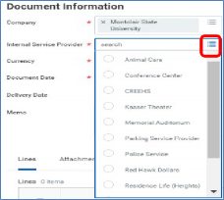
c) The Currency field defaults to USD.
d) The Document Date field defaults as the current date.
e) The Delivery Date is the date the event occurs.
f) The Memo field is required and must include the event name and date;
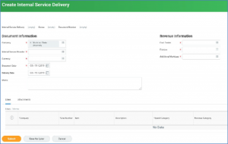
- Click the plus sign in the Lines section to add a line to this request.
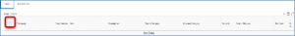
- In the Item field, select the prompt icon and Catalog Items to select the specific service for parking.
- Once the Item has been selected, the corresponding data fields populate.
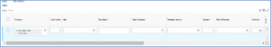
- Scroll to the right to continue to complete the line information.
- In the Extended Amount field, enter the total cost of the expense line.
- Enter the requester’s name in the Requester field, to auto-populate the corresponding worktags.
Note – if different worktags need to be indicated, click the X in the corresponding field to remove the default and search for the appropriate worktag via the prompt icon.
- Any information entered into the Memo field will display in the journal lines, as a journal description when looking at the budget report.
- Complete the Cost Center to fill in other related worktags.
- If this expense involves a grant, the Initiator/Grant Manager should type in Transaction Detail within the Additional Worktags field to select the appropriate Object Class Override detail.
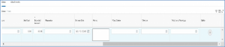
- Click the Attachments tab and click the Select Files button to browse to and load the Special Parking Event Form, this form is REQUIRED.
- Click the External checkbox to send your attachment to the Internal Service Provider along with the request.
- Click the Submit button to save this request and send it to the approver for review and processing.
- Parking Services will be notified and issue passes once the requesting department fiscal manager has approved the internal transfer.
If you have any questions, please contact ext. 5223 or review the internal service delivery process

