Reference Guide for PeopleSoft Requisitioner

Contents
Key Terms 5
General PeopleSoft Tasks 7
Sign into PeopleSoft from onsite MSU 7
Sign into PeopleSoft Remotely 7
Roles within PeopleSoft/FMS 9
PeopleSoft Home Page 10
Home Page Buttons 10
Home 10
Worklist 11
Add to Favorites 11
Sign Out 12
Open a New Window 12
Personalize Your Screen 12
Alphabetize the Main Menu 12
Open the Chart of Accounts 13
Chartfield Codes 13
List of Funds 15
Requisition Process 16
Requisition Lifecycle 17
Purchasing Methodologies 18
Requisition Requirements 19
Categories with Additional Approvals 20
Budget Control Tree 20
Creating a Requisition 20
Requisition Heading 20
Requisition Settings 20
Split the Cost of a Line Item 22
Add Approvers to a Requisition 23
Adding Attachments to a Requisition 23
Viewing Attachments on a Requisition 24
Punch Out Requisition 26
Internal Catalog Requisition 28
Confirm Supplier is in PeopleSoft 31
If Your Supplier is NOT in PeopleSoft 34
Correcting Supplier Information 34
Special Request Requisition 34
Quotes for Special Request Requisitions 39
Freight and Shipping 39
Attachments 39
Line Items 39
Zero Value Lines in a Request 39
Discounts on Line Items 39
Requisition Approvals 40
Approval Flow Thresholds 40
Approved Requests Process 41
Denied Requests Process 41
Requests on Hold Process 44
Business Rules When Changing a Requisition 46
Standard Approval Flow 47
Standard Print Approval 47
Standard IT Approval 48
Standard Grant Approval 48
Full IT Approval 49
Denied 49
Hold 50
PushBack 50
Add Approvers onto a Requisition 50
View Approval Flow Comments 51
Manage Requisitions 53
Access a Saved Requisition 54
Edit a Request 54
Cancel a Requisition 56
Uncancel a Requisition 57
Receiving Goods and Services 59
Cancel a Receipt 62
Returning Goods 64
Invoices and Payments 65
Invoice Process 65
Read the PO Payment Screen 66
Cancel a Voucher, Receipt, and Purchase Order 67
Manage Your Requisition Queue 72
Requests Not Submitted for Approval – OPEN STATE 72
Requisition Not Completely Received – PARTIALLY RECEIVED STATE 73
Request States 76
Request Never Approved – PENDING STATE 77
Duplicate Requests – VARIOUS STATES 77
Requests Stuck in Budget Errors – PENDING STATE 77
Cancel a Voucher, Receipt, and Purchase Order 77
Purchase Orders 82
Print an Unofficial Purchase Order via Email 82
Change/Edit a Purchase Order 84
Cancel a Purchase Order 84
Queries for Requisitioners 86
Requisition-Purchase Order Cross Reference 86
Department Query 86
Quick Invoices 87
Employee Reimbursements 87
Non-Travel Reimbursements (Non-travel reimbursements for students are prohibited) 87
Travel Reimbursements 87
Student Stipends 87
Quick Invoice User Tips 88
Quick Invoice Request Process 89
Confirm Supplier/Employee in the FMS System 90
Confirm Invoice from Supplier/Create Invoice Record 90
Confirm the Expense Purpose of your Request 90
Refunds 91
Enter the Quick Invoice Information 91
Change a Request 95
Denied/Held Requests 96
Check the Status of a Request 97

Key Terms
Account – the code within the Chartfields which indicates for what commodity/product a purchase is made.
Accounting Period – the month within the fiscal year. At MSU, the fiscal year begins in July, thus the accounting period for July is “1”.
Accounts Payable - the department responsible for ensuring an organization pays its invoices appropriately.
Approver – the individual in PeopleSoft with the responsibility to confirm the fund, department, and account are correct for their department, as well as the good/service, price and quantity. For grant purchases, the PC Business Unit, Project Code, and Activity will also need to be confirmed.
Budget – a financial plan for an organization showing estimates of income and expenses for the coming year. Used to compare against the actual figures and/or “budget check” to control spending.
Buyer - an individual within the Procurement department responsible for confirming the purchase of goods and services meet the policies and procedures of MSU, issuing public bids, and reviewing all purchases over $6,420 for compliance with the MSU and State of NJ regulations.
Category - broad groupings within the PeopleSoft system which specify commodities and products. MSU has its own groupings called accounts.
Chart of Accounts – the compilation of codes for Fund, Department, Account, PC Business Unit, PC Project/Grant, PC Activity, Product, Detail Code, University Event, and General Code.
Chartfield - these values represent individual account numbers, department codes, and so forth.
Encumbrance – a commitment from an organization to use funds for a specific purchase, such as to pay for goods/services on a purchase order. Once requisitions are entered and approved, these funds cannot be used for anything else.
ERP - Enterprise Resource Planning - integrated computer systems that share management information across many departments within an organization. The purpose is to enable the flow of information between managers within the organization and create a single version of data so that decisions are based on consistent views of common data.
Fiscal Year - the 12 months between one annual settlement of financial accounts and the next; a term used for budgeting, etc. Montclair State University’s fiscal year is July 1 to June 30.
Fund - a budget that can be used to fund promotional activity. There are four funding methods: top down, fixed accrual, rolling accrual, and zero-based accrual.
Internal Catalog – the top 90 most bought items within the University. These items have University Contracts set up for ease of purchase and can be identified and ordered through a checklist within the PeopleSoft system.
Invoice - A list of goods or services sent to a purchaser showing information including prices, quantities and shipping charges for payment. The bill the supplier sends for payment to be made.
Pre-Encumbrance – reserved funds held for requested purchases, like those listed on a purchase requisition.
Procurement - the act of sourcing, acquiring, buying goods, services or works from an external source at the best possible cost to meet the needs of the acquirer in terms of quality and quantity, time, and location.
Punch Out Catalog - a method for a purchasing agent to buy from a supplier's website from within the buying organization’s own eProcurement system.
Purchase Order - a document issued by a buyer to the supplier that defines what is needed, in what quantity, when performance is required, and on what terms, including price and payment terms.
Purchasing Methodology – the identification to Procurement on how the specific goods/services on a requisition are able to be purchased.
Quick Invoice – a request for limited types of payments to a supplier or reimbursement for an employee.
Quote - A formal statement of promise (submitted usually in response to a request for quotation) by potential supplier to supply the goods or services required by an organization, at specified prices, and within a specified period. A quotation may also contain terms of sale and payment, and warranties.
Receipt - A receipt is a document of confirmation that goods have been delivered or services performed. The receipt is usually part of a three-way match between the purchase order, the invoice and the goods receipt, and is needed to confirm that the invoice might be paid
Requisition - An internal document that a department (stores, maintenance, etc.) sends to the purchasing department containing details of materials to meet its needs, replenish stocks or obtain materials for specific jobs or contracts.
Requisitioner - an individual who requests goods or services and whose ID appears on the various procurement pages that reference purchase orders.
RMA – Return Material Authorization - part of the process of returning a product in order to receive a refund, replacement, or repair during the product's warranty period. The purchaser of the product must contact the manufacturer (or distributor or retailer) to obtain authorization to return the product.
Sole Source – sourcing exclusively from one supplier as there are technical, design, or patent reasons that there is only one suitable source for a particular good or service.
Special Request Requisition – a request for any good or service which is not available within a punch out or internal catalog.
Supplier – an external organization that delivers services or goods to a buyer.
Three Way Match – the method of approving a supplier’s invoice for payment against the purchase order and the receipt note, thus determining if the invoice presented should be paid in its entirety. The act of matching the purchase order price and quantity to the received price and quantity to the billed price and quantity.
Thresholds – ongoing levels of financial transactions that, when reached, trigger a requirement of document in order to continue business with a specific supplier.
Voucher - a form authorizing a disbursement of cash or a credit against a purchase or expense to be made in the future, or a document or receipt, that gives evidence of an expenditure.
Worklist - The automated to-do list that PeopleSoft Workflow creates. From the worklist, you can directly access the pages you need to perform the next action, and then return to the worklist for another item.

General PeopleSoft Tasks

Sign into PeopleSoft from onsite MSU
- Use the following URL below to log into the PeopleSoft site: https://finance.montclair.edu

- On the sign in screen, enter your CWID and NetID Password and click the Sign In button.

Sign into PeopleSoft Remotely
In order to access FMS from off of the MSU campus, you must go through CITRIX on your computer.
To access CITRIX and PeopleSoft from offsite, on your Montclair State laptop:
- Click the Start icon
in the lower left corner
of your screen.

- Select All Programs

- Click Citrix Receiver.

- When the application launches, enter ADMSU\your NetID, (example smithj) in the Domain/Users field, and your NetID password in the Password field.
- Click the Log On button.
If you have not added the Citrix published application links to your Citrix Receiver desktop, you must add them the first time you connect.
- Click on the “+” sign on the left side of the window.
An application list displays:
- Click All Applications.
- Scroll to and click the PeopleSoft Portal with the Windows Explorer icon.
- A green check mark displays next to it to indicate it has been added to your favorites.
A

B
C

- Click the PeopleSoft Portal Internet Explorer icon to launch Internet Explorer. It may take a moment to load.
The PeopleSoft portal page will display similar to when you launch it from your desktop at MSU.

Roles within PeopleSoft/FMS
There are many different players within the PeopleSoft system, each responsible for certain activities, in order to create and process the requests for the organization. Below is a list of the main roles for FMS.
Role | Activity
Requisitioner | Initiates request by completing requisition and selecting “Save and Submit” in FMS
Supplier | Provides the University with goods and/or services
Approver | Department Manager, Project Manager or Principal Investigator approves requisitions
Specialty Approvers | Approve IT, Printing, Grant Accounting requisitions
Budget Department | Budget errors must be brought to the attention of the Budget Department or Grant Accounting (if grant related)
Procurement Approver (Buyer) | Review and approve purchases greater than or equal to $250
Receiving | Requisitioner MUST log into FMS to confirm the physical receipt of goods/services, before payment can be processed
Accounts Payable | Processes payment ONLY after the invoice with a PO and receipt number has been sent to Accounts Payable AND goods/services have been received in the system

PeopleSoft Home Page
Once you log into PeopleSoft, you will be brought to the Home Page. The Home Page has specific functionality on it to help you be more efficient in the system.
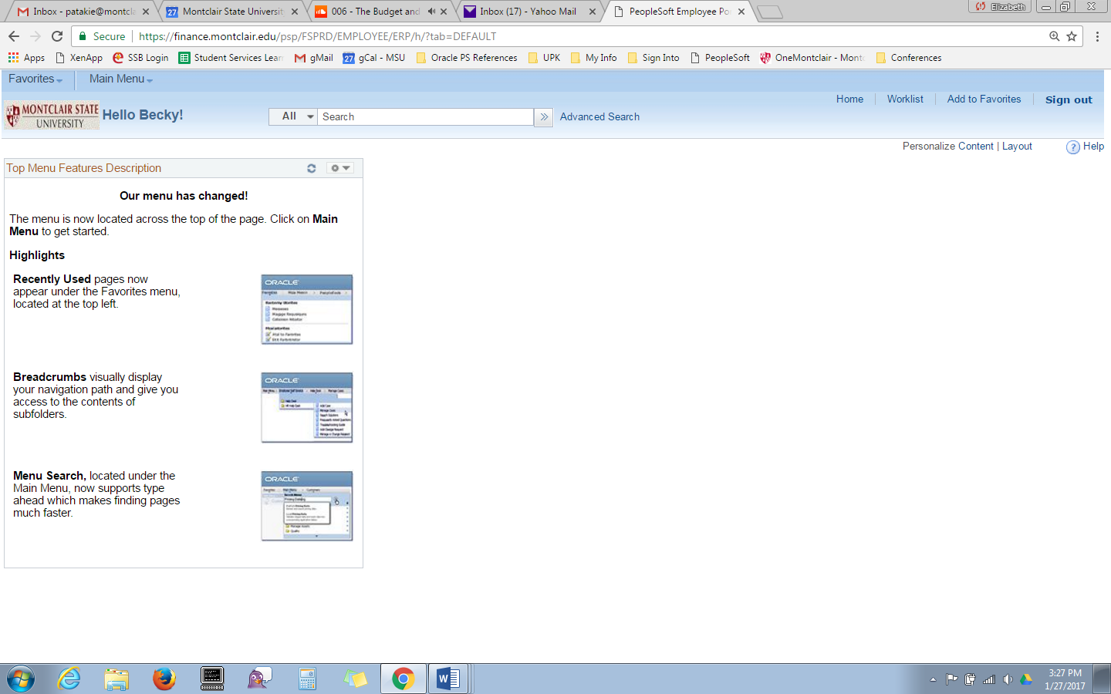

Home Page Buttons
The Home Page buttons are located in the upper right corner of every screen within PeopleSoft.

Home
From any screen within PeopleSoft, click the Home link to return to the Home page.

Worklist
Click the Worklist link to open the Worklist and view a list of items that need to be processed by the Approver, or to see a list of the requisitions that the Requestor has created recently.

Add to Favorites

Create Favorites
- Navigate to the screen to create as a favorite.
- Click the Add to Favorites link in the upper right corner of the screen.

- The system will suggest a name for your favorite. You can change the name or keep the suggested one.
- Click the OK button.

Access Favorites
- Your Favorites can be accessed by clicking the Favorites drop down button in the upper left corner of the Home Page.
- The top portion of the displayed list contains shortcuts to the last five (5) screens that were viewed.
- Your list of Favorites is in the bottom section of the drop down.
- Click the name of a screen in either list to be brought to a specific screen.

Sign Out
The Sign Out link should always be selected when you are done working in PeopleSoft. The system will automatically lock you out after 30 minutes of inactivity. However, by selecting the Sign Out button, any data vulnerabilities within the system are minimized.

Open a New Window
It is possible to have multiple windows opened within PeopleSoft at the same time. This allows for higher efficiencies when using the system, such as data review on one screen, and data entry on another, for example. The New Window link is available on most PeopleSoft pages in the right corner of the screen.
To open a new window in PeopleSoft, click the New Window link in the top right corner of the screen. A new tab will display and open a new window on the same screen as where the link was clicked. It is recommended to not have more than five (5) windows opened at one time within PeopleSoft.

Personalize Your Screen
There are some minor changes that an end user can make in PeopleSoft from clicking the Personalize link in the top right corner most screens within the system. It is not recommended to personalize the screens in PeopleSoft as system defaults will neutralize some options and there is a potential to hide significant sections of screens.

Alphabetize the Main Menu
When in PeopleSoft, click the double arrow in the top right corner of the Main Menu listing to alphabetize it. You will need to reset this feature every time you go into PeopleSoft.

Open the Chart of Accounts
The Chart of Accounts is a listing of the new PeopleSoft codes used to identify the fund, department, and account number associated to every transaction in the system. It also identifies grant information for grant specific tasks.

To access the Chart of Accounts, go to: http://www.montclair.edu/finance-and-treasury/news/article.php?ArticleID=14802&ChannelID=48, and click the COA.xls link on the right of the page.

An Excel spreadsheet opens and contains the FRS Account Codes – now FMS Departments and Funds, and the FRS Object Codes – now FMS Account numbers.

Chartfield Codes
The Chartfield codes are a set of eleven (11) different fields which allow for the correct management of funds within departments, specific financial reporting on events, and a clear picture as to what was spent on commodities throughout the fiscal year.
When creating transactions in PeopleSoft, these codes should be entered on the Chartfields 2 tab of the Accounting information.
The Chartfields are:
- Business Unit – Defaulted for all users as MSU01 and representing the overall Montclair State University organization.
- Fund – Identifies where the money is coming from for the specific transaction. Must be entered for ALL transactions.
- Department – Identifies who is spending the money. Must be entered for ALL transactions.
- Account – Identifies what the money is being spent on. This code is entered automatically on all transactions.
- PC Business Unit – Identifies if transaction is for a grant or capital project. MSU01 must be entered for all Grant transactions. MSUCP must be entered for all Capital Project transactions.
- PC Project/Grant – The six digit code for the grant or capital project initiating the transaction. Must be entered for all Grant and Capital Project transactions.
- PC Activity – Identifies the phase within a Capital Project. For Grants, a ‘1’ should always be entered. Must be entered for all Grant and Capital Project transactions.
- Product – Identifies the semester for tuition and fees. Must be entered when working on transaction when referring to semester transactions.
- University Event – Codes created for activities in which many departments/groups are involved. Allows for tracking of spending for specific events, such as convocation. Users will receive a communication when these codes should be used.
- Detail Code – Overall codes created to categorize transactions into larger groups. Used primarily by Finance department.
- General Code – Codes requested by individual departments to aid in categorizing and compartmentalizing transactions into groupings for easier analysis. Contact the IT Service Desk, option 2, to request codes to be set up.
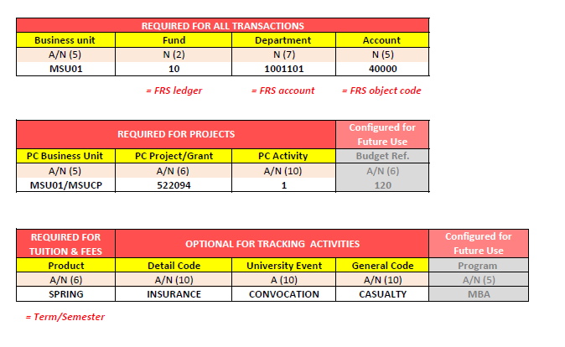

List of Funds
When creating a requisition, use the corresponding Fund code from where your money is originating.
Fund | Fund Description | Required Chartfields
10 | Operating or General Fund | Fund/Account/Department
11 | Auxiliary | Fund/Account/Department
12 | Revenue Centers (Self-Support) | Fund/Account/Department
13 | Course & Lab Fees | Fund/Account/Department
14 | Indirect Cost Recovery | Fund/Account/Department
15 | Unrestricted Loans | Fund/Account/Department
16 | Cost Share – GRANTS | Fund/Account/Department/Project
18 | Internal Awards | Fund/Account/Department/Project
19 | Revolving/Clearing Fund | Fund/Account/Department
20 | Federal Grants | Fund/Account/Department /Project
21 | State Grants | Fund/Account/Department /Project
22 | Local Grants | Fund/Account/Department /Project
23 | Nongovernmental Grants | Fund/Account/Department /Project
30 | Financial Aid - Federal | Fund/Account/Department/Project
31 | Financial Aid - State | Fund/Account/Department/Project
32 | Financial Aid - Other | Fund/Account/Department/Project
40 | Loans - Other | Fund/Account/Department/Project
41 | Loans - PERKINS | Fund/Account/Department/Project
42 | Loans – State | Fund/Account/Department/Project
43 | Loans – Federal | Fund/Account/Department/Project
50 | Debt Service Reserve | Fund/Account/Department/Project
70 | Capital Project Reserve | Fund/Account/Department/Project
71 | Capital Projects Unrestricted | Fund/Account/Department/Project
72 | Capital Projects - Restricted | Fund/Account/Department/Project
79 | Investment in Plant | Fund/Account/Department
80 | Research Service Center | Fund/Account/Department
90 | Agency | Fund/Account/Department

Requisition Process
The requisition process listed below is the most efficient way to confirm that all required data and backup information is available in the system, therefore allowing for a faster process for a request.
- Each special request requisition should begin with a quote from one or more suppliers to indicate the expected goods or services being requested.
- Once the best quote is identified (price and other factors) the associated supplier must be confirmed in the system.
- The request should be entered in the same format as the quote received, and how the goods/services will be confirmed as received in the system. This means that different line items should be entered for different products such as S, M, L, and XL t-shirts each listed on an individual request line in the requisition.
- The request is budget checked and submitted for approval.
- When the request is submitted, it will be automatically forwarded to the appropriate approver(s) for review and processing. A request can be approved, placed on hold, or denied by an approver. If placed on hold or denied, the requisitioner will receive a notification from the system with a link to the approver’s comments so that any updates to the original request can be made and resubmitted.
- After the department and any additional approvers process the request, it is routed to the Procurement department so that the buyer of that specific commodity can review the request and confirm the State and University policies have been followed. Once confirmed, this request will become a purchase order and will be dispatched, via email or mailed, to the supplier noted in the request.
- Should any changes be needed, the requisitioner can edit the request and send it through the approval process again.
- When the goods/services are delivered, the requester must go back into the system to confirm receipt by physically entering the data into the system.
- If any returns are needed to be sent back to the supplier, make sure to get a Return Material Authorization (RMA) number from the supplier before starting the process in FMS.
- The supplier should send an invoice, with the Purchase Order number included, directly to Accounts Payable at invoices@montclair.edu. If a requisitioner receives the invoice instead, they will need to confirm the purchase order number is listed on the invoice, along with the receiving number(s) and their name and extension. Then the requisitioner should scan and send the invoice to invoices@montclair.edu.
- Once the system confirms that a receiving was done for the request, and an invoice is noted in FMS, a payment can be released to the supplier.

Requisition Lifecycle
Once a requisition is created in PeopleSoft, it gets processed through workflows for approvals. Each phase of a requisition is captured on the Requisition Lifecycle. To access a lifecycle, click the expansion arrow to the left of the specific requisition line in the Manage Requisitions results list.

Purchasing Methodologies
Purchasing Methodologies identify to the Procurement department how the goods/services are able to be purchased. Please review the table below to identify the correct methodology to use for each of your requisitions.
2 Quotes (Delegated Purchasing Authority) | Used to compare two potential prices for goods and services for orders  between $2,000 ‐ $6,419. Quotes must be attached to the requisition.
3 Quotes (Delegated Purchasing Authority) | All three (3) quotes are required to be attached to the requisition when the total cost is $6,420 to $33,299. Refer to Procurement Policy # 1 for details.
BOT Waiver of Advertising | An RFP is not publicly advertised for purchases $33,300 and greater. Board Of Trustees (BOT) must approve the award before it becomes a contract.  Refer to Procurement Policy # 1 for applicable categories.
Educational Services Commission of NJ | Middlesex co‐operative contracts for all State agencies to utilize. Contact Procurement Services for assistance.
National Association of State Procurement Officials (NASPO) | A Cooperative Purchasing Organization that issues publicly bid contracts. Please contact Procurement Services for details.
National Joint Powers Alliance (NJPA) | A Cooperating Purchasing agency that was created to serve education entities and revised in 1995 to allow cities, counties, local governments and non-profits to benefit from the use of service cooperatives.  Please contact Procurement Services for details.
Purchasing Association of Cooperative Entities (PACE) | A Cooperative Purchasing program designed assist members in meeting their operation goals and save funds when obtaining best value supplies.  Please contact Procurement Services for details.
U.S. Communities Government Purchasing Alliance | A Cooperative Purchasing program that provides procurement resources to local & state government agencies, school districts (K-12), higher education institutions, and nonprofits looking for the best overall supplier government pricing.  Please contact Procurement Services for details.
Emergency Procurement | Used by Procurement Services in situations that affect the health, safety or welfare of the students. Please refer to Procurement Policy # 14 for details.
General Services Administration Contracts (GSA) | Federal government contracts for goods/services which can be found by going to Quicklinks> Procurement> Resource Links.
Other | Used when no other purchasing methods meets the University’s needs. Contact Procurement Services for assistance.
Renewals | Used to renew existing contracts that are not suited for rebid, such as software licenses.
Sole Source | Justification must be attached to the requisition when there is only one source for services or goods. Please refer to Procurement Policy # 22 for full definition of Sole Source.
State Contracts | State of New Jersey publicly bid contracts for goods/services can be found by going to Quicklinks> Procurement> Resource Links. Contact Procurement Services for assistance.
University Contracts (UNC#) | Publicly bid contracts for specific goods/services. Used with Punch‐out Requisitions, Internal Catalog Requisitions, as well as, specific departmental contracts.

When purchasing via a contract or co-op, a quote must still be obtained from the supplier, The quote must have the contract or co-op number included on it, and be attached to the first line item within the requisition.
For further information on Procurement policies, please click the link below:
http://www.montclair.edu/media/montclairedu/financetreasurer/forms/procurementforms/Procurement_Policies.pdf

Requisition Requirements
Depending on the dollar threshold of a purchase, or the ongoing purchases with a single supplier, there are specific requirements which must be met before a requisition can be processed.
Dollar Threshold | Requirements | Comments
$250 - $1,999 | Suggested - 1 quote attached to requisition | Per requisition submitted
$2,000 - $6,419 | Suggested - 2 quotes attached to requisition  Required 1 quote | Per requisition submitted
$4,950 and above | Business Registration Certificate (BRC) | State of NJ Requirement  Cumulative across University purchases
$6,420 - $32,999 | Required 3 quotes | Per requisition submitted  Procurement Policy #1
$17,500 and above | Chapter 51 (Political Contributions Disclosure Form) | State of NJ Requirement  Cumulative across University purchases
$33,000 and above | Public Bid, BOT Contract Approval and Affirmative Action Compliance | Per requisition submitted  Procurement Policy #1

When purchasing via a contract or co-op, a quote must still be obtained from the supplier, The quote must have the contract or co-op number included on it, and be attached to the first line item within the requisition.

Categories with Additional Approvals
Some categories within the FMS will have additional approvers attached to a request automatically. These categories are IT items and Printing. When a requisition is created for one of these categories, an approver, in addition to the Department or Principal Investigator, will be added to the approval flow to ensure the parameters of the request conform with the University’s policies.

Budget Control Tree
A breakdown of the current Parent and their corresponding Child Accounts can be found on Finance webpage. This tree shows which child accounts roll up to which parent pools for Unrestricted operating budgets. This is a handy tool for departments to understand which Accounts they can purchase against, based on whether there is available budget in the Pool.

Creating a Requisition

Requisition Heading
Each requisition header and line item within the requisition will need to have specific information entered. The requisition header must include a Requisition Name, Purchasing Methodology and Contract/Waiver Number.
The Requisition Name should be something specific to the goods or service being requested. This will make it easier to locate the requisition when searching for it in the Manage Requisitions screen. There is no pre-set naming convention for the Requisition Name. Entering something that will help you, the Requisitioner, identify the request from a list is beneficial and time saving.
The Purchasing Methodology identifies how the goods/services are able to be purchased. This is a required field in order to process the request. Please review the Purchasing Methodology chart in the above section.
The Contract/Waiver Number identifies which contract or Board of Trustees waiver (if any) is being used to purchase the specific goods/services. A list of the current contracts being used by the University can be found on the Supplier Contracts section of the Procurement website.
For contracts not originating within the University (i.e., State contracts), please contact the Procurement department directly. If the purchasing methodology does not include a contract or waiver number, please enter N/A.

Requisition Settings
Each line item within a requisition will require identifying the Supplier, Ship To address, Attention To field, Due Date, and Chartfield codes. For requisitions with one (1) or two (2) line items, it is simple to complete these fields manually. However, when dealing with a larger, multi-line requisition, it is more efficient to complete the Requisition Settings for the specific request before adding items to requisition.
Requisition Settings can be opened from the Create Requisition screen before you select the type of requisition to create, or above the requisition header on any requisition screen.
Click the Requisition Settings link to open the pop-up window, and complete the following fields to have the information automatically entered into the Requisition Header and corresponding line items.
- Requisition Name – enter something unique and easily identifiable regarding what is being requested
- Purchasing Methodology - identifies how the goods/services are able to be purchased.
- Contract/Waiver # - identifies which contract or Board of Trustees waiver (if any) is being used to purchase the specific goods/services. If the purchasing methodology does not include a contract or waiver number, please enter N/A.
- Default/Override – The DEFAULT option uses the system information already assigned to the CWID and will add data from this pop-up window only to blank fields. The OVERRIDE option adds data into each corresponding field and will over write any default data.
- Supplier – only ONE supplier per requisition. Use the corresponding magnifying glass to search for a supplier. For Special Requests only.
- Categoty – enter or search for the category number for all requistion lines ONLY if they are identical for EACH line within the request.
- Unit of Measure - enter or search for the unit of measure for all requistion lines ONLY if they are identical for EACH line within the request.
- Ship To – the main location for delivery of goods/services. Use the magnifying glass to confirm the location.
- Due Date – when the goods/services are expected to be delivered.
- Attention - the name, building code, room number, and extension of where the goods/services should be delivered MUST BE COMPLETED
- Chartfields1 codes –Fund, Department. PC Bus Unit, Project, and Activity for Grant and Capital Project purchases. Do NOT enter any information into the Account field as this will change based on the commodity being requested. When completing the Ship To and Account information within each line item of a requisition, the Chartfields 2 tab would normally be selected. However, when completing this information via Requisition Settings, it is the Chartfields 1 tab that contains this information.
When all applicable fields are completed, click the OK button.

Split the Cost of a Line Item
When an item’s cost needs to be distributed among multiple departments, the requisitioner can assign portions of the cost to each department.
- From the Create Requisition screen, select the Expand Arrow of the Accounting Line on the appropriate line item.
- In the Accounting Lines section, click the Chartfields1 tab.
- Click the plus sign to the right of the line item, to add another cost line.
- Enter the accounting codes of the additional department and include the percent of expense for each line. Note: the overall percent of the line item MUST equal 100.
- Click the Chartfields2 tab to enter the appropriate Chart of Accounts information for each line.

Add Approvers to a Requisition
Additional approvers, or reviewers (parties that will have read-only access to the requisition) may need to be added to the approval flow of a requisition. Amend the preset approval flow to include these individuals on the Confirmation screen of the requisition.
- Click the green plus sign next to the last approver’s name in the Requistion Approval box.
A dialog box opens displaying search and selection options.
- Click the Search button to enter the name of the additional individual.
- Enter the search term and click Search.
- Select the appropriate user name. Note: The selected approver must have requisition approval access already assigned to their profile.
- Click OK.
You will be brought back to the Insert window.
- Select the role for the adhoc approver.
- Click Insert.
The Approval Flow will update to display the additional individual’s name and role.

Adding Attachments to a Requisition
When creating a requisition, comments and attachments should be added to the line level of a request, so that they are available to view by approvers.
From within the Checkout – Review and Submit screen of PeopleSoft, click the Add button on the appropriate line item to open the Attachments dialog box. You can insert comments along with any relevant documentation.
When items are attached to a line, the Add button icon will change to read Edit.

Quotes are recommended to be added to requests in order to validate the conditions of the goods or services being ordered, and verify the specifics of the purchase. For requisitions of $250 to $2,000, it is recommended that a single quote be attached. Requistions between $2,000 and $6,420, it is recommended that two (2) quotes be attached to the request. For all requisitons $6,420 and above, it is required that three (3) quotes be attached.
Quotes should break down the request in a detailed manner which includes a specific description of the goods or services to be delivered including an exact quantity and unit price for each line item within the quote.
When purchasing via a contract or co-op, a quote must still be obtained from the supplier, The quote must have the contract or co-op number included on it, and be attached to the first line item within the requisition.

Viewing Attachments on a Requisition
Once you have added items onto the line item of the requisition, the documents will be available for the Requisitioner, Approver, and Procurement Buyers to view. To view an attachment:
- From the Search Results area of Manage Requisitions, click the targeted requisition number under the Req ID column.
- When the line items display, click the paper clip icon underneath the item description.
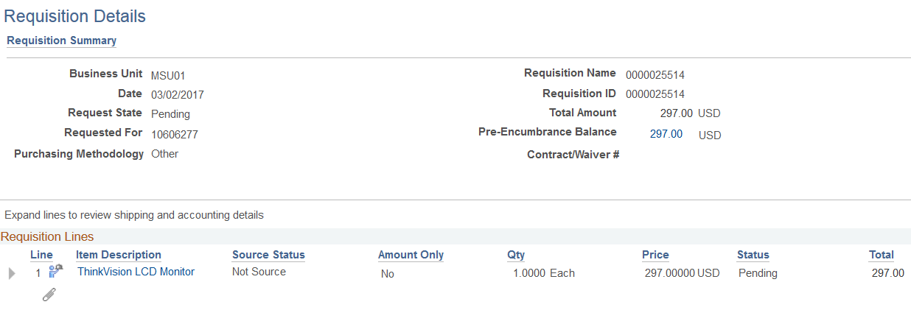
- In the Line Attachments pop up window, click the View button.
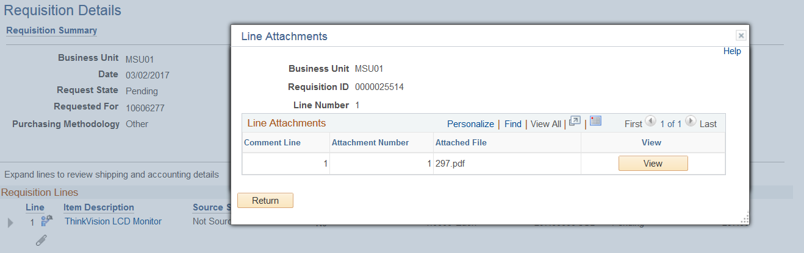
The attachment will display in its native format.
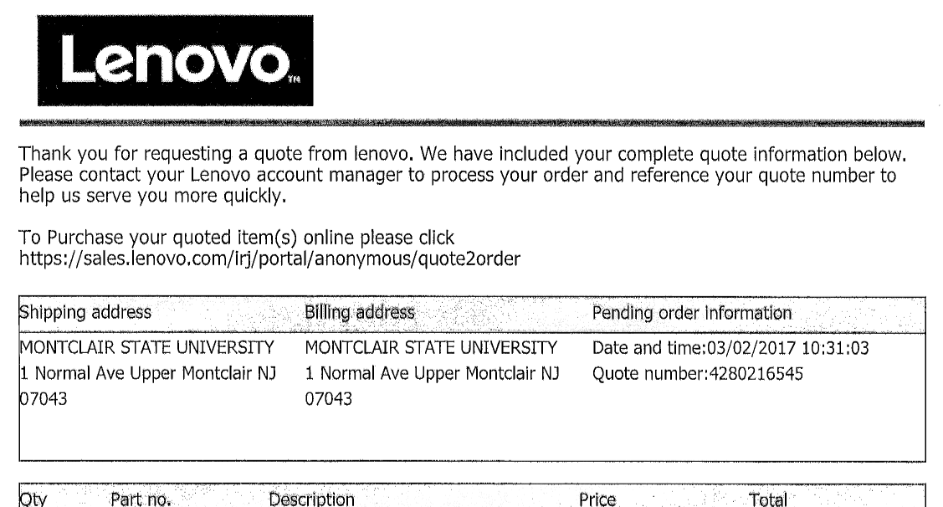

Punch Out Requisition
Punch Out catalogs are direct links to our supplier websites for those commodities where a high volume of purchases occur. When ordering from a punch out catalog, the MSU discounts are already applied, and all available items to purchase are contained available. When in a punch out catalog, the user is still in the MSU PeopleSoft instance.
- To access the link to the Punch Out catalog, follow the menu path:
Main Menu > eProcurement > Requisition.
Note: Current punch out catalogs are located in the Web section of the Create Requisition screen. Once submitted and approved, Punch Out catalog orders cannot be changed or canceled. These orders are immediately released to the supplier. Should an edit or a cancelation need to be completed on a punch out requisition, contact the Procurement department to determine if it can be done.
- Enter a search term in the Search field, and click the Search button to display your results. From the list of catalog items displayed, select the item to purchase.
- Click in the Qty field of the corresponding item to enter an amount to purchase.
- Click the Add to Cart button to include this item in your purchase.
- Repeat steps 2 through 4 to enter additional items into your cart by selecting the Continue Shopping button.
- When you have entered all of the items to purchase, click the Checkout button to continue.
NOTE: All requisitions must be budget checked before submitting. The note displayed reinforces that a budget check must occur before requisition can be submitted.
- Click the OK button to proceed
Complete the requisition header information.
- Click in the Requisition Name field and enter a unique name for this requisition. When naming your requisition, use names that easily identify the items being purchased.
- Click the Purchasing Methodology drop down arrow to select the correct purchasing method.
- Click in the Contract/Waiver # field and enter the correct contract number. Get the Contract number from the Procurement Services website.
- Scroll down to the body of the requisition where your line item details are listed out.
- To add an attachment, go to the corresponding line item, and at the far right, click the Add link
- Click the Add Attachments button.
- Click the Browse button in the Upload field to navigate to the file you want to attach to the requisition.
- Click the file name of the item to attach.
- Click the Open button
- Click the Upload button to attach your file to the purchase requisition
- Click the Send to Supplier checkbox on the corresponding line of your attachment to make sure the supplier gets your file.
- Click the OK button to return to the body of your requisition.
For each line item, you will need to indicate the Ship To and Accounting codes for the goods ordered.
- Click the Show Ship To and Accounting button (the right pointing arrow to the far left of your line item) on your order line.
- In the pop-up window, click the Ship To Look Up button (magnifying glass) and select the appropriate ship to location. Note: MSU01 is the default location corresponding to 1 Normal Avenue.
- The “Attention To” field is required to be completed to include the Requestor’s Name/Building Code and Room Number/Extension. An example of this information is: Sue Johnson/UNIV5100/1234. Please note, there is a 30 space limit within the “Attention To”, which includes the slashes and spaces as well as characters. If this information is not completed within the requisition line, the request cannot be saved and processed within PeopleSoft.
- Office supplies orders are next day delivery. For all other punch out catalog orders, indicate a due date.
- Click the Expand Section button in the Accounting Lines section of the screen.
- Click the Chartfields2 tab.
The Accounting information will be pre-populated based on the CWID entered at sign in. Typically, these fields will not need to be changed unless you are ordering for your non-primary business area.
- If you need to change any of the Chartfield codes, click the Look Up button (magnifying glass) of the corresponding field and search for your code.
In a punch out requisition, the Account field is populated based on the items you are purchasing, so you do not need to change the defaulted Account code(s).
- If you are purchasing for a grant or capital project, you will also need to complete the PC Bus Unit, Project, and Activity fields.
- Scroll down to the Enter requisition comments field and enter any comments that you want to send to the supplier.
- Click the Send to Supplier checkbox to include these comments on the purchase requisition.
- Click in the Enter approval justification for this requisition field and enter any comments your approver/buyer may need to see regarding this requisition.
Purchase requisitions cannot be submitted without a budget check performed.
- Click Save for Later to store your purchase requisition information while you perform budget checking.
- Click the Check Budget link. If your Budget Check produces an Error code instead of a Valid status, review your budget report to confirm there is enough money in the account and check the chartfield string to ensure the correct Fund, Department, Account combination are used before contacting the Budget Department. If the purchase is for a grant, then contact Grant Accounting instead of the Budget Department for any budget issues.
- Once a Valid status displays for your budget check, you can click the Save & submit button to submit the purchase requisition for approval.
The Purchase Requisition Confirmation screen will display with the purchase requisition name and number listed and the approval flow for the request.

Internal Catalog Requisition
Internal Catalogs contain the top 100 items purchased at MSU, outside of the punch out items. The current item categories within the Internal Catalog are: Printing, Information Technology (IT), Janitorial/Housekeeping Supplies, and Tires.
When ordering from an internal catalog, the MSU discounts are already applied, and all available items to purchase are contained available. When in an internal catalog, the user is still in the MSU PeopleSoft instance.
- To access the link to the Internal Catalog, follow the menu path:
Main Menu > eProcurement > Requisition.
Note: Current internal catalogs are located in the Catalog section of the Create Requisition screen.
- In the Item Category list, click the More… link at the bottom of the list, to view all item categories.
- In the Complete Category List pop up window, select the category for the items to request.
- When the items within the selected category display, scroll through the list and click the checkbox to the left of the item to select.
- Enter the quantity of the item to purchase in the quantity field of the specified item.
- Click the Add button on the selected line to include that item in your purchase.
- Continue to scroll, select, and add items until all items are included.
- When you have entered all of the items to purchase, click the Checkout button to continue.
NOTE: All requisitions must be budget checked before submitting. The note displayed reinforces that a budget check must occur before requisition can be submitted.
- Click the OK button to proceed
Complete the requisition header information.
- Click in the Requisition Name field and enter a unique name for this requisition. When naming your requisition, use names that easily identify the items being purchased.
- Click the Purchasing Methodology drop down arrow to select the correct purchasing method.
- Click in the Contract/Waiver # field and enter the correct contract number. Get the Contract number from the Procurement Services website.
- Scroll down to the body of the requisition where your line item details are listed out.
- To add an attachment, go to the corresponding line item, and at the far right, click the Add link
- Click the Add Attachments button.
- Click the Browse button in the Upload field to navigate to the file you want to attach to the requisition.
- Click the file name of the item to attach.
- Click the Open button
- Click the Upload button to attach your file to the purchase requisition
- Click the Send to Supplier checkbox on the corresponding line of your attachment to make sure the supplier gets your file.
- Click the OK button to return to the body of your requisition.
For each line item, you will need to indicate the Ship To and Accounting codes for the goods ordered.
- Click the Show Ship To and Accounting button (the right pointing arrow to the far left of your line item) on your order line.
- In the pop-up window, click the Ship To Look Up button (magnifying glass) and select the appropriate ship to location. Note: MSU01 is the default location corresponding to 1 Normal Avenue.
- The “Attention To” field is required to be completed to include the Requestor’s Name/Building Code and Room Number/Extension. An example of this information is: Sue Johnson/UNIV5100/1234. Please note, there is a 30 space limit within the “Attention To”, which includes the slashes and spaces as well as characters. If this information is not completed within the requisition line, the request cannot be saved and processed within PeopleSoft.
- Enter a delivery date in the Due Date field for the requested items.
- Click the Expand Section button in the Accounting Lines section of the screen.
- Click the Chartfields2 tab.
The Accounting information will be pre-populated based on the CWID entered at sign in. Typically, these fields will not need to be changed unless you are ordering for your non-primary business area.
- If you need to change any of the Chartfield codes, click the Look Up button (magnifying glass) of the corresponding field and search for your code.
In an internal catalog requisition, the Account field is populated based on the items you are purchasing, so you do not need to change the defaulted Account code(s).
- If you are purchasing for a grant or capital project, you will also need to complete the PC Bus Unit, Project, and Activity fields.
- Scroll down to the Enter requisition comments field and enter any comments that you want to send to the supplier.
- Click the Send to Supplier checkbox to include these comments on the purchase requisition.
- Click in the Enter approval justification for this requisition field and enter any comments your approver may need to see regarding this requisition.
Purchase requisitions cannot be submitted without a budget check performed.
- Click Save for Later to store your purchase requisition information while you perform budget checking.
- Click the Check Budget link. If your Budget Check produces an Error code instead of a Valid status, review your budget report to confirm there is enough money in the account and check the chartfield string to ensure the correct Fund, Department, Account combination are used before contacting the Budget Department. If the purchase is for a grant, then contact Grant Accounting instead of the Budget Department for any budget issues.
- Once a Valid status displays for your budget check, you can click the Save & submit button to submit the purchase requisition for approval.
The Purchase Requisition Confirmation screen will display with the purchase requisition name and number listed and the approval flow for the request.

Confirm Supplier is in PeopleSoft
When creating a Special Request Requisition, it is imperative that the following procedure be followed so that potential delays can be avoided during the Purchase Order (PO) process.
- To confirm the Supplier information in PeopleSoft, navigate to Main Menu > Suppliers > Supplier Information > Add/Update> Supplier.
- Search for your supplier on the Supplier Information screen by entering in the Supplier Name and clicking the Search button.
- Click the appropriate supplier link from the Search Results list to view the details. Once you locate your supplier within the system, you can confirm various pieces of information which will allow you to expedite the processing of your requests. The supplier file contains data on various tabs, with each tab housing specific information for the requester and the Procurement team.
- The supplier details will display on the Summary tab. This tab contains the physical address of the supplier. This is the address that will typically be used to send a paper copy of a purchase order to a supplier that did not provide an email address for electronic delivery. Additionally, the Remit to address is the location that a paper check will be sent to if no banking information was provided by the supplier. Finally, the Status field reflects the current status of the specific supplier. The status must state Approved in order to be included on a requisition. If the status reads Unapproved, that supplier cannot be entered on a request.
- The Identifying Information tab contains a copy of any of the certificates required for a supplier to submit, based on the threshold levels of the cumulative purchases with that supplier. From within the screen, click the expansion arrow to the left of the Government Classifications section to view the number of certificates for the specific supplier. To view the specific certificate information, including expiration date, select the Previous and Next arrows on the Government Sources line.
  - $4,950.00 – Need a Business Registration Certificate – (BRC)
  - $6,420.00 – Need a BRC & 3 Quotes
  - $17,500.00 – Need a BRC, 3 Quotes, & Chapter 51/EO134 Form
  - $33,000.00 – Requires an RFP & Affirmative Action Certificate (Board of Trustee Waiver or Waiver of Advertisement)
- The Contacts tab should be reviewed to confirm the correct contact name, email, and phone number are in the system. If there are multiple contacts for a supplier, select the Previous and Next arrows to view each record.
- On the Custom tab, you can find the Year-To-Date (YTD) Spend cumulative for the University with the specific supplier. This spend amount (threshold amounts from the Identifying Information tab section – above) will help to discern what certificate information is required for the supplier per the threshold requirements.

If Your Supplier is NOT in PeopleSoft
To have a new supplier added into the system, the Requisitioner will need to provide their targeted supplier with the Supplier Create/Maintenance Form found in the Forms section of the Procurement webpage.
Please note, the Requisitioner will need to complete the shaded area at the top of this form and then have the targeted supplier complete the form and submit it, along with a W9 (or W8 for international suppliers) directly to the Supplier Create Team at VendorCreate@mail.montclair.edu.
Once the completed form and required documents are received, allow 4-5 business days for the supplier to be created and approved.

Correcting Supplier Information
If you find incorrect information or data that needs to be updated on a supplier screen, you can request an update by completing the appropriate section(s) of the Supplier Create/Maintenance Form and submitting it to the Supplier Create Team at VendorCreate@mail.montclair.edu. Please make sure to circle “Maintenance” at the top of the form for all corrections/changes.
At this time, it takes approximately 5 business days to enter and approve Supplier Create / Maintenance information into FMS, once complete information and supporting documentation is submitted. Please check in FMS to see if the submitted Supplier is completed.

Special Request Requisition
Special Request Requisitions are to be completed for requests for goods and services for those items not found in the Punch Out or Internal Catalogs. Once the supplier has been confirmed as Approved and in the system, follow the steps below to create a Special Request requisition.
- To access the link to the Special Request Requisitions, follow the menu path:
Main Menu > eProcurement > Requisition.

- On the Create Requisitions screen, select the Special Requests link.
The blank request form displays. Complete the form for each specific line (individual good or service being requested) within your requisition. Note: each line item should be based on the supplier’s quote.
- When the request form displays, complete the following fields:
  - Description – add in a complete and detailed description of the item(s) or service(s) being requested. Include model number and color when applicable.
  - Price – enter the price for the item or service based on the unit of measure (i.e.-each, dozen, hours, weeks).
  - Currency – leave this field as the default, USD.
  - Quantity – enter the quantity of the request based on the unit of measure.
  - Unit of Measure – enter the standard measurement of the item(s) or service(s) being requested. To view the list of options, click the search icon (magnifying glass) to the right of the field.
  - Category – the category is the PeopleSoft version of the Account code. Search for the appropriate category by selecting the magnifying glass, changing the Search By term from Category to Description and entering a description of the commodity being requested into the field. Click Find to view the search results. Alternatively, you can refer to the Category Code-Account Code Crossmap on the OneMontclair site to see a reference of all categories and accounts listed alphabetically by description. Please note, the account code is locked in the system so any changes to the account will need to be initated by changing the Category code.
  - Supplier ID/Name – if you know the Supplier ID number, enter it in the corresponding field. Otherwise, click the magnifying glass to search your supplier’s name. Enter part or all of the supplier’s name in the Name field of the Supplier Search pop-up window and click Find. From the results list, click the supplier to use for this request.
  - Additional Information – if you have a supplemental description of the item or service being requested, or further information for the supplier or internal MSU departments, enter it into the Additional Information field. To have the supplier view the details, click the Send to Supplier checkbox. To have Accounts Payable see the information, click the Show at Voucher checkbox.
- When you have entered all of the items to purchase, click the Add to Cart button to continue.
- If you have another line item to add to this request, complete the blank form that displays on the screen, and repeat this process until all items/services have been added to the request.
- Once all items have been entered, click the Checkout button to continue.
NOTE: All requisitions must be budget checked before submitting. The note displayed reinforces that a budget check must occur before requisition can be submitted.
- Click the OK button to proceed
Complete the requisition header information.
- Click in the Requisition Name field and enter a unique name for this requisition. When naming your requisition, use names that easily identify the items being purchased.
- Click the Purchasing Methodology drop down arrow to select the correct purchasing method.
- Click in the Contract/Waiver # field and enter the correct contract number. Get the Contract number from the Procurement Services website.
- Scroll down to the body of the requisition where your line item details are listed out.
To ensure the correct items and services have been purchased for the University, it is recommended to attach backup documentation, such as a quote or sole source justification (if applicable), to all requisitions over $250. When the Buyer reviews the request, the backup documentation provides details to allow for more precise confirmation of Category & Account codes and supplier selections.
- To add attachments to a requisition line, click the Add Comments icon on the corresponding line of the requisition in PeopleSoft.
Please note, the icon will read “Edit” if there are comments or attachments already added for that line.
- Click the Add Attachments button.
- Click the Browse button in the Upload field to navigate to the file you want to attach to the requisition.
- Click the file name of the item to attach.
- Click the Open button
- Click the Upload button to attach your file to the purchase requisition
- Click the Send to Supplier checkbox on the corresponding line of your attachment to make sure the supplier gets your file.
- Click the OK button to return to the body of your requisition.
For each line item, you will need to indicate the Ship To and Accounting codes for the goods ordered.
- Click the Show Ship To and Accounting button (the right pointing arrow to the far left of your line item) on your order line.

- In the pop-up window, click the Ship To Look Up button (magnifying glass) and select the appropriate ship to location. Note: MSU01 is the default location corresponding to 1 Normal Avenue.
- The “Attention To” field is required to be completed to include the Requestor’s Name/Building Code and Room Number/Extension. An example of this information is: Sue Johnson/UNIV5100/1234. Please note, there is a 30 space limit within the “Attention To”, which includes the slashes and spaces as well as characters. If this information is not completed within the requisition line, the request cannot be saved and processed within PeopleSoft.
- Enter a delivery date in the Due Date field for the requested items.
- Click the Expand Section button in the Accounting Lines section of the screen.
- Click the Chartfields2 tab.
The Accounting information will be pre-populated based on the CWID entered at sign in. Typically, these fields will not need to be changed unless you are ordering for your non-primary business area.
- If you need to change any of the Chartfield codes, click the Look Up button (magnifying glass) of the corresponding field and search for your code.
In an internal catalog requisition, the Account field is populated based on the items you are purchasing, so you do not need to change the defaulted Account code(s).
- If you are purchasing for a grant or capital project, you will also need to complete the PC Bus Unit, Project, and Activity fields.
- Scroll down to the Enter requisition comments field and enter any comments that you want to send to the supplier.
- Click the Send to Supplier checkbox to include these comments on the purchase requisition.
- Click in the Enter approval justification for this requisition field and enter any comments your approver or Procurement buyer may need to see regarding this requisition.
Purchase requisitions cannot be submitted without a budget check performed.
- Click Save for Later to store your purchase requisition information while you perform budget checking.
- Click the Check Budget link. If your Budget Check produces an Error code instead of a Valid status, review your budget report to confirm there is enough money in the account and check the chartfield string to ensure the correct Fund, Department, Account combination are used before contacting the Budget Department. If the purchase is for a grant, then contact Grant Accounting instead of the Budget Department for any budget issues.
- Once a Valid status displays for your budget check, you can click the Save & submit button to submit the purchase requisition for approval.
The Purchase Requisition Confirmation screen will display with the purchase requisition name and number listed and the approval flow for the request.

Quotes for Special Request Requisitions

Freight and Shipping
When requesting a quote for goods, have estimated shipping and freight charges included and itemized within the quote. The specific freight and shipping charges must be included as individual line items to ensure an accurate budget check is executed.

Attachments
For any request between $250 and $1,999 it is suggested to attach one (1) quote onto the first line within the requisition.
For requests between $2,000 and $6,419, one (1) quote is required to be attached to the first line of the request. It is suggested that two (2) quotes be attached.
For requests between $6,420 and $32,999, three (3) quotes are required to be attached to the first line of the requisition.

Line Items
Line items should be described in the same manner they are listed on the supplier’s quote. This will ensure that the purchase order and requisition both line up with the invoice from the supplier, and make receiving the goods or services easier as all items should then be broken down the same way.

Zero Value Lines in a Request
Should a request include line items that have a cost of $0, that line item should NOT be included within the line of a requisition. In order to document a zero value line, include the information of the $0 item within the additional comments of the previous line item. This will ensure that the item is included in the requisition, but will also allow that the request can be closed. As no receiving can be completed on a $0 line item, any requests with these items will automatically stay open and disrupt the management of requisitions.

Discounts on Line Items
If a request includes a discount, that discount should be included as a separate line item with a negative price within the special request requisition. The negative price will be included within the requisition as the discount and should be received in proportion to the overall items it is related to within the request.

Requisition Approvals
Depending on the commodity being requested, additional approvers other than your department manager or principal investigator will automatically be added onto the approval flow of your requisition by the system. Review the various types of approval flows below.

Approval Flow Thresholds
If the requisition is under $250, or a punch out request of any value, the standard workflow displays and no additional reviewers are added.
If the requisition is over $250, the Buyer from the highest dollar category item group will be added onto the approval flow.

If the requisition is over $33,000, the Buyer and the Procurement Director will be added onto the approval flow.

If the requisition is over $500,000, the Buyer, Procurement Director and the VP/AVP of Finance are added onto the approval flow.

Approved Requests Process
When a request is approved, the Requisitioner will receive an email from peoplesoft@montclair.edu stating that the requisition has been “Approved” within the subject line.
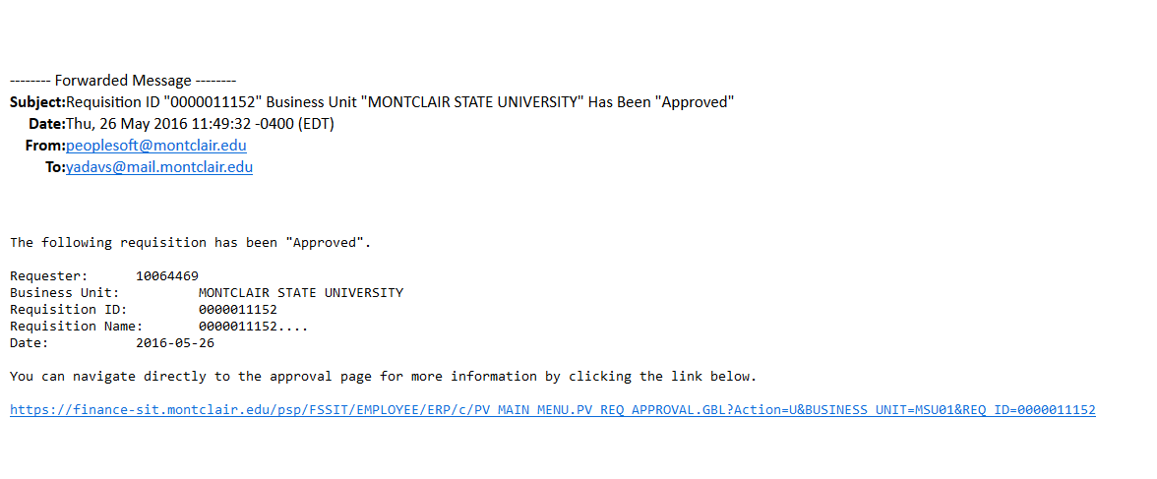
No further action is required by the Requisitioner for this request to be processed.

Denied Requests Process
If a request is denied, the Buyer will be required to add comments to the approval flow.
To edit a requisition per the buyer’s comments:
- The Requisitioner will receive an email from peoplesoft@montclair.edu stating that the requisition has been “Denied” within the subject line.
- The Requisitioner must be logged into PeopleSoft then click the link contained within the email to be brought to the Review Request page and view the Approval Flow.
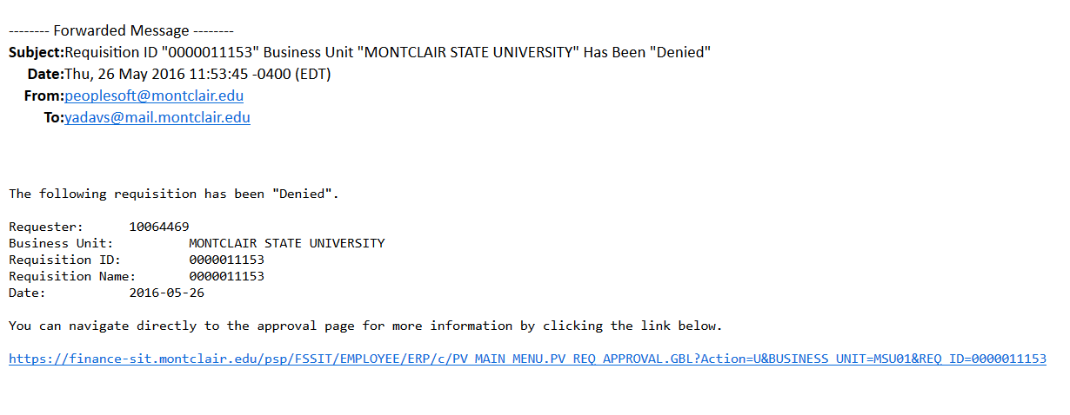
Click this link to be brought to be Approval Flow and view any comments.
- From the Approval Flow, the Requisitioner must click the View/Hide Comments link in the right corner of the Additional Approvals box.
The comments from the specific Buyer will expand and the Requisitioner can read what the Buyer needs in order to process the request.
- For a denied request, the Requisitioner should either make the changes requested by the Buyer, or cancel the requisition per the Buyer’s instruction.
- To edit and resubmit the requisition for approval, the Requisitioner should click the Edit Requisition button at the top of the screen to access the requisition in edit mode.
- The standard requisition form displays, where the Requisitioner should make the necessary changes to the request.

- When finished with the changes, click Save for Later, perform a Budget Check, and Save and Submit the requisition to the Approver.
To cancel a requisition per the buyer’s comments:
- If the Approver has asked that the request be canceled, the Requisitioner should search for and cancel the request from the Manage Requisitions screen. Once canceled, the pre-encumbered funds will be released back into the respective budget after night processing is complete.

Requests on Hold Process
If a request is placed on hold, the Buyer needs additional information or documentation, and must add comments to the approval flow.
- The Requisitioner receives an email from peoplesoft@montclair.edu stating that “Information is Requested” within the subject line.
- The Requisitioner must be logged into the PeopleSoft system, and then click the link in the email to be brought to the Review Request page and Approval Flow.
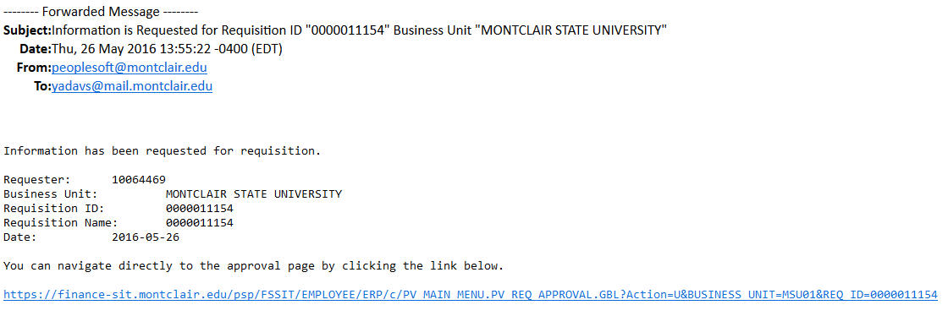
Click this link to be brought to be Approval Flow and view any comments.
- From the Approval Flow, the Requisitioner must click the View/Hide Comments link in the right corner of the Additional Approvals box.
The comments from the specific Buyer will expand and the Requisitioner can read what the Buyer needs in order to process the request.
- For a request put on Hold, the Requisitioner should enter comments into the Approval Flow, as necessary, to capture all pertinent information into the system. To add comments to the Approval Flow, the Requisitioner should click the View/Hide Comments link in the right corner of the Additional Approvals box.
- When the Comments section expands, the Requisitioner can then add comments into the Enter Comments field, and click the Save Comments button.
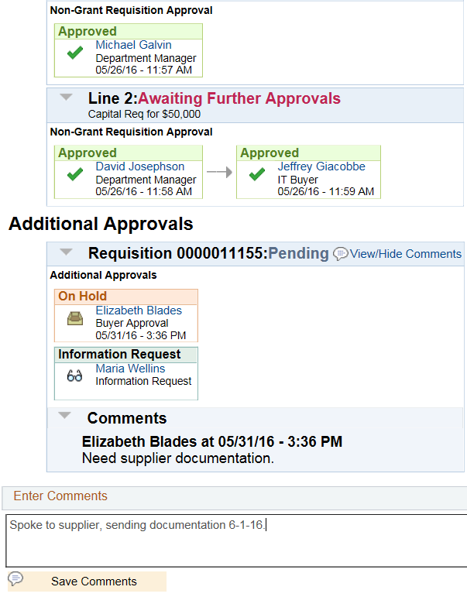

Business Rules When Changing a Requisition
The following rules apply when working with changes to a requisition:
- Requisitions can be increased or decreased (Unit, Dollar Amount, or Quantity) until the request has been fully received.
- At any point in the process, an edit to a requisition will cause the approval workflow to restart.
- Once a requisition is sourced into a purchase order and dispatched, any change to a request will cause a change request to be issued to the supplier.
- Additional lines CANNOT be added to a purchase order through the edit requisition function. A new requisition for additional line items must be created.
- The new quantity on the requisition cannot be less than the received quantity.
- Distribution line information on requisition cannot be changed.
- Changes to your requisition will be removed if the buyer or requisition approver denies the change in quantity or price on the requisition during the approval.
- If a requisition line with a special request item is sourced to a purchase order, you can change item price as well as the quantity.
- If commitment control is being used, a change to quantity or price that alters the amount of the requisition is not allowed if the purchase order to which it is associated has not successfully budget checked.3
Standard Approval Flow
Most requisitions will need to be approved by the Department Manager, and then a Buyer from the Procurement Department.

Standard Print Approval
An additional approver (Printing Administrator) is automatically added on for requisitions with print item categories.

Standard IT Approval
An additional approver (IT Buyer) is automatically added on for requisitions with IT item categories.

IT Buyer

Standard Grant Approval
All grant requisitions will automatically be routed to the Post Award Administrator (Grant Accounting) for review and processing.

Full IT Approval
Requisitions over $33,000 will automatically be routed to the Procurement Director for approval.
Requisitions over $500,000 will also be routed to the Finance VP/AVP for approval.

Denied
If a requisition is denied within the Approval Flow, the requestor receives an email with a link to the requisition.
To see the comments regarding the denial, click the View/Hide Comments link within the Approval Flow.
Any edits or changes to the original request should be made from the Manage Requisitions screen.

Hold
If a requisition is put on hold, the requestor receives an email with a link to the requisition.
To see the comments regarding the hold, click the View/Hide Comments link within the Approval Flow.

PushBack
Requisitions that are pushed back will go back to the previous person in the Approval Flow. That individual will need to push it further back, so that it eventually gets to the requestor, if changes are needed to be made.
To see the comments regarding the pushback, click the View/Hide Comments link within the Approval Flow.

Add Approvers onto a Requisition
If other additional approvers, or reviewers (parties that will have read-only access to the requisition) need to be added to the approval flow of a requisition, they can be added onto the preset approval flow from the Confirmation screen of the requisition.
- Click the green plus sign next to the last approver’s name in the Requistion Approval box.
A dialog box opens displaying search and selection options.
- Click the Search button to enter the name of the additional individual.
- Enter the search term and click Search.
- Select the appropriate user name. Note: The selected approver must have requisition approval access already assigned to their profile.
- Click OK.
You will be brought back to the Insert window.
- Select the role for the adhoc approver.
- Click Insert.
The Approval Flow will update to display the additional individual’s name and role.

View Approval Flow Comments
Approvers must add comments on any requisition they Deny or put on Hold. Requisitioners will receive a notification regarding the status of the request, and should go into the request to view the comments from the Approver.
- From within the Requisition Lifecycle, click the Approvals icon to open the detail of the Approval flow for the specific requisition.

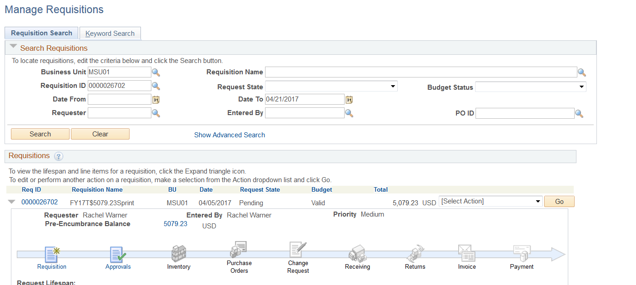
- Click the expansion arrow to view the comments within the Approval flow.
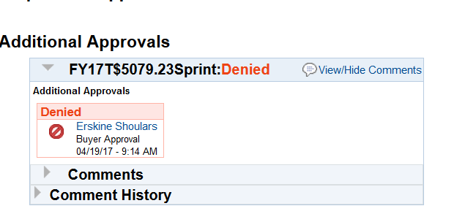

- Review the comments displayed.
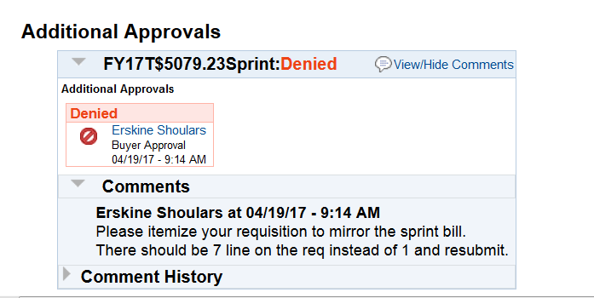

Manage Requisitions
The Manage Requisitions screen displays a history of the requisitions for a specific user. A requisitioner will be able to view all of their requisitions and their current states within this screen, as well as access the Requisition Lifecycle for a specific request.
To access the Manage Requisitions screen, go to Main Menu > eProcurement > Manage Requisitions.
The screen displays with a number of search parameter fields. Search for a specific requisition by name, ID number, PO number, request state, or date range. Note – the Date From and Date To fields will default to the past week. To extend your search beyond these dates, clear the preset data from these fields. When you have entered all parameters, click the Search button.
The results of the search display in the lower part of the screen, and can be sorted by clicking on any of the column headers.
Each requisition contains a lifecycle which can be accessed by clicking the arrow to the far left of the requisition line. The lifecycle displays each phase and indicates, through colored icons, where actions have taken place, along with the specific line details of the request. Click on a colored icon to get additional details of the specific phase of the request.
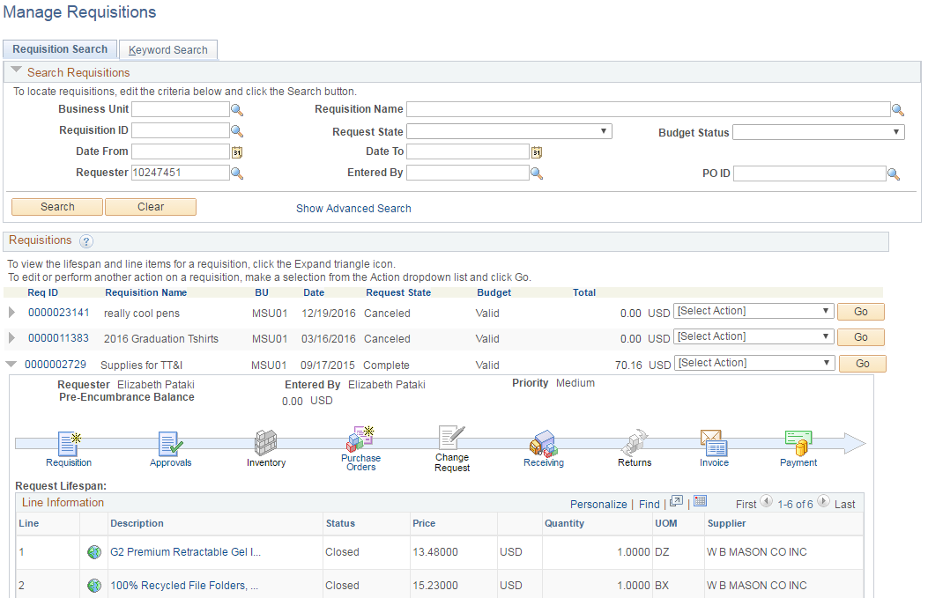

Access a Saved Requisition
To access a saved requisition, search for the request from the Manage Requisitions screen, typically by Requisition Name.
From the Search Results, go to the Select Action drop down box at the far right of the specific Requisition line and select Edit, then click Go.
The requisition opens in the system.
To add additional lines to the requisition, click the Add More Items button from the Edit Requisition screen.

Edit a Request
Only Special Request requisitions can be edited in the system. To edit a request in the system, search for and locate the requisition from the Manage Requisitions screen.
- On the specific line in the search results, click the Select Action drop down at the far right of the line.
- Select Edit from the drop down list and then click the Go button to open the requisition form.
- A warning message will appear that the Approval Flow will be restarted. Click OK.
- Click the line description of the item to be edited to be brought back to the original Special Request requisition.
- Make the changes needed in the original requisition form and click Apply.
NOTE: All requisitions must be budget checked before submitting. The note displayed reinforces that a budget check must occur before requisition can be submitted.
- Click the OK button to proceed
- If additional line items need to be adjusted, repeat the above steps.
- When all changes are made to the original requisition, click the Save and Submit button at the bottom of the requisition form, perform your Budget Check, and Submit your request.
Please note, only adjustments in price or quantity should be made to a requisition. New line items should not be entered to a requisition that has an associated Purchase Order created.

Cancel a Requisition
- Click the Select Action drop down for the corresponding requisition and click Cancel.
- Click the Go button.

- Click the Cancel Requisition button.
The requisition will be canceled in the system and the pre-encumbered dollars will be released back into your budget for another use.

Uncancel a Requisition
When a request is canceled in the system, the information is stored in the database. Canceled requested can be restored in the system with minimal effort.
- From the Manage Requisitions screen, search for the specific request.
- In the search results, identify the requisition and click the Select Action drop down menu.
- Click the Undo-Cancel option and click the Go button.
- On the Requisition Details screen, click the Reopen Requisition button.
The requisition will reopen and process to the next phase in the lifecycle.

Receiving Goods and Services
All goods and services must be formally received within the FMS system in order to allow for processing of payment to the supplier.
Receipts can be complete or partial, depending on the total amount received versus the total amount requested. There can be multiple receipts against a single requisition. It is important to receive accurate quantities within the system, and to confirm partial receipts when appropriate so that payments to suppliers are accurate and timely.
Attachments, such as packing slips and delivery receipts, MUST be attached to the receivings for your goods and services. For Goods that have been received, a packing slip or delivery document should be attached to the Header Comments on the Receiving screen. For Services that have been received, please complete the Certification of Receipt of Services template (located on the OneMontclair > Finance > Forms website) and attach it to the Header Comments area of the receiving screen.
NOTE – Do NOT attach any invoices to the Receiving screen in FMS. If a Requisitioner has received an invoice to be paid, it must be sent separately to the Accounts Payable department at invoices@montclair.edu.
When searching for a requisition that has not previously had any receipts posted against it, use PO(s) Dispatched in the Request State field of the Manage Requisitions screen. If a requisition has had previous receipts against it, use Partially Received in the Request State field of the Manage Requisitions screen.
- After signing into the system, navigate to the Manage Requisitions screen via Main Menu > eProcurement > Manage Requisitions.
- In the Search Requisitions section, click the Clear button and then set the Request State to PO(s) Dispatched for an initial receiving or to Partially Received for subsequent receipts. Enter any other search parameters as needed.
- Click the Search button.
3
2
1
A list of all of the requisitions meeting the search criteria will display.
- Locate the target requisition from the list, and click the Select Action drop-down on the corresponding line.
- Select Receive from the list of options.
- Click the Go button to open the Requisition Lines to Receive screen.
6
5
4
- Select the individual line(s) to be received by placing a checkmark to the left of the specific line(s). To receive all lines at once, click the Check All button in the bottom left corner of the screen.
- Click the Receive Selected button at the top of the list.
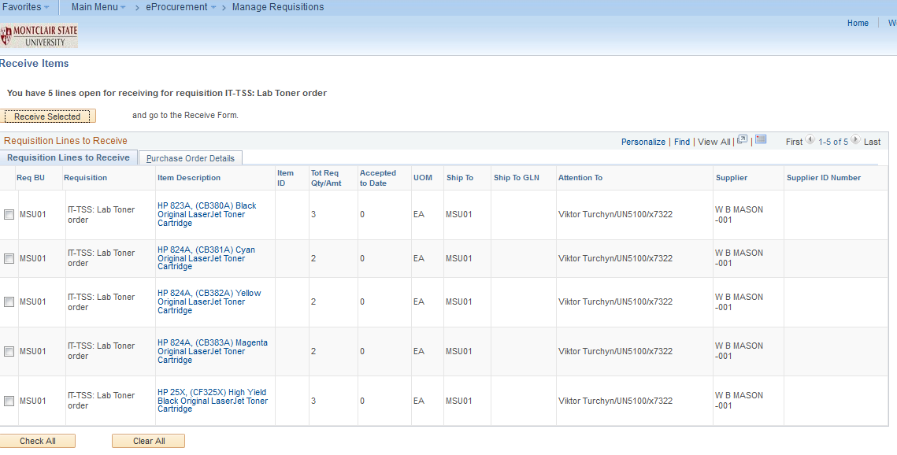
8
7
The Receive Items screen displays.
- Review each line and enter the amount received for each item in the Received Quantity column.
NOTE: If the actual amount received for each line item is less than the total amount ordered, enter the actual amount received, this is known as a partial receipt.
- Click the “Add Header Comments” link at the top of the Receipt Lines to attach your packing slip or delivery document to the receiving.
- Click the Save Receipt button to add this receipt into the system.
11
9
10
The Receipt Saved Successfully screen displays and lists the specific receiving number for this record in the system.

Cancel a Receipt
A receipt may need to be canceled for a variety of reasons. One reason is the purchase order must be canceled, but to do so, the receiving must be reversed BEFORE the purchase order can be canceled.
- From the Manage Requisition search results, expand the arrow of the targeted requisition to view the Lifecycle.
- Click the Receiving icon to display the line item(s) for this request.
- The Manage Receipts screen displays. Click the Details icon for the selected requisition, to open up line detail information.
- To cancel the receiving for a specific line(s), click the Receipt Comments icon, on the Receive Items screen, to add comments to a specific line, and click the red X(s) to cancel receipts of specific line(s).
To cancel the receiving for the entire request, click the Add Header Comments link to add comments to the entire request, and click the red X(s) to cancel receipts of specific line(s).
NOTE - Comments should reflect the reason for the cancelation of the receipt, and include any available supporting documentation.
Click to add receipt comments for the entire request
Receipt Comment icon for each corresponding line item
Now that the Receiving has been canceled, the Purchase Order can be canceled.

Returning Goods
Goods which need to be returned cannot exceed the quantity that have been received to date.
- From the Manage Requisitions screen, search for the targeted requisition.
- Click the Select Action drop down at the far right of the requisition line and select Process Return.
- Click the Go button to open the Return to Vendor screen.
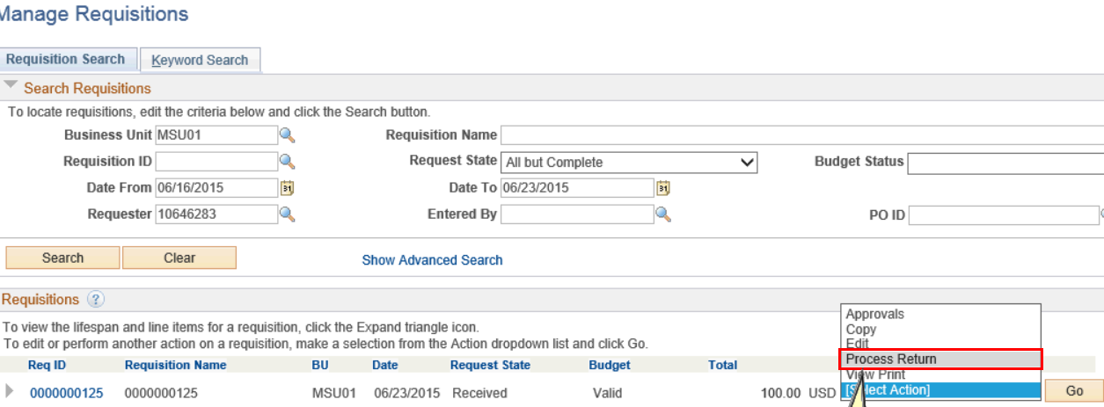
- On the Return to Vendor screen, complete the following fields:
- Return Quantity – indicate how much of each line item is being returned
- Return Action – choose how the supplier should remediate the return: Credit, Exchange, Replacement. Typically select Credit so that the funds can be reassigned back to your budget.
- Return Reason – select the magnifying glass to the right of the field to select the main reason for the return of the goods
- RMA Number – enter the Return Material Authorization number received by the supplier before starting the return process in the system.
- Click the Ship RTV button to set the shipped quantity equal to the return quantity for the selected line items.
- Click the Save Return to Vendor (Supplier) button to save this data in the system.
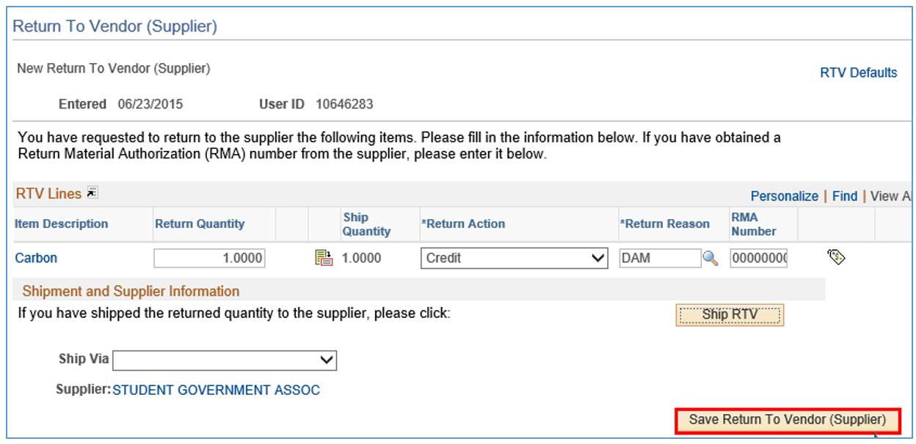
The system will display a confirmation message on the Return to Vendor (Supplier) Saved Successfully screen, and provide a Return to Vendor (Supplier) number which will be associated with the original requisition.
Physically process the return as you would with any other package to be sent out.

Invoices and Payments

Invoice Process
Invoices should be sent directly to the Accounts Payable department from the supplier, and should contain the purchase order number on the invoice. If a Requisitioner receives an invoice instead, the Receiving number(s), requisitioner name and extension must also be added onto the invoice before it is sent to Accounts Payable. All invoices should be emailed to Accounts Payable at invoices@montclair.edu.
MSU policy requires that only actual invoices be used when paying obligations. Please do not submit quotations or packing slips. Packing slips should be attached to the PO Receipt only. DO NOT send them to invoices@montclair.edu.
When forwarding a final invoice for a PO that will result in funds being left in the PO, please write on the invoice “FINAL INVOICE.” This allows Accounts Payable to not only issue the payment, but to finalize and close the PO in FMS, thus minimizing future cleanup efforts.
If submitting multiple invoices from a single Supplier, please add each of the individual scanned invoices onto a single PDF file and submit it. Please ensure that the PO number and Receipt numbers are on the corresponding invoices. When emailing the invoices, please include the Supplier name and first invoice number in the subject field of the email.
When Accounts Payable receives the invoice, they will enter it into the system. The system will then perform a three point check to confirm there is a purchase order, receipt of goods/services, and an invoice logged into the system. If all three are present, a payment can be released to the supplier. If one of these components is missing, the Requisitioner will be notified so that they add the missing data into the system.

Read the PO Payment Screen
- From the Manage Requisitions screen, search for and select the targeted requisition.
- Click the expand arrow at the left side of the requisition line to display the life cycle timeline.
- Click the Payment icon to access payment information.
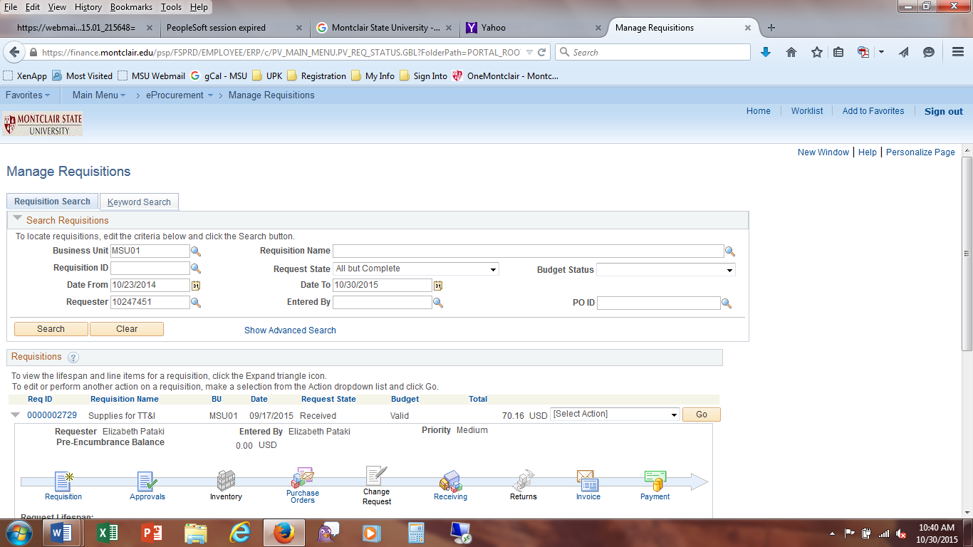
The PO Payment screen displays and contains the following information:
Payment Reference ID – check number
Accounting Date – date the voucher was entered into the system
Payment Date – date the check was issued from MSU
Days Outstanding – number of days the check is waiting to be cashed
Payment Clear Date – date the check cleared from the MSU bank account
Reconcile Date – date debit occurs in the MSU accounting department from the bank statement
Payment Method – how payment was made; CHK - paper check, ACH - electronic funds transfer

Cancel a Voucher, Receipt, and Purchase Order
The Requisition Lifecycle displays each phase of a requisition. When an icon is colorized, it represents actions within a phase have been started. In order to cancel a Purchase Order, any invoices and receivings must be reversed in the system. Therefore, if an invoice has been created and a receiving has been completed, these two (2) steps need to be canceled before the purchase order can be canceled.
Reverse an Invoice
If an invoice has been issued against a purchase order, the voucher (which is the reference document for the invoice) must be reversed in the system before any other information can be canceled/corrected.
- From the Manage Requisitions results screen, select the arrow to the left of the target requisition.
- In the Requisition Lifecycle, click the icon for the Invoice.
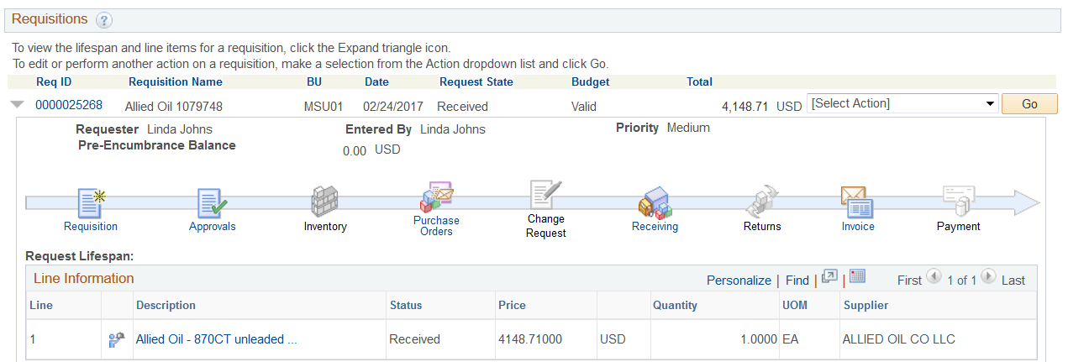
- In the PO Line detail area of the screen, take down the Voucher number.
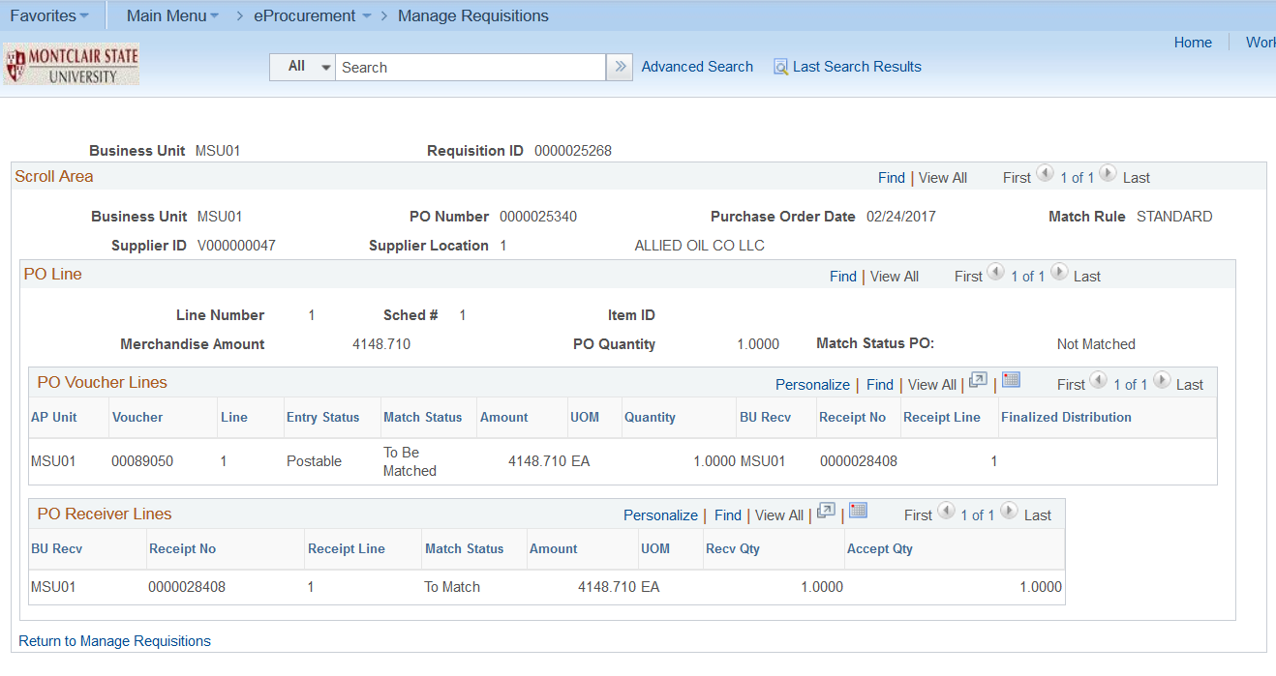
- Call or email the Accounts Payable department to have the voucher deleted, in order to move to the next step of the process – reversing a receipt.
Reverse a Receipt
A receipt may need to be canceled for a variety of reasons. One reason is the purchase order must be canceled, but to do so, the receiving must be reversed BEFORE the purchase order can be canceled.
- From the Manage Requisition search results, expand the arrow of the targeted requisition to view the Lifecycle.
- Click the Receiving icon to display the line item(s) for this request.
- The Manage Receipts screen displays. Click the Details icon for the selected requisition, to open up line detail information.
- To cancel the receiving for a specific line(s), click the Receipt Comments icon, on the Receive Items screen, to add comments to a specific line, and click the red X(s) to cancel receipts of specific line(s).
To cancel the receiving for the entire request, click the Add Header Comments link to add comments to the entire request, and click the red X(s) to cancel receipts of specific line(s).
NOTE - Comments should reflect the reason for the cancelation of the receipt, and include any available supporting documentation.
Click to add receipt comments for the entire request
Receipt Comment icon for each corresponding line item
Cancel a Purchase Order
Once the cancelation of the receiving has been completed, the Lifecycle displays a black and white icon for the Receiving phase.
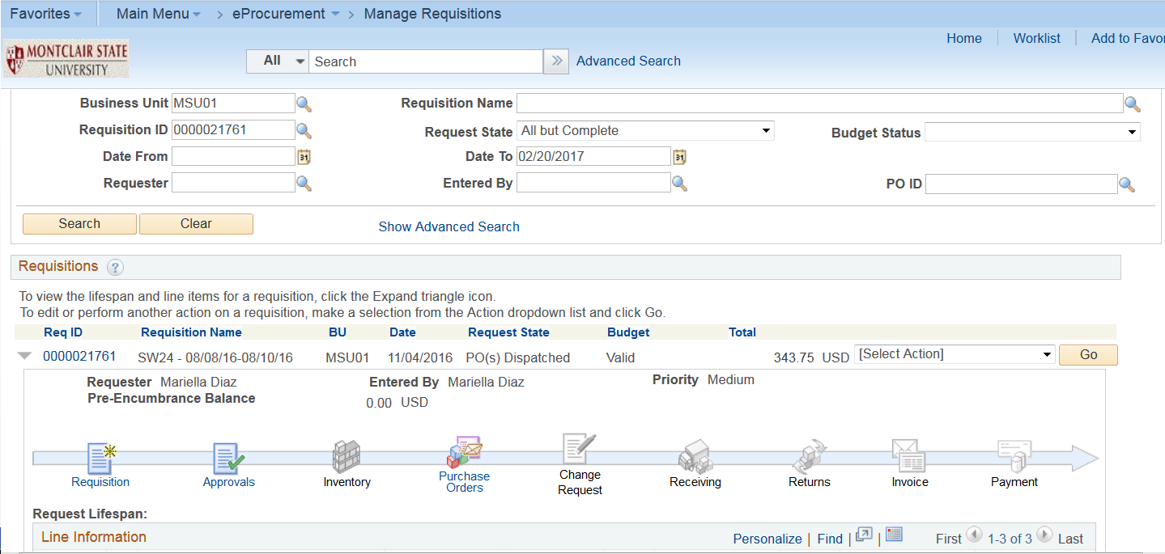
Only after a receipt has been canceled can a purchase order be canceled.
- From the Manage Requisition search results, expand the arrow of the targeted requisition to view the Lifecycle, and the line items details underneath.
- Click the red X on the specific line to be canceled from the purchase order.
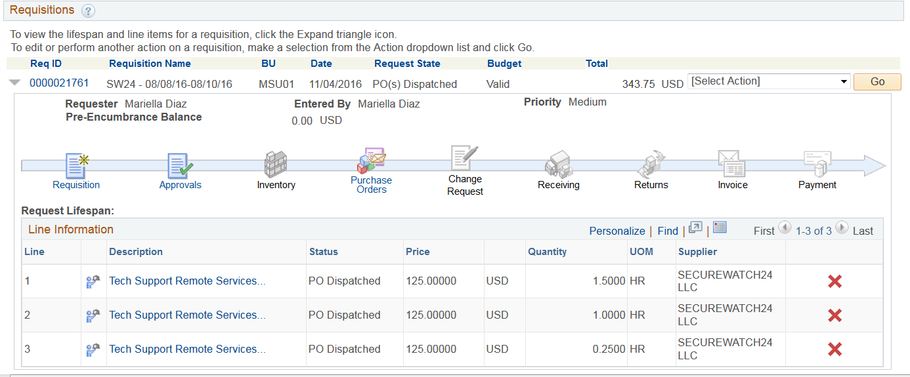
- A warning message displays where you must select OK to continue with the requisition line cancelation.
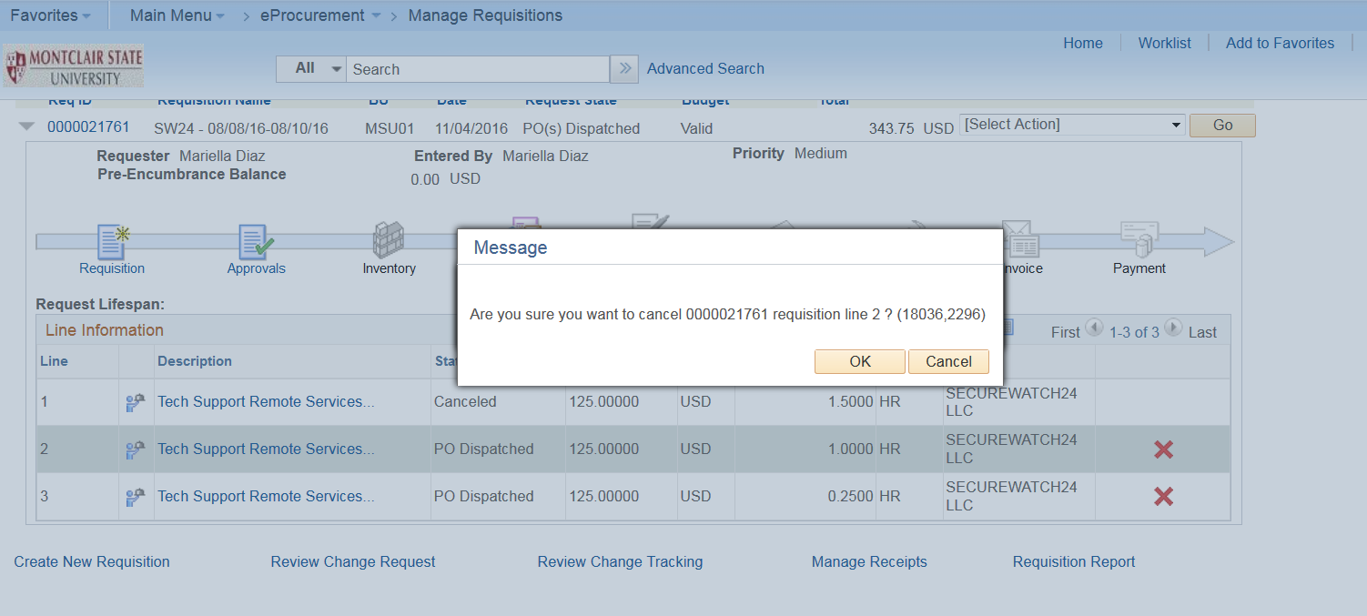
Repeat steps 2 and 3 for each line to be canceled.
- From the Manage Requisition search results, expand the arrow of the targeted requisition to view the Lifecycle. Note the Status column within the line items details lists each line as Canceled.
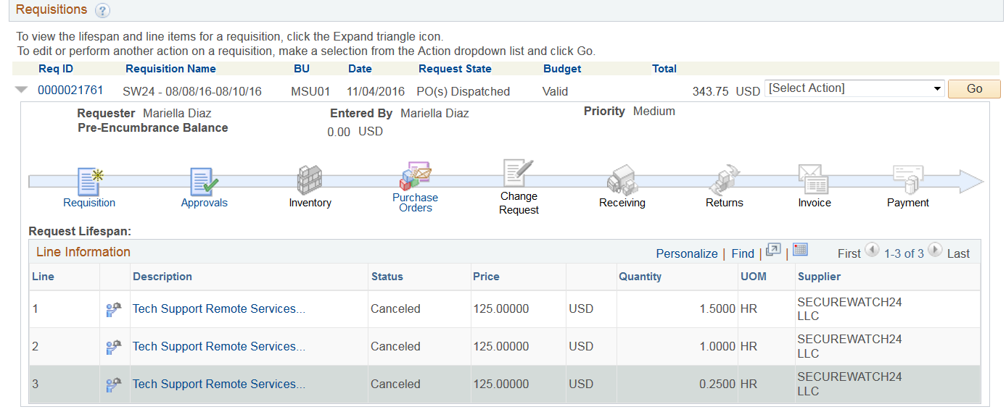

Manage Your Requisition Queue
When requisitions are created in PeopleSoft, the complete amount of the purchase is reserved from the budget as a pre-encumbrance. These budget funds are used to ensure that monies are available for the payment of the goods and services being purchased.
However, if an order is not completely received in the system for whatever reason (short shipment, etc.), or the request has not been processed completely, the remaining dollars of the purchase are still locked into the encumbrance and therefore, not available for the Department to use.
In order to free up your budget money, and keep the PeopleSoft system as clean as possible, Requisitioners should periodically review their Manage Requisitions screens to identify those requests which are holding up budget funds. These requests could be:
- requests not submitted for approval
- remaining items not being shipped
- requests submitted but not approved
- duplicate entries
- requests stuck in budget errors
It is recommended that reviews be done on a recurring basis in December, March, May and September of each year to maximize the use of your budget funds.

Requests Not Submitted for Approval – OPEN STATE
In the Manage Requisitions screen, search on the Request State of OPEN to find those requisitions that have been created in the system, but not submitted for approval. These requests have pre-encumbered (reserved) budget dollars not currently available to use.
To release these requests, either Cancel the requisition for items no longer needed, or Submit the requisition for approval.
To cancel the requisition, click the Select Action drop down for the corresponding requisition and click Cancel. Click the Go button. Click the Cancel Requisition button. The requisition will be canceled in the system and the pre-encumbered dollars will be released back into your budget for another use.
To submit the requisition for approval, click the Select Action drop down for the corresponding requisition and click Edit. Scroll to the bottom of the requisition and click Save for Later, perform a Budget Check, and click Save and Submit.

Requisition Not Completely Received – PARTIALLY RECEIVED STATE
If you have a requisition that you will not be fully receiving (short shipped or no longer available), you must go into the original request and change the overall quantity to the actual amount that was received for the request. This will ensure that the already appropriated pre-encumbered funds for this request are released for the quantity never to be received.
In the Manage Requisitions screen, search on the Request State of PARTIALLY RECEIVED to find those requisitions that still have open items to be received. These requests have pre-encumbered (reserved) budget dollars not currently available to use. To release these requests, click the Select Action drop down for the corresponding requisition and click Edit.
Click the Go button.
A warning message will appear that the Approval Flow will be restarted. Click OK.
Click the line description of the item to be edited to go back to the original Special Request requisition.
Make the changes needed in the original requisition form and click Apply.
Adjust the quantity of the original request and click the Apply button to update the amount of the request.
NOTE: All requisitions must be budget checked before submitting. The note displayed reinforces that a budget check must occur before requisition can be submitted.
Click the OK button to proceed
If additional line items need to be adjusted, repeat the above steps.
When all changes are made to the original requisition, click the Save and Submit button at the bottom of the requisition form, perform your Budget Check, and Submit your revised request.
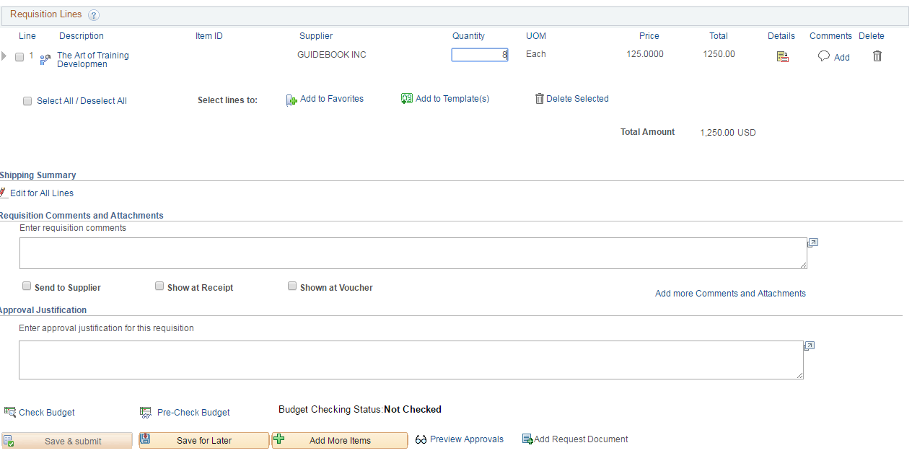
The requisition will be routed back to your Approver for processing so your encumbered funds can be released back to your budget.

Request States
A purchase requisition is not an official MSU purchase order until the status reads PO(s) Dispatched in the Manage Requisition screen. Up until that point, no order should be placed with any supplier. If an order is placed with a supplier before this status, the Requisitioner, not MSU, is personally liable for the purchase and payment of the goods/services, pursuant to Procurement Policy 1.
The various Request States in the system signify the status of specific requisitions within the system, and their current phase within the lifecycle. Searching on specific Request States can help you to clean up your requisition queue more efficiently.

Request Never Approved – PENDING STATE
At times, requests are submitted to Approvers, but they are never processed. These requests will have pre-encumbered dollars against them and without being processed, the pre-encumbrance can never be released.
In the Manage Requisitions screen, search on the Request State of PENDING to find those requisitions that have not been processed by the Approver. These requests have pre-encumbered (reserved) budget dollars not currently available to use.
Print the screen shot or create a list of the requisition numbers to review with your Approver. If the goods/services are no longer needed, the Requisitioner will need to Cancel the request, thus releasing the pre-encumbered dollars. If the goods/services are still needed, the Approver will need to approve the requests to continue the process of the purchase.

Duplicate Requests – VARIOUS STATES
At times, duplicate requests are entered in to PeopleSoft for the same goods/services. One request may get approved and processed and the duplicate one may be in an OPEN (never submitted) or PENDING (submitted for approval and not processed) state. These duplicates requests still have pre-encumbered dollars being held to cover their costs, and should be cleaned up in the system.
If you review your requisitions in Manage Requisitions and notice there are duplicate requests in your list, please Cancel those requests so that your pre-encumbered dollars can be released back into your budget.

Requests Stuck in Budget Errors – PENDING STATE
If you have a request in PeopleSoft with a budget error, please contact the Budget and Planning office or your Grants Accounting liaison to get help clearing the error, and, therefore, allowing the request to process properly.

Cancel a Voucher, Receipt, and Purchase Order
The Requisition Lifecycle displays each phase of a requisition. When an icon is colorized, it represents actions within a phase have been started. In order to cancel a Purchase Order, any invoices and receivings must be reversed in the system. Therefore, if an invoice has been created and a receiving has been completed, these two steps need to be canceled before the purchase order can be canceled.
Reverse an Invoice
If an invoice has been issued against a purchase order, the voucher (which is the reference document for the invoice) must be reversed in the system before any other information can be canceled/corrected.
- From the Manage Requisitions results screen, select the arrow to the left of the target requisition.
- In the Requisition Lifecycle, click the icon for the Invoice.
- In the PO Line detail area of the screen, take down the Voucher number.
- Call or email the Accounts Payable department to have the voucher deleted, in order to move to the next step of the process – reversing a receipt.
Reverse a Receipt
In order to cancel a purchase order with a receiving against it, the receiving must be reversed BEFORE the purchase order can be canceled.
- From the Manage Requisition search results, expand the arrow of the targeted requisition to view the Lifecycle.
- Click the Receiving icon to display the line item(s) for this request.
- The Manage Receipts screen displays. Click the Details icon for the selected requisition, to open up line detail information.
- To cancel the receiving for a specific line(s), click the Receipt Comments icon, on the Receive Items screen, to add comments to a specific line, and click the red X(s) to cancel receipts of specific line(s).
To cancel the receiving for the entire request, click the Add Header Comments link to add comments to the entire request, and click the red X(s) to cancel receipts of specific line(s).
NOTE - Comments should reflect the reason for the cancelation of the receipt, and include any available supporting documentation.
Click to add receipt comments for the entire request
Receipt Comment icon for each corresponding line item

Cancel a Purchase Order
Once the cancelation of the receiving has been completed, the Lifecycle displays a black and white icon for the Receiving phase.
Only after a receipt has been canceled can a purchase order be canceled.
- From the Manage Requisition search results, expand the arrow of the targeted requisition to view the Lifecycle, and the line items details underneath.
- Click the red X on the specific line to be canceled from the purchase order.
- A warning message displays where you must select OK to continue with the requisition line cancelation.
Repeat steps 2 and 3 for each line to be canceled.
- From the Manage Requisition search results, expand the arrow of the targeted requisition to view the Lifecycle. Note the Status column within the line items details lists each line as Canceled.

Purchase Orders
Purchase order is a legal document between the organization and a supplier to supply goods or services at an agreed rate and at an agreed duration of interval, which covers the payment terms and terms of delivery.

Print an Unofficial Purchase Order via Email
- From the Home page, navigate to Main Menu > Purchasing > Purchase Orders > Review PO Information > Print PO.
- If this is the first time printing any purchase order:
  - Select the Add a New Value tab to enter a Run Control ID on the Purchase Orders Print screen.
  - Enter the Run Control ID name in the corresponding field. In this instance, enter “Print_PO”.
  - Click the Add button.
- If you have previously set a Run Control ID (step 2), then enter the ID code (Print_PO) in the Run Control ID field, on the Find Existing Values tab, and click the Search button.
- Fill out the required fields of Business Unit and To, and enter the PO ID to print.
- Click the Run button.
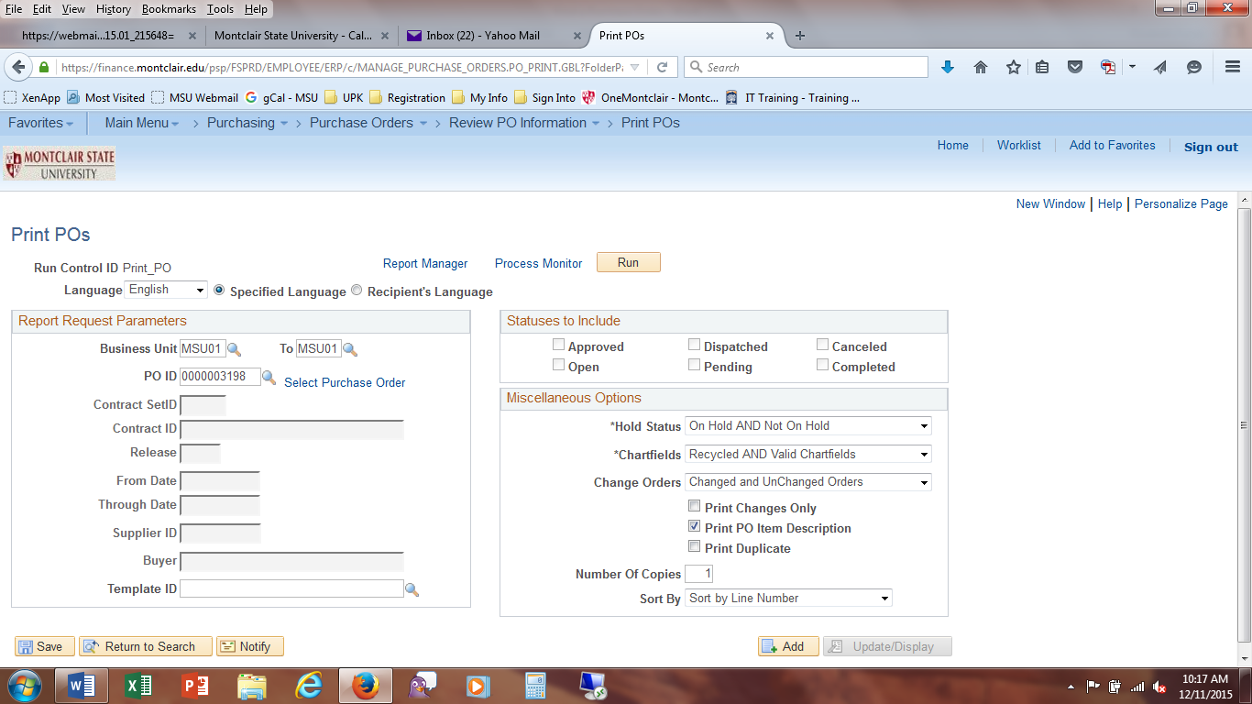
The Process Scheduler Request screen displays.
- Verify the Type is selected as Email and the Format is PDF in the Process List section.
- Click the Distribution link to send the unofficial purchase order to someone other than yourself. Enter the email address(es) into the Email Address List field, and click OK.
You will automatically get a copy of the PO as the CWID requesting the process.
- Click the OK button on the Process Scheduler Request window.
A Process Instance number will display indicating the request is being generated.
An email, with a PDF attachment of the unofficial purchase order, will be sent to the addresses indicated and the email associated with the CWID.
- Once received, open the email and PDF attachment to view/print the unofficial purchase order.

Change/Edit a Purchase Order
If the price, quantity, unit of measure, or an item description needs to be changed, the requisitioner can go to the original purchase requisition, and edit those components. Please see the Edit a Request section under Manage Requisitions.
Once updated in the system, the purchase order will be changed and the Change Request icon in the Requisition Lifecycle will be colorized to indicate something occurred in this phase.

Cancel a Purchase Order
Once the cancelation of the receiving has been completed, the Lifecycle displays a black and white icon for the Receiving phase.
Only after a receipt has been canceled can a purchase order be canceled.
- From the Manage Requisition search results, expand the arrow of the targeted requisition to view the Lifecycle, and the line items details underneath.
- Click the red X on the specific line to be canceled from the purchase order.
- A warning message displays where you must select OK to continue with the requisition line cancelation.
Repeat steps 2 and 3 for each line to be canceled.
- From the Manage Requisition search results, expand the arrow of the targeted requisition to view the Lifecycle. Note the Status column within the line items details lists each line as Canceled.

Queries for Requisitioners
There are a number of queries in PeopleSoft designed to efficiently provide data and data summaries to the end users in order to easily identify information. Queries can be accessed from the following breadcrumb trail:
Main Menu > Reporting Tools > Query > Query Viewer
- Once on the Query Viewer screen, enter the Query Name into the Begins with field and click the Search button to locate the query.
- From the results list (or the My Favorite Queries list) click the HTML link to launch the targeted query.
- On the Query page, enter parameters and click Search, if required, to view your data.
To download and sort query data, click the ExcelSpreadSheet link in the upper left corner of any results screen in PeopleSoft.
Some of the most popular queries are listed below:

Requisition-Purchase Order Cross Reference
Query Name – MSU_REQ_PO_INFO_1
Displays information based on a CWID for the following:
Requisition ID Number – Purchase Order Number – Requisition Name – Requester CWID – Requester Name – Date Entered – Buyer CWID – Buyer Name – Merchandise Amount – Status – Department – Supplier ID Number – Supplier Name
Note: if you are a requisitioner and someone else’s receiver, you will see data on all of the requests associated to both CWIDs.

Department Query
Query Name – MSU_DEPT_BALANCES_BY_ACCT
Displays information based on the Department and Fiscal Year selected for all revenues and expenses for both Children and parent accounts. Allows for drill down into financial summaries to view line item detail for Budget, Actual Expenses/Revenue, Encumbrances, and Pre-Encumbrances.

Quick Invoices
Quick Invoices should only be used by employees for travel and non-travel reimbursements of funds expended for MSU activities. Compensation requests for any type of work performed must be processed through the Payroll Department.

Employee Reimbursements
All employee reimbursements for travel and non-travel expenses are processed through PeopleSoft using the Quick invoice functionality. Please note the following parameters of submitting requests for these types of expenses.
Reimbursements for a Department Manager automatically route to the Deaprtment Manager’s supervisor for review and approval within FMS. An email will be sent to the supervisor once the voucher is ready for processing.
In accordance with MSU Travel Regulations, requests for reimbursements should be submitted within 15 days of returning from the trip.

Non-Travel Reimbursements (Non-travel reimbursements for students are prohibited)
- Any receipts for the expense
- A completed Quick Invoice Number Template form - found on the Accounts Payable > Forms website
- A completed and signed Employee Non-Travel Reimbursement form - found on the Accounts Payable > Forms website

Travel Reimbursements
As was the practice in the past, a Travel Authorization (TR-1) form must be completed BEFORE travel will take place for any overnight trip. All international trips MUST be authorized by the Provost’s office. This document may be held and submitted along the final Employee expense report. Additionally, the following support materials must be attached to the Quick Invoice request in PeopleSoft:
- Any receipts for the expense
- A completed Quick Invoice Number Template form - found on the Accounts Payable > Forms website
- A completed and signed Travel Reimbursement (T&E Expense Invoice) form - found on the Accounts Payable > Forms website
- If trip is to attend a conference, the conference brochure must be submitted along with the TR-1.
Forms website: http://www.montclair.edu/finance-and-treasury/forms/

Student Stipends
A stipend is a payment for living expenses made to a student who is in a position which focuses on training rather than employment. The training must be predominantly for the benefit of the student, not the employer, and the student can't be entitled to a job at the end of training; the student also can't displace regular employees. Finally, the student and the employer both acknowledge that the student isn't entitled to wages for training time.
If the requirements are met, the amount of the stipend is at the employer's discretion, and not required to pay at least the minimum wage per hour worked. If a stipend is paid, it isn't considered wages so Social Security or Medicare taxes are not paid on it. However, it still counts as taxable income for income tax purposes. The employer won't withhold any income taxes from the stipend, so, monies need to be set aside by the recipient to pay the taxes owed at the end of the year.
Stipends are paid at Montclair State University through Quick Invoice requests, and reported to the government for tax purposes. When requesting a stipend payment be made, the Supplier ID # for the recipient should be a standard supplier number, not an EMP or S identification number within the PeopleSoft system.

Quick Invoice User Tips
Only one invoice (supplier invoice or Quick Invoice Number Template) can be associated to a Quick Invoice request.
If you have a supplier invoice with an invoice number on it, do not use the Quick Invoice Number Template.
If freight or shipping charges are included in your Quick Invoice request, make sure that you have budget in these accounts before starting the Quick Invoice request. When requesting a quote for goods, have estimated shipping and freight charges included and itemized within the quote. The specific freight and shipping charges must be included as individual line items to ensure an accurate budget check is executed.
If a request gets denied, the original supplier invoice can be re-used when resubmitting the request. Quick Invoice Number Templates may be reused if no information needs to be updated/corrected on the saved PDF. Denied requests will now be deleted from the system on a nightly basis. This has been changed from previously needing to submit a new, unique invoice number.
When searching for an employee for a Quick Invoice request, you must go to Main Menu > MSU Implementation > Accounts Payable > Quick Invoice and enter the last name of the employee in the Supplier Name lookup screen. The correct employee number will be the one with the EMP pre-fix.
When submitting an employee reimbursement form, please include the employee’s or student’s full mailing address on the Quick Invoice Number Template form. This has been changed from previously entering only the Building and room number of the employee/student.
Students may be listed in three separate ways within PeopleSoft, depending on why the student was entered in the system.
- If a student received a tuition refund, they will be listed with an “S” as the first character of their ID number, and will be found only on the Quick Invoice Supplier lookup screen.
- If a student is an MSU employee and has an expense reimbursement, select the “EMP” as the first three characters of their ID number. They will be found only on the Quick Invoice Supplier lookup screen.
- If the student is a vendor, they will be found on the View Supplier Details screen and will have a standard vendor ID number.
The acceptable expense purpose codes for Quick Invoices are listed within the Quick Invoice Number Template and the Quick Invoice – Requisitioner reference guide. When selecting the “Employee Non-Travel Reimbursement” or “Petty Cash Replenish” codes, use the child account numbers normally associated with the specific expense.
When completing the Quick Invoice Number Template, note the reference number in the upper right hand of the template form will change with every data entry. The correct reference number to use will be the one on the saved copy of the request. To save this form with the data contained, right click on the completed form and select Print…. Change the printer destination to Save as PDF. Click Save and enter the file name and destination in the Save As dialog box, and click the Save button.
The suggested naming convention for the Quick Invoice Number Template is to use the supplier name and date as the file name. This will make it easier for you to identify the contents of the file, as well as Accounts Payable.
If sales tax is included on a receipt for a reimbursement from a store, the tax should be deducted from the total check amount request. If sales tax is included on an OUT OF STATE HOTEL, then it will be included within the total check reimbursement amount.
Requesters and Approvers can add attachments to Quick Invoice requests that are placed on hold from Accounts Payable due to lack of back up. In order to add attachments once the request has been submitted and approved, go to Main Menu > MSU Implementation > Accounts Payable > Voucher Search. Click on the Voucher number of the targeted request to open the voucher information. Add the attachment by clicking the Attachments link and uploading the backup documentation.

Quick Invoice Request Process
The process of initiating requisitions with a CR category has been eliminated. In order to request a payment without a purchase order, or an employee reimbursement, you will need to execute a Quick Invoice. NOTE – A Quick Invoice request will not be available for Approver processing until the day after the creation of it in the system.
The main steps of the Quick Invoice are as follows:
- Confirm supplier/employee in the FMS system
- Confirm Invoice number from Supplier, or create an invoice record using the Quick Invoice Number Template for both supplier and employee requests
- Enter the Quick Invoice information
- Change a Request (Any changes to the information must be made by the end of the same day)
- Check status of request
Confirm Supplier/Employee in the FMS System
BEFORE beginning the Quick Invoice process, confirm the supplier or employee exists in PeopleSoft.
For SUPPLIERS, go to View Supplier Details (Main Menu > Suppliers > Supplier Information > Add/Update > Supplier) to search the supplier name.
For EMPLOYEES and STUDENTS, go to Main Menu > MSU Implementation > Accounts Payable > Quick Invoice, click the magnifying glass at the Supplier Name field and search the last name of the person in the Supplier Name field. NOTE- Use the EMP number for the employee as Supplier ID numbers.
Confirm Invoice from Supplier/Create Invoice Record
The requestor needs an invoice number before the data entry process can be started. If the supplier has provided an invoice, enter the invoice number in the Invoice Number field. If no invoice has been provided, or an employee reimbursement is to be done, a Quick Invoice Number Template must be completed so that an invoice number can be generated within the system. It is important to complete the correct address of the employee being reimbursed so that Accounts Payable can confirm it is the correct individual. The Quick Invoice Number Template is available on the Finance and Treasury website, under Forms, in the Accounts Payable section.
NOTE – A new Quick Invoice Number Template must be completed each time a new request is initiated. The completed template cannot be reused for multiple requests, as a unique invoice number will need to be generated each time there is not a supplier invoice provided.
Save the completed template as a PDF (print as PDF) in your computer to ensure the entered data is retained within the form and that the invoice number is locked on the completed form. Once saved, attach it to the Quick Invoice request in PeopleSoft, along with any other backup.
To Print as a PDF:
- Right click on the screen and choose Print…
- In the Print dialog box, select Print as Pdf or Adobe PDF for the printer name.
- Click the Print button.
- In the Save PDF File As dialog box, enter the name and select the location of the file, and click Save.
NOTE – The request for a reimbursement for a Department Managers will be automatically routed to the Department Manager’s Supervisor within FMS. All approvals will be captured within the system.

Confirm the Expense Purpose of your Request
Next, confirm that the expense purpose of your request is valid for a Quick Invoice. The valid Quick Invoice uses are:

DESCRIPTION | CODE
Employee Non-Travel Reimbursements | VARIOUS
Petty Cash Replenish | VARIOUS
Bursar_3rd Party Refund_Only | XXXXX
Conference_Registration | 62515
Const_Permit | 70210
Co-Op_Teachers | 60518
Credit_Card_Renewal_Fee | 60559
Curriculum_Food_Supplies | 60116
Express_Delivery | 60420
Grant Incentives | 60725
Honorarium | 60524
Instructors/Models | 60502
Insurance | 60526
Internet_Svcs | 60562
License_Fees | 60511
Membership | 60559
Officials | 60542
Other_Registration | 62510
Participant_Payment | 60725
Participant_Stipend | 60901
Real_Estate_Taxes | 60752
Refunds | 44250
Refunds_Grantors | 64981
Royalties | 60745
Storage/ Shredding | 60542
Student_ Award | 60535
Student_Fee_Liability (Bursar use only) | 20090
Student_Prizes | 60750
Student_Stipends | 64080
Subscriptions | 60558
Travel_Domestic | 62011
Travel_International | 62021
Travel_Local | 62001
Travel_Non-Employee | 62211
Travel_Student Excursion | 62516
Visa_H1B/Homeland Security | 60557
Washington_Ctr | 64100

Refunds
With the exception of account 64981 (Refunds_Grantors), all other refunds will be processed via account 44250 (Refund), so that refunds will be taken directly from revenue.
If the Supplier being refunded does not appear in the FMS Supplier list, there will no longer be a need to have them added to FMS for a refund only. Instead, please send the following information to refunds@mail.montclair.edu
- Name (Full correct name)
- Address (including zip code)
- Documentation supporting the refund
- ALL Chartfields: Fund, Dept., Account (use 44250), PC Bus Unit, Project, and Activity (if necessary).
Refunds will be made via paper check payment. If an ACH refund payment is needed, a Supplier Create Form must be submitted to Procurement and the Requestor will need to follow the Quick Invoice process procedures. Please do not submit this request to Refunds@mail.montclair.edu if the Supplier already appears in the FMS Supplier List as this will only delay the refund process.

Enter the Quick Invoice Information
Once the supplier has been confirmed and an invoice number is in hand, go to Main Menu > MSU Implementation > Accounts Payable > Quick Invoice to begin the Quick Invoice process.
The Quick Invoice screen displays. With the Add a New Value tab selected, complete the fields on the first page.
- Business Unit, Voucher ID – Do not adjust these fields as they are set as system defaults.
- Supplier Name – Search for the name of the supplier or employee. When selected, the Short Supplier Name and Supplier ID fields will autocomplete.
- Invoice Number – Enter the supplier invoice number or the Quick Invoice Number.
- Invoice Date – Enter the date of the invoice. For today’s date, enter “T”.
- Gross Invoice Amount – Enter the total amount of the check to be written, including any freight or sales tax amount.
- Estimated No. of Invoice Lines – The default for a Quick Invoice is four line items. You can adjust this value, if needed.
- Freight Amount – Enter the amount of any freight to be included in the payment. If you are indicating freight costs on a Quick Invoice, you must have budget in your freight account or the request will not pass budget check.
- Sales Tax Amount – Enter the amount of any sales tax to be included in the payment. NOTE – This field can only be used for restaurant reimbursements.
- Misc Charge Amount – Do NOT enter any amount in this field. Miscellaneous charges cannot be included in the payment.
- Transaction Currency, Origin, Quick Invoice Template, Voucher Style – Do not adjust these fields as they are set as system defaults.
Note – The information completed on the first screen page will be carried over to the Quick Invoice form.
Click the Add button to continue to the Quick Invoice form.
The Quick Invoice form displays and the information from the first screen is filled into the appropriate fields.
Invoice Lines Section
Amount Section
Supplier Section
Header Section
The Quick Invoice screen is broken down into four sections. Confirm all information is correct within the top three sections (imported from the first screen) and make any necessary changes.
- The top section is the Header which contains the Invoice Number and Date, as well as functional buttons.
The Calculate button should be used to reset the overall value of the quick invoice if changes are made to the initial values entered. By clicking the calculate button, the system reconfirms the Invoice Lines are equal to the Total line in the Amount Section.
The Print Invoice button is only available to produce a hardcopy of an external supplier’s invoice. This functionality is not available for employee or student payments.
The Edit Combinations button should be selected once all Invoice Lines have been completed on the form. This allows the system to validate that the Chartfield codes are valid.
- The Supplier section displays information on the selected supplier or employee who receives the payment.
Additionally, there are links within this section to add attachments and comments to this request. NOTE - To ensure all data is saved within the system, BEFORE adding any attachments or comments, SAVE your request.
Click the Attachments link to upload and attach your invoice, and any related documentation, to the Quick Invoice request. An invoice MUST be attached to each request or the request cannot be processed.
To upload an attachment:
- Click the Attachments link.
- Click Add Attachments button.
- Click the Choose File button.
- Navigate to the document to attach, and select it.
- Click Open.
- Click Upload.
- Enter a description of the document in the Description field.
- Click OK.
The Comments link allows special instructions regarding the Quick Invoice request to be entered. There are 254 spaces available for comments.
- The Amount section breaks down the cost of the payment. If you need to add additional costs to the overall request, enter the appropriate values on the corresponding lines within the Amount section.
Note, to change the Line Amount value, adjust the Total Line within the Amount section first, and the corresponding line item within the Invoice Lines section. Then click the Calculate button in the Header section of the screen.
- The bottom section is the Invoice Lines and provides fields to enter the appropriate Chartfield codes for each line of this payment.
In the Invoice Lines section, enter the description of the expense in the Description field, and type the appropriate Chartfield codes (Funds, Departments, and Accounts) into the corresponding fields. For Capital Projects and Grants, the PC Business Unit, Project Number, and Activity fields must also be entered.
To break down the payment into multiple accounts or departments, enter the appropriate Chartfield and expense data on separate line for each item. To add additional lines, click the plus sign icon on the far left of a line.
Once Chartfield data has been entered for the request, click the Edit Combinations button, in the Header section of the form, to validate the codes within the system.
If values were entered for Freight or Sales Tax lines, no Chartfields will need to be completed in the Invoice Lines section as these categories will automatically map to the appropriate accounts, and will not display within the Invoice Lines section. However, if there is no available budget in these specific accounts, the request will not pass budget check.
Click the Save button to submit this form to the Approver for review and processing.
The Add button and Update/Display button, in the lower right corner of the screen, will bring you back to the first screen. If your data has not yet been saved, a warning message will appear on the screen.
NOTE – All requests will be processed in the system via a system run on the night they were saved. Should any changes need to be made to a request, it must be done by the end of the day of request creation. Once the process is run, no changes can be made to the request.
Change a Request
If adjustments need to be made to a request, the requisitioner must recall the original Quick Invoice from the system database by the end of the day of entry.
Navigate to Main Menu > MSU Implementation > Accounts Payable > Quick Invoice and select the Find an Existing Value tab.
Enter any search criteria in the field(s) for which you have information, such as Invoice number or Supplier name.
Click the Search button to generate a list of Quick Invoices which match the search criteria.
From the search results list, click on the line of the corresponding Quick Invoice to open.

Notice there is a new field in the Header section of the screen. Build Status indicates how the system should process this saved request. In order to have this request processed, the Requestor should keep this field as “To Build”. To delete this request in the system, change this field to “To Delete”.
Make any necessary changes to the request, and click the Save button. The request will be processed overnight.
To undelete a request by the end of the day, search for and select the Quick Invoice request. Change the Build Status back to “To Build” and click the Save button.

Denied/Held Requests
Should an approver deny or put a request on hold, a Quick Invoice request, the Requisitioner will get an email notification indicating the action and reason. NOTE - The Requisitioner cannot revise the request and will need to reinitiate the entire process (including a new Quick Invoice Number Template, if it had been used). No notifications will be sent to the Requisitioner when the Approver approves the Quick Invoice request. Notifications will only be sent at the final step of a request (i.e.-paid, held, and denied).

Check the Status of a Request
Once a request has been processed, a user can check the status by pulling up the request on the Voucher Search screen. Note, Quick Invoice requests are not available to view from the Manage Requisitions screen.
Go to Main Menu > MSU Implementation > Accounts Payable > Voucher Search to view the request.
Enter any search parameters for your request and click the Search button.
Any open requests that match your parameters will be listed below the search button. Note – Search results will be limited by CWID ownership of the requests.
The Search Results columns include:
- Business Unit – indicates the main business area for the transaction; always MSU01.
- Voucher – Accounts Payable document reference number.
- Invoice Number – the number of the invoice as entered into the Quick Invoice.
- Invoice Date – the date of the invoice as entered into the Quick Invoice.
- Entry Status – current status of the voucher entry process. Status includes Postable - the voucher passes all validations; Recycle – the voucher has failed one or more validations.
- Gross Invoice Amount – the total amount of the invoice as entered on the Quick Invoice.
- Approval Status – current status of the request per the Approver’s role.
- Budget Status – result of the final budget check completed in A/P.
- Payment Count –indicates payment was made against this request.
- Payment Amount – the total amount of payment for this request.
- Payment Number – the paper check or electronic transfer number of the payment.
- Payment Status – current status of payment process. Status includes the following: not selected, selected for payment or paid.
- Transaction Currency – defines the currency of the transaction; always USD.

Click the link within the Voucher column to open the corresponding request.
The request will open on the Approval tab, which displays the request data, the approval flow and the status for each approval. Any attachments can be accessed on this screen by clicking the Attachments link.
The Line Information tab shows details entered on the Invoice Line section of the Quick Invoice request. Freight and sales tax are not broken out as they are listed on the Approval tab summary.
The Charge Information tab shows the breakdown of the expense by the Chartfield codes entered in the system. Freight and sales tax are not broken out as they are listed on the Approval tab summary.

