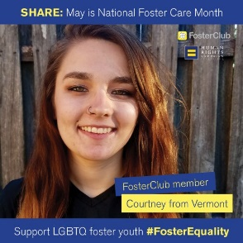
https://www.fosterclub.com/blog/real-stories
Each of the entries have been written by a
child in foster care and shares their experience.

After visiting the website, click through the
pages. Skim through a couple of stories before
you choose the blog entry you want to read.

After reading,

Name 3 things about their story you could relate to

Describe 2 things that stood out or surprised you

Write 1 question you wish you could ask

Be sure to write down one quote to share with
your peers.

Then, in pairs summarize the entry, share your
quote, and the six things you wrote down.
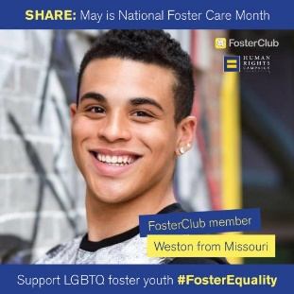
After the pairs are done discussing, engage in
a class discussion that centers on the similarities
between the group member’s answers.

