DACA: Analyzing the Good, Bad, and Ugly
Created by: Victor Diaz
Date: 11 May 2020
Email address: diazv5@montclair.edu

Lesson Title: DACA
Grade/Course: EDFD 445 Lesson duration: 1hr 30 Mins
Unit:
Topic of Lesson: Human Rights and Immigration

Central Focus: DACA and the Aftermath: What does DACA do, why is it criticized, what can be salvaged, who is in danger? Laying out common myths or controversies about DACA. Students will learn to better voice their concern about a current and political topic

Essential Question(s): What does DACA do? Who qualifies for DACA? What will shutting down DACA cause? Why could President Trump rescind DACA? What struck out to you the most?

State/Disciplinary Standards:
6.1.12.B.15.a: Evaluate the effectiveness of the United States government’s efforts to provide humanitarian assistance during international natural disasters and times of crises.
6.1.12.A.13.b: Analyze the effectiveness of national legislation, policies, and Supreme Court decisions (i.e., the Civil Rights Act, the Voting Rights Act, the Equal Rights Amendment, Title VII, Title IX, Affirmative Action, Brown v. Board of Education, and Roe v. Wade) in promoting civil liberties and equal opportunities.
6.1.12.D.14.d: Evaluate the extent to which women, minorities, individuals with gender
preferences, and individuals with disabilities have met their goals of equality in the workplace,
politics, and society.
6.1.12.A.15.f: Evaluate the effectiveness of United States policies and actions in supporting the economic and democratic growth of developing nations.

Daily Performance Objectives: Allow students to view their personal opinions about immigration. Create a Safe Space to talk about politically controversial topics. Educate students about the reality of immigration. What can you do to help?

Prior Knowledge Resources: Prior knowledge regarding immigration and citizenship.

Academic Language: “DACA”, Dream Act, DUI’s, misdemeanor, taxes, COVID-19.

Materials and Preparation: Computer, internet access, headphones to listen to podcast and to read (if needed)

Assessment/Evaluation—note: all lessons must include checks for understanding
- Have a brief discussion regarding the podcast and the poetry to make sure the students did their assignments and that they understood the topic.

Lesson Progression (add rows as necessary): Instructional strategies and learning tasks (including what you and the students will be doing) that support diverse student needs. Please note all assessments that were described in the previous section.

Duration: | The teacher will… | The student(s) will…
10 minutes | Hand out “Worksheet and Assignment” sheet that includes poetry and assign it as classwork or homework. Also, hand out the “What You Can Do To Help” Sheet | Receive paper or will access worksheet online.
20 minutes | Ask students to go on the links in the “Worksheet and Assignment” sheet and read the poem. Teacher will pick 2 or more students to read out loud while the rest read one | Students will access readings and read on with their fellow classmates
5 minutes | Send the podcast to all students online and assign it to the students for next class. Also ask them to read the “What You Can Do to Help” Sheet after listening to podcast. | Receive Link and will be assigned the task as homework.
20 minutes |  | Listen to the podcast at home and prepare for discussion
15 minutes |  | Answer questions regarding podcast
10-15 minutes | During next class, start a discussion regarding the Podcast and/or poetry | Be prepared to voice their own opinions regarding DACA and what they learned
5 Minutes | Remind students that they can voice their own opinions even if it is not of popular belief | Voice controversial or opposing view/ opinion regarding immigration/ DACA

Homework: Listen to Podcast and answer questions regarding Podcast and Poetry. Read “What You Can Do to Help” Sheet

Notes / Reflection : This is a controversial topic, the main objective is for Students to voice their concern or view regarding a current and political topic.

WORK SHEET AND ASSIGNMENT

http://www.thingsillneversay.org/driving-while-undocumented.html (Links to an external site.)
This is one poem the students need to read. They will also have to read "The New Colossus" by Emma Lazarus: https://www.poetryfoundation.org/poems/46550/the-new-colossus (Links to an external site.)

Why these poems? Well, the first reason being the sharp contrast of them. "The New Colossus" is a classic American Poem that is forever known for being in the Statue of Liberty. It is also a very Strong and Passionate poem. "Driving While Undocumented" is a poem filled with reminiscing and fear. It is the sad truth for many undocumented people and one many DACA recipients may have to face once again.

- Read “The New Colossus” First and once you have processed it, read “Driving While Undocumented”
- Select words or passages from each poem that impacted you.
- Write a short response regarding both poems, compare and contrast the two poems, identify and reflect on their differences.

- Now, Listen to the podcast
- While listening, write down important or interesting parts of the podcast that you want to talk about in class.
- Questions you need to answer:
  - What does DACA do? Who qualifies for DACA? What will shutting down DACA cause? Why could President Trump rescind DACA?
  - What struck out to you the most?
    - It can be something funny, interesting/ important, or something you would like to know more about.

What YOU Can Do To Help:
DACA and Dreamers

- Try to understand the daily challenges DACA recipients and other undocumented people have to go through daily. Also, understand one's privileges as a US citizen compared to them.
- Educate yourself regarding DACA and the process, policies, and facts regarding immigration. Be smart and only read articles from credible sources.
- Post on Social Media!
  - #DACA #Dreamers with your own opinion and view regarding DACA and Dreamers.
- If you are Interested in Political Topics…
  - See if your school has a Law. Criminal Justice, Politics / Government Class
  - Join/ Create a Debate Team, Political Team, etc.
- Also, Visit:
  - https://unitedwedream.org/getinvolved/
  - https://www.thedream.us/get-involved/
  - https://www.unidosus.org/issues/immigration/daca/
  - https://www2.ed.gov/about/overview/focus/supporting-undocumented-youth.pdf
    - Learn more about Dreamers and Undocumented people and their fight.
    - Discover ways you can help
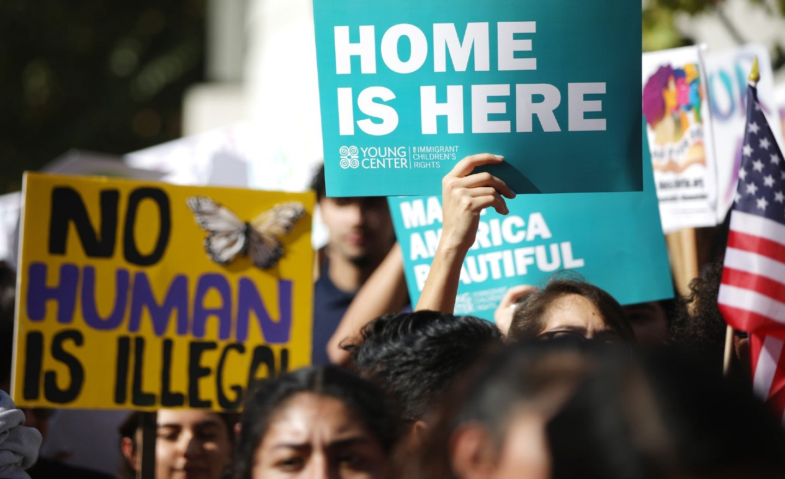
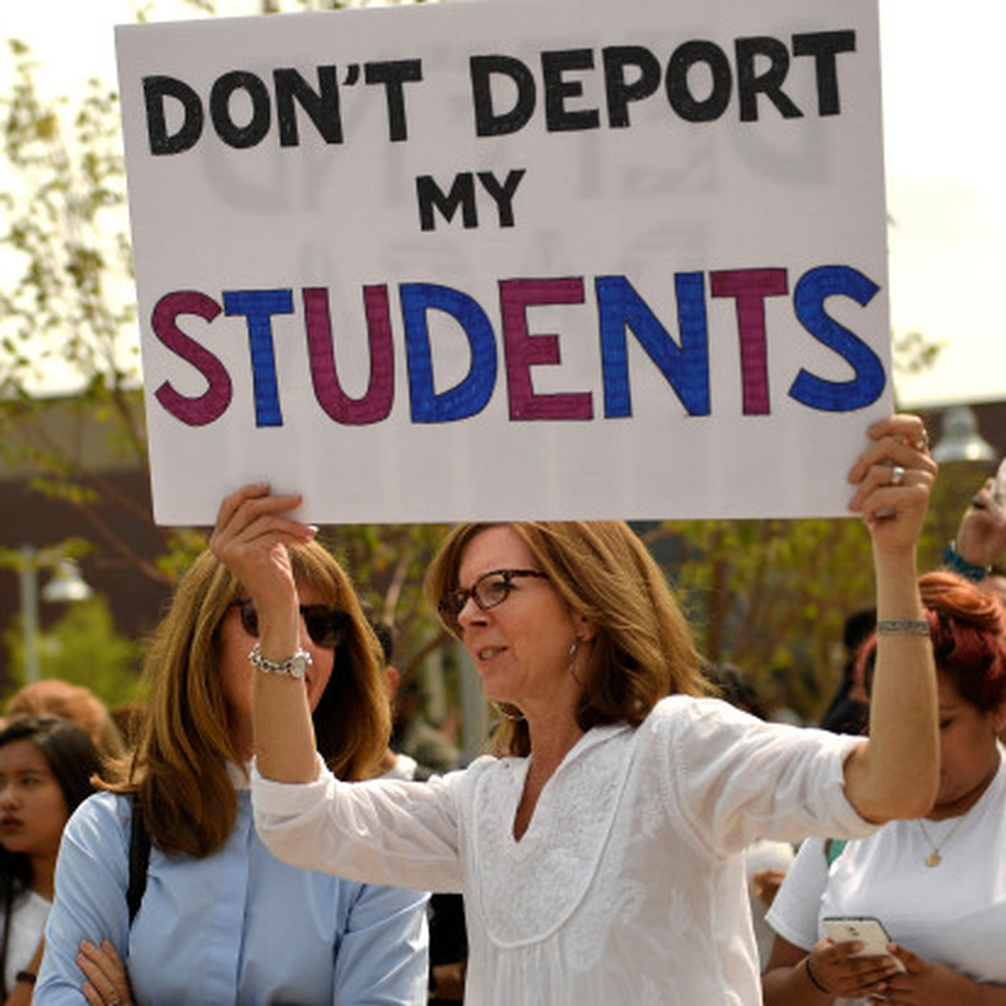
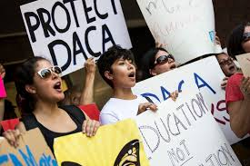

Annotated Bibliography
Alulema, Daniela. "DACA and the Supreme Court: How we Got to this Point, a Statistical Profile of Who is Affected, and what the Future may Hold for DACA Beneficiaries." Journal on Migration and Human Security, vol. 7, no. 4, 2019, pp. 123-130. ProQuest, http://ezproxy.montclair.edu:2048/login?url=https://searchproquestcom.ezproxy.montclair.edu/docview/2332037582?accountid=12536,doi:http://dx.doi.org.ezproxy.montclair.edu:2048/10.1177/2331502419893674
- This article provides context over immigration and the DACA program and how it was created. This article allows the listener to first know the facts of DACA. The Requirements of being into DACA was also important for listeners to know as there are a lot of documentations and limitations DACA receives or gives. Alulema’s article also helps shed light on some of the Myths talked about in the podcast by providing statistics regarding DACA recipients. In the end, the article also provides insight over why DACA is important for the recipients and why more needs to be done for the future generation of possible recipients that were too young to apply.
Bier, David. “Five Myths about DACA.” Cato Institute, 8 Sept. 2017, www.cato.org/publications/commentary/five-myths-about-daca.
- This sources outlines the main topics and almost everything that will be addressed in the Podcast. The five Myths mentioned in Bier’s article serve as a pivotal way to address the misrepresentation given to Dreamers and the DACA program. The article serves as a way to form the podcast into a form of debate with factual and relevant information. The myths, along with some true disparities over DACA, serve to bring to light the ideological perspectives over DACA and immigration. While some myths were not as covered or explained, the myths regarding how DACA incentivizes illegal immigration and how DACA has taken jobs from Americans were well covered and serve as a critical point in the Podcast.
Jordan, Miriam. “Most Americans Want Legal Status for 'Dreamers.' These People Don't.” The New York Times, The New York Times, 25 Jan. 2018, www.nytimes.com/2018/01/25/us/dreamers-opponents-daca-deal.html.
- This article was personal and it showed the other viewpoint regarding DACA. Huy Pham and his view regarding DACA was particularly interesting. As a citizen that came here legally, Mr. Pham showed his disapproval over favoring illegal immigrants with DACA. He talks about his fear regarding an influx of immigration if we give DACA recipients citizenship. The article also talks about “Chain Migration” which is a fear many conservatives have when it comes to granting DACA recipients citizenship.
Robertson, Lori. “The Data on DACA and Crime.” FactCheck.org, 13 Nov. 2019,
www.factcheck.org/2019/11/the-data-on-daca-and-crime/.
- Robertson’s fact check allowed me to disprove the fallacy that DACA recipients committed Crimes. While it is true some have committed violence or are affiliated with gangs, the DACA recipients that were arrested was due to minor misdemeanors like driving or immigration related offenses. This article helped me see that and to emphasize that while it is still a problem, the amount of DACA recipients that have committed serious crimes is drastically low compared to the percentage of American Citizens who have committed crimes. Also it provided me with the actual 2018 USCIS report about the topic which helped me develop my own thoughts on the topic.
Rodriguez, Darlene X., Sanjuana C. Rodriguez, and C. V. Z. Banti. "A Content Analysis of the Contributions in the Narratives of DACA Youth." Journal of Youth Development, vol. 14, no. 2, 2019, pp. 64-78. ProQuest, http://ezproxy.montclair.edu:2048/login?url=https://search-proquest-com.ezproxy.montclair.edu/docview/2293158890?accountid=12536,doi:http://dx.doi.org.ezproxy.montclair.edu:2048/10.5195/jyd.2019.682.
- This article is important as it outlines the challenges facing the DACA recipients. Having to pay for their higher education with more difficulties to obtain financial aid from the government is one of those challenges. Uncertainty over their protection and what will happen if DACA is deemed illegal is another fear of the recipients and this article highlights this. Also, the words of DACA recipients that are present in the Article helps connect how personal and important DACA is for the people and the actions they have done because of it. The focus of the article is what DACA contributes to the United States and it highlights this by showing how politically or socially active the recipients tend to be.
Roth, Benjamin J. “The Double Bind of DACA: Exploring the Legal Violence of Liminal Status for Undocumented Youth.” Ethnic & Racial Studies, vol. 42, no. 15, Dec. 2019, pp. 2548–2565. EBSCOhost, doi:10.1080/01419870.2018.1540790.
- This research outlines what DACA has done for the recipients, such as allowing them to have a driver’s license, open a bank account, find a better job, and getting a higher education. This allows the household of the recipient to rise from poverty, which a portion of the recipients suffer from. It also shows, why the federal government needs to help the immigrants more as state laws sometimes limits the potential or chances the recipients could have of going to college or even being allowed to work. DACA is a double bind where the recipients can work and study, however they live with an anxiety looming over them due to being considered outsiders and they are still at risk of deportation.
Talamantes, Efrain, et al. “The Termination of Deferred Action for Childhood Arrival (DACA) Protections and Medical Education in the U.S.” Journal of Immigrant & Minority Health, vol. 22, no. 2, Apr. 2020, pp. 353–358. EBSCOhost, doi:10.1007/s10903-019-00891-9.
- This article explains the possible outcomes if DACA is terminated. It also highlights the need for diverse applicants in Medical schools as they are needed in urban communities with many immigrants, DACA recipients help this much needed problem and the US is at risk of losing a much needed aid. The study shows how the termination of the policy will hurt diversity and efforts to provide culturally and linguistically appropriate services. The article also points out how the medical students enrolled in DACA help lower the vast shortage of physicians and aids that the US could need in the future and how many of the growing population is in urban and immigrant communities.
Vinopal, Courtney. “What Ending DACA Could Cost the U.S. Economy.” PBS, Public
Broadcasting Service, 12 Nov. 2019, www.pbs.org/newshour/economy/making-sense/what-ending-daca-could-cost-the-u-s-economy.
- This Article addresses the economic impact DACA recipients have in the US. Vinopal’s article helped me illustrate the impact in a simple yet important way to allow the reader to understand.

