NJ EARNED SICK LEAVE EMAIL NOTIFICATION FOR CAMPUS

Dear Colleagues and Students,

The purpose of this memo is to summarize the Earned Sick Leave Law (“Sick Leave Law”) enacted by the State of New Jersey on Monday, October 29, 2018.

The Sick Leave Benefit:

Under the Sick Leave Law, Eligible Employees earn sick leave at the rate of one-hour for every 30 hours worked, up to a maximum of 40 hours of earned sick leave per benefit year. Montclair State University’s benefit year commences on January 1 and ends December 31. For example, an Eligible Employee who works five hours on Monday, Wednesday and Friday earns one-hour (1) of earned sick leave after working two weeks, or 30-hours.

Eligible employees will begin to accrue earned sick leave on October 29, 2018, or on their first day of employment, whichever is later (“Accrual Start Date”). Eligible employees can begin using earned sick leave accrued under the Sick Leave Law 120 days after their Accrual Start Date and may carry-over up to 40 hours of leave per benefit year.

Eligible Employees:

The Sick Leave Law extends earned sick leave benefits to employees who were not previously entitled to this benefit -- in particular, Adjuncts, per diem or temporary employees, and student workers are now eligible. The Sick Leave Law does not apply to University employees who already receive paid sick leave.

Consideration for Adjuncts:

Adjuncts (unless they are otherwise affiliated with the University in positions for which they receive paid leave) will be eligible to accrue earned sick leave beginning on the date that their collective bargaining agreement expires, which is June 30, 2019. Human Resources will provide additional guidance for adjuncts regarding sick leave accruals and submitting sick leave requests prior to that date.
Uses of Sick Leave:

Eligible employees may use earned sick leave to take time off when: an employee/family member needs diagnosis, care or treatment or recovery from an illness, or preventive medical care; an employee/family member has been a victim of domestic violence and needs time for treatment, counseling, or to prepare for a court proceeding; an employee needs to attend to a school-related conference or meeting, or; the University closes due to a public health emergency. Please note, sick leave accrued under the Sick Leave Law may not be used for bereavement.

Sick Leave Procedures to Employees Paid on an Hourly Basis

Sick Leave Accrual -- Hourly Basis: Sick leave accruals for employees paid on an hourly basis will be processed automatically by Workday using the rate of one-hour for every 30 hours worked and reflected in the employee’s Workday “Time off Balance.”

Submitting Sick Leave Time Off in Workday: Beginning on Monday, October 29, 2018, any employee eligible to accrue time under the Sick Leave Law will be able to view their accrued time off under the “Time Off Balances” tab. This tab is located in the “Time” worklet on your Workday homepage.

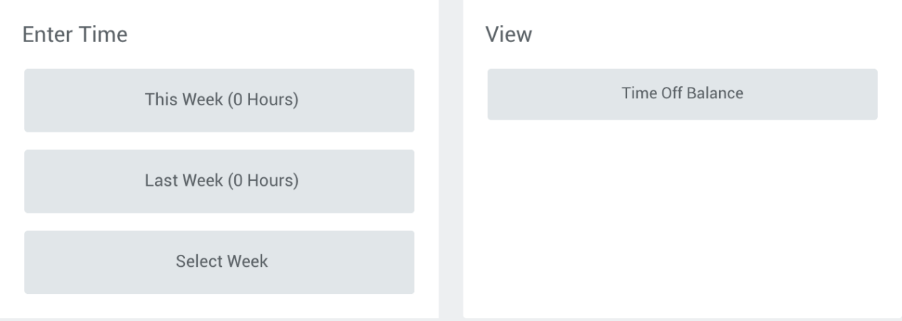

Once an employee has accrued earned sick time under the Sick Leave Law, the Employee must use the “NJ Sick Leave” tag in Workday to apply the earned sick time to their timesheet.
New employees must wait to use sick time until after their 120th day of employment.

Sick Leave Procedures to Employees Paid by Stipend

Sick Leave Accrual -- Stipend: Sick leave accruals for employees paid using stipends will be entered by Human Resources into the employee’s Workday Time Off Balance using the rate of one-hour for every 30 hours worked based on the number of hours encompassed by the stipend.

Submitting Sick Leave Time Off in Workday: The employee may use the steps outlined above to submit sick time, or at a unit level a Workday timekeeper may be designated to receive and process sick leave requests for the employee (for example, in Athletics Department).

Additional Information:

Please review the Notice of Employee Rights from the New Jersey Department of Labor and Workforce Development, as it contains additional information about rights under the new law, notification requirements, as well as the types of absences covered by the Sick Leave Law.

If you have any questions regarding the University’s implementation of the Earned Sick Leave Law, please contact the Workday Help Desk at 973-655-7971, option 4, or at workday@montclair.edu.

