- Log in to the Cayuse research suite and click Cayuse IRB.
- Locate your study by clicking “Studies” on the left sidebar.
- Click “New Submission” on your Study Details page and select “Closure”

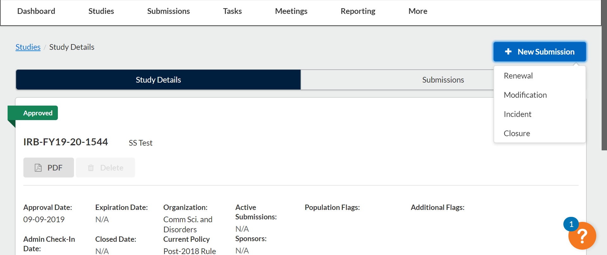
- Click “Edit” to begin the submission.

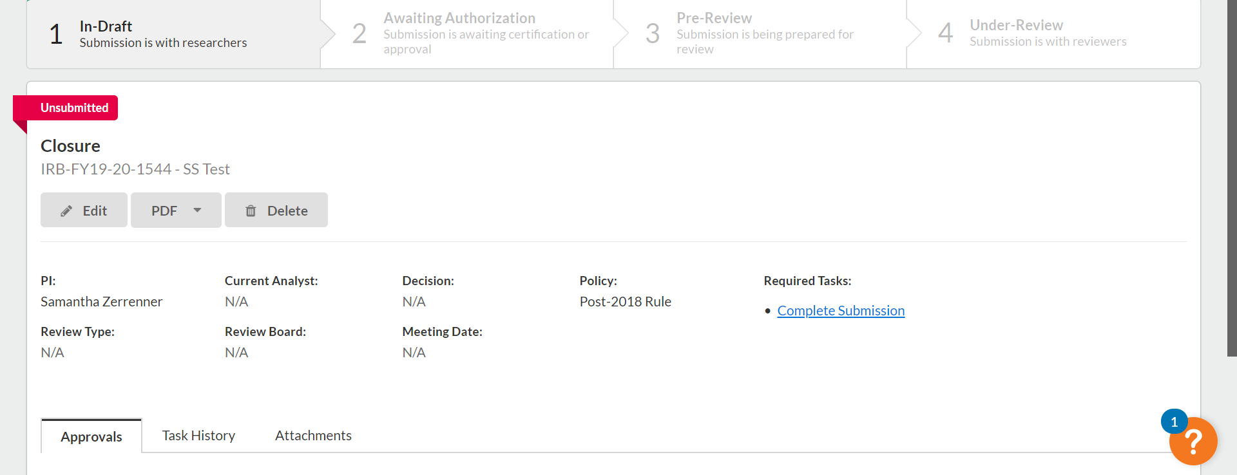

- You will use the arrows in the upper right hand corner to navigate through the submission as you would for an initial submission. Click save at any time to leave Cayuse IRB and complete your submission at a later time.

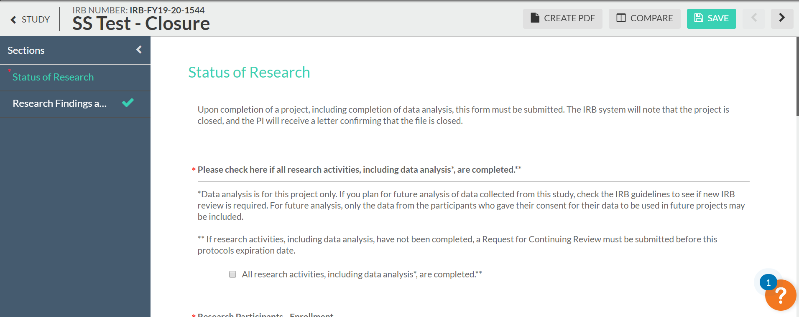

- When you complete the section, a green check mark will appear on the sidebar.
- When the submission is complete, the options to “Complete submission” and “send to PI for certification” will appear in the sidebar. You can click Complete Submission on the sidebar if you are the PI. Student researchers must send the submission to the PI.
- If you are the PI, certify the submission by clicking “certify.” Read the pop-up statement and confirm. The submission must be certified for IRB staff to begin the review process.
You may have to make revisions to your submission which might involve responding to comments. To do this you will click “Expand comments.” Type your reply and click “Save.” Then change the status from “not addressed” to “addressed.”

