How to enter a Research Determination Form (RDF) in Cayuse IRB?
You should begin your submission as you would a general initial submission, please start your study title with the initials “RDF” i.e., “RDF – Research on Established School Practices”. After completing the “Personnel” section, you will see the “Activity” section, you can choose either Secondary Data Analysis or Activities without a Plan to Conduct Research – depending on your project.
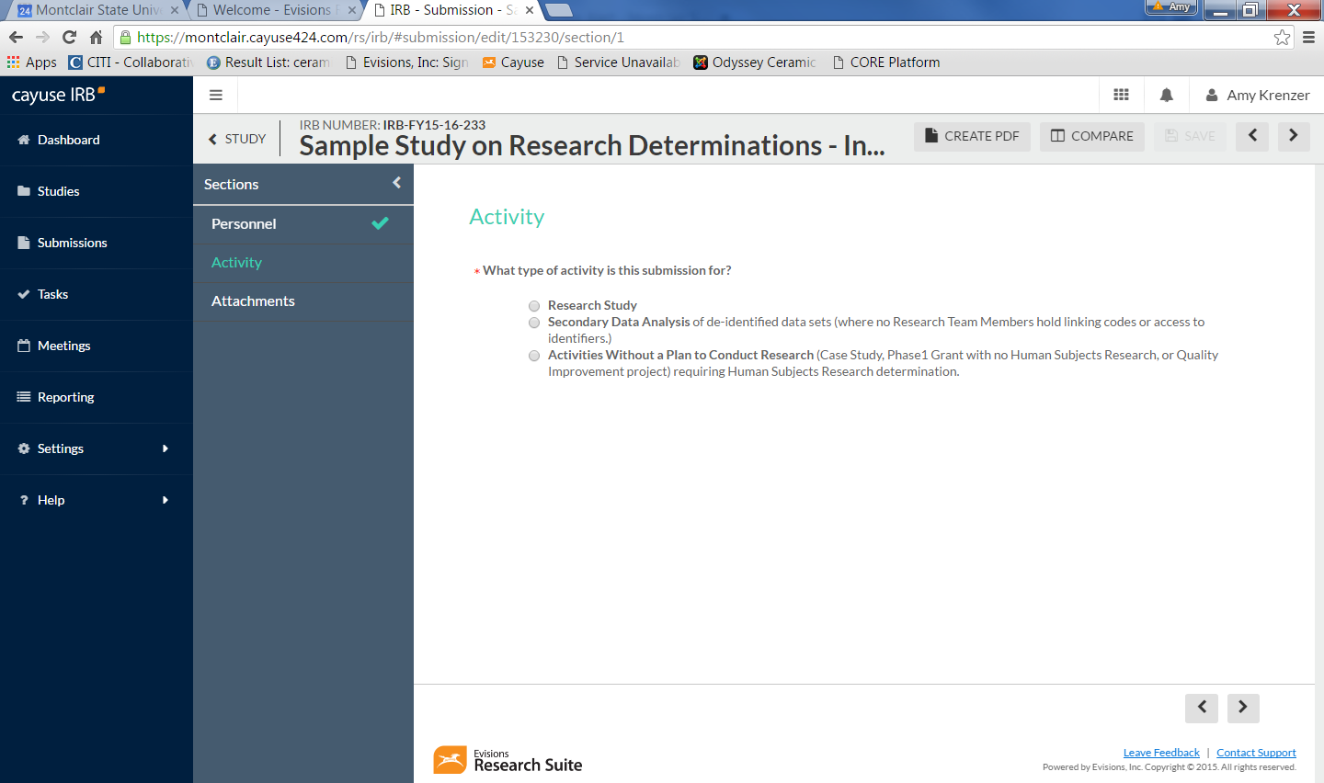
If you choose either of those choices, you will find the Research Determination section will open up.
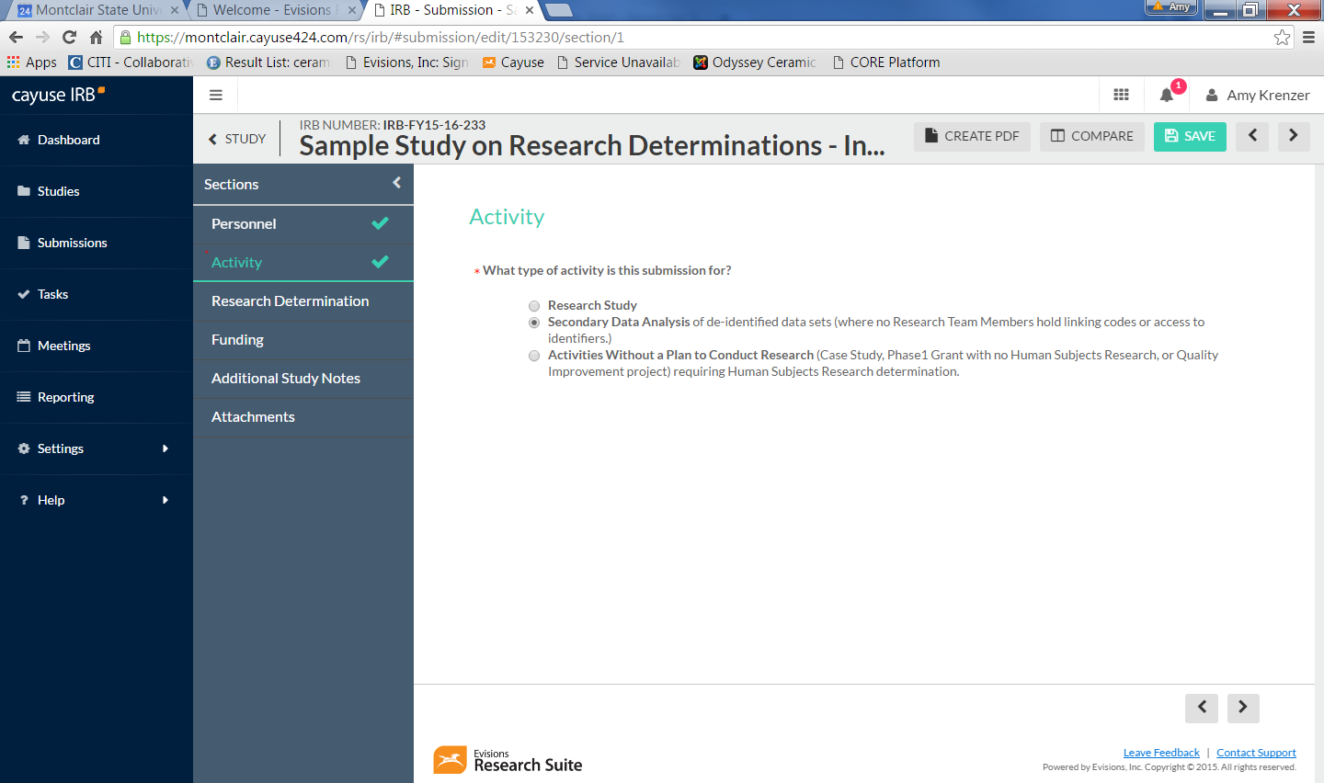
Then you will answer questions in the required sections, complete and certify the submission and it will go into pre-review.

