- Log in to the Cayuse research suite (montclair.cayuse424.com)and click Cayuse IRB.
- Locate your study by clicking “Studies” on the left sidebar.
- Click “New Submission” on your Study Details page and select “Renewal”
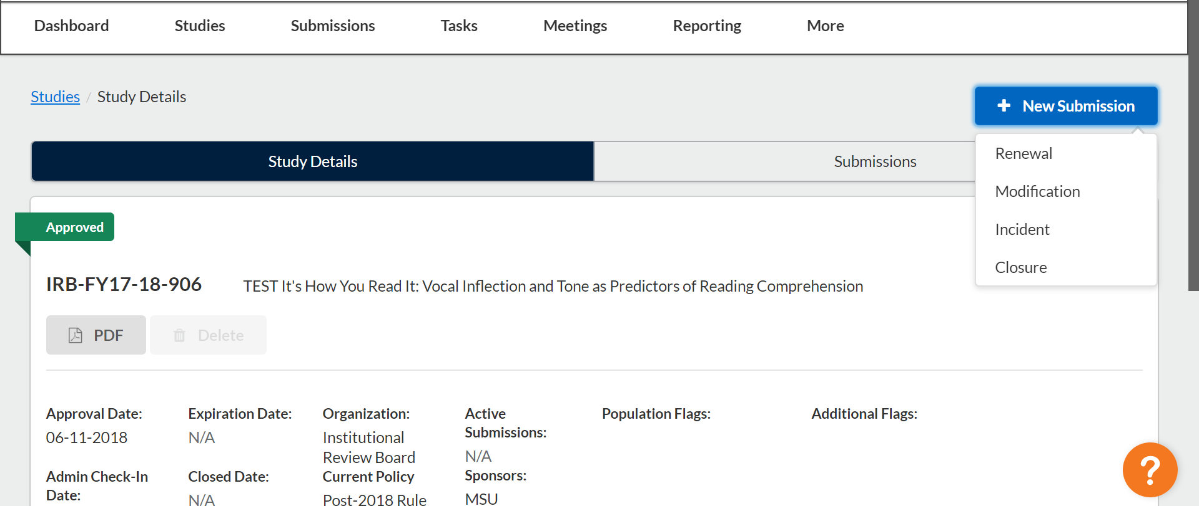
- Choose “Edit” to begin working on your submission.
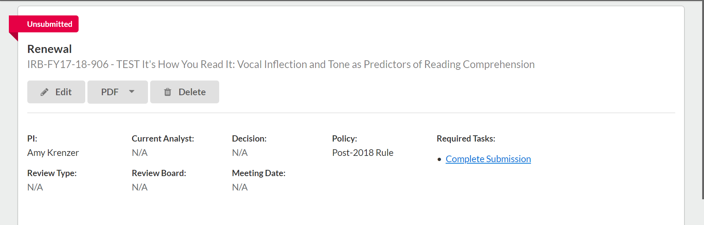
- If you are completing an Administrative Check-in, choose “Administrative Check-in” as your Submission type and if you are instead completing a Renewal, please choose “Renewal”. If you’re not sure which to check off, email reviewboard@montclair.edu If completing an Administrative Check-in, continue to 6a. If completing a Renewal, please continue to 6b.
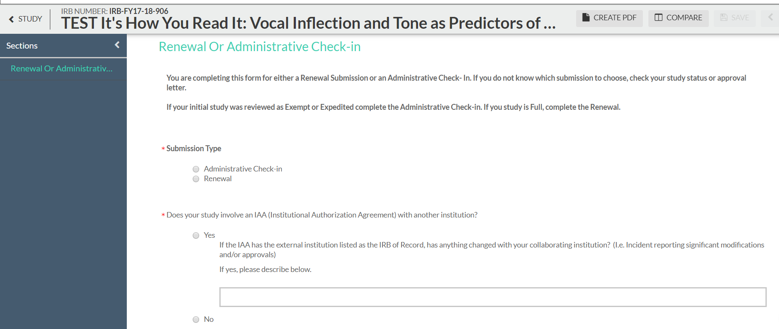

  - For Administrative Check In - You will notice three new tabs on the left-hand sidebar. Use the arrows in the upper right-hand corner to navigate through the submission as you would for an initial submission. Click save at any time to leave Cayuse IRB and complete your submission at a later time.
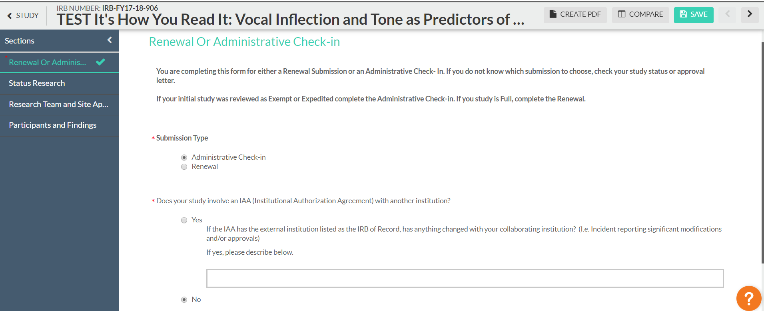
  - For Renewal - You will notice five new tabs on the left-hand sidebar. Use the arrows in the upper right-hand corner to navigate through the submission as you would for an initial submission. Click save at any time to leave Cayuse IRB and complete your submission at a later time.
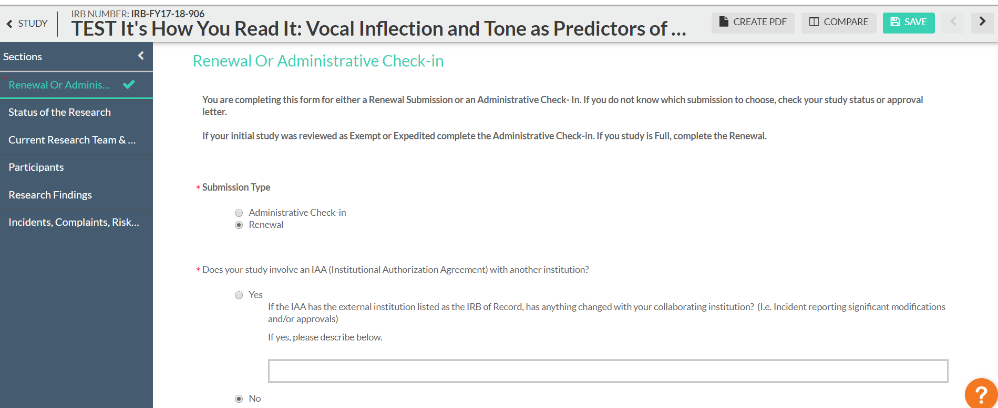
- When you complete the section, a green check mark will appear on the sidebar.
- When the submission is complete, the options to “Complete submission” and “send to PI for certification” will appear in the sidebar. You can click Complete Submission on the sidebar if you are the PI. Student researchers must send the submission to the PI.
- If you are the PI, certify the submission by clicking “certify.” Read the pop-up statement and confirm. The submission must be certified for IRB staff to begin the review process.

*Please see next page for an additional comment
It is unlikely you will have to have to make revisions to your submission which may involve responding to comments. If you do, follow the normal directions for addressing comments and click “Expand comments.” Type your reply and click “Save.” Then change the status from not addressed to “addressed.”

