Electronic Process for Proposing COURSE ALTERATIONS
IMPORTANT: Please note your changes cannot be saved in the database to alter again at a later late. Please be sure to save a copy to your desktop in case you need to make changes prior to submission.
STEP 1: PREPARE YOUR COURSE SUBMISSION
Access the following link, available on the Provost’s website: https://coursesubmission.montclair.edu/coursesubmission/dataentry/showlandingpage.aspx
This link will take you to the Home Screen of the Course Submissions/Course Actions Database.
The electronic forms for course alterations are located on the left hand side of the screen under the “Course Submissions” area, click on the course alteration new link. You will be redirected to a new page to locate your existing course.
In the upper right search field provided, enter the alpha code and number of the course you wish to edit (e.g., ACCT 202) and click on the magnifying glass to the right. Once your course appears, click on the icon to the left. The course alteration form will open.
STEP 2: COMPLETE ONLY FIELDS THAT ARE BEING ALTERED
The form is divided into two parts:
The left hand side of the screen contains the existing course catalog file report information (CCFR).
The right side of the form contains fields for indicating changes to be made to the existing course.
Additional information regarding the form fields to be completed can be found in the document “Form Field Definitions – Course Alterations” available here.
NOTE: Only populate fields in which a change is to be made. If you are not changing the information in a particular field, leave the field blank.
STEP 3: COMPLETE THE SIGNATURE WORKFLOW
Verify the pre-populated names and e-mail addresses for each person who will be required to sign off and approve the course proposal. These fields will provide the routing list for the electronic course approval. NOTE: It is the responsibility of the person proposing the course to provide an accurate list of signees with their submission. Failure to do so will result in the submission being returned to you, thereby delaying the routing and approval of the course. Once the appropriate names and e-mails have been entered, click the CONTINUE button at the bottom left. This will bring you to a course submission checklist.
STEP 3A: Please review the checklist and click CONTINUE.
STEP 4: SAVE YOUR COMPLETED FILE AS A PDF (For your records only, this does not save your changes in the database)
Clicking on the CONTINUE button will generate your completed course form. Once the form appears, if no edits are necessary, click on the “Print to PDF” button on the form. The print dialogue box will open.
Use the printer name dropdown and choose “Adobe PDF” or “PDF Creator.” Then choose OK. (NOTE: This will not actually print the file; rather, it will “SAVE” your file as a PDF.)
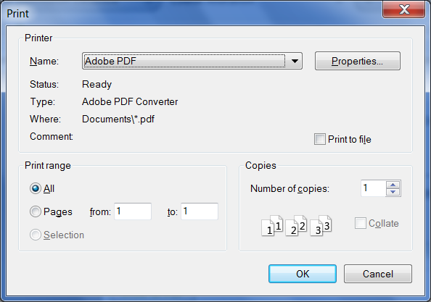
After clicking OK, the SAVE FILE AS Dialog box will open
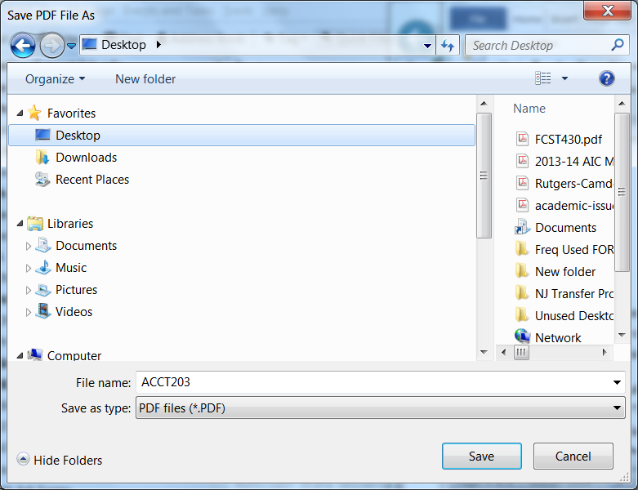
From this screen, name the file with the four digit alpha code and course number of the course you are proposing (e.g., ACCT203) and save it to a file or your desktop.
STEP 5 – VETTING YOUR COURSE BEFORE SUBMISSION
At this stage, proposers must have preliminary conversations with all entities to whom the course will be routed (e.g., dept. curriculum committee, dept. chair, college/school curriculum committee chair, etc.). These preliminary conversations and discussions will ensure the course is not stopped/delayed/rejected during the routing process. NOTE: Courses which are denied approval during the signature routing process are required to be resubmitted from the beginning of the process. Hence, it is in the interest of the course proposer to communicate with all entities to ensure approval prior to the submission of the course.
STEP 6 – NEED TO MAKE EDITS PRIOR TO SUBMISSION?
In many instances, the vetting process will necessitate edits to be made to the course before actual submission. Because course alterations cannot be saved for editing purposes, you need to start from the beginning entering into the fields the correct course alteration information. NOTE: Once changes are completed, you must follow the same process listed above in STEP 4 to save your file to PDF (see above).

STEP 7: SUBMIT YOUR COURSE FOR SIGNATURE ROUTING:
Once your course submission information has been vetted, edited where necessary, and saved to PDF, you are now ready to submit your proposal for the signature routing process!
To submit your course for Signature routing:
From the Home Screen of the Course Submissions/Course Actions Database, click on the Course Submissions link at the bottom left hand side of the page. An email will open up, addressed to coursesubmissn@mail.montclair.edu. Attach your course alteration PDF and be sure to reference the course Alpha Code, number, and type of proposal (e.g., ACCT202ALT) in the Subject Field when submitting the file.

SO WE COMPLETED THE STEPS, NOW WHAT HAPPENS?
Once submitted to the Course Submissions email, your course will receive a technical review prior to being forwarded for approval to those entities listed in the Signature Workflow.
If all appears correct, your course will be forwarded via email for signature to those listed on the Signature Workflow in the order in which they appear.
Each person required to sign the form will receive an email from Adobe Sign (formerly Echosign); once the form is electronically signed, it will pass to each person on the Signature Workflow up to and through the level of the Dean.
Once signed by the Dean, the course will be placed on the Course Circulation List for circulation. This list is now located on the right hand side of the Course Submission/Course Action Database Home Screen.
Once the circulation period has passed, the course will be placed on the monthly Course Approval list. This list can also be found on the right hand side of the Course Submission/Course Action Database Home Screen.
For more information and to arrange a training session, please contact John Bonanno at x5412 or via email at bonannojo@mail.montclair.edu.

