Electronic Process for Proposing NEW COURSES

STEP 1: PREPARE YOUR COURSE SUBMISSION
Access the following link, available on the Provost’s website: https://coursesubmission.montclair.edu/coursesubmission/dataentry/showlandingpage.aspx
This link will take you to the Home Screen of the Course Submissions/Course Actions Database.
The electronic forms for new courses are located on the left hand side of the screen under the “Course Submissions” area, click on the link for New (undergraduate or graduate) to open the form and begin to fill in the fields.
STEP 2: COMPLETE FIELDS AS INDICATED
For help with this step see the document “Form Field Definitions – New Courses” available here.
STEP 3: COMPLETE THE SIGNATURE WORKFLOW
Verify the pre-populated names and e-mail addresses for each person who will be required to sign off and approve the course proposal. These fields will provide the routing list for the electronic course approval. NOTE: It is the responsibility of the person proposing the course to provide an accurate list of signees with their submission. Failure to do so will result in the submission being returned to you, thereby delaying the routing and approval of the course.
Additional signature lines are provided in the event a course requires signatures from additional departments (e.g., cross listed courses).
Once the appropriate names and e-mails have been entered, click the SAVE & CONTINUE button at the bottom left. This will bring you to a course submission checklist.
STEP 3A: Please review the checklist and click CONTINUE.

STEP 4: SAVE YOUR COMPLETED FILE AS A PDF
Clicking on the CONTINUE button will generate your completed course form. Once the form appears, if no edits are necessary, go to File (top of page), Print. The print dialogue box will open.
Use the printer name dropdown and choose “Adobe PDF” or “PDF Creator.” Then choose OK. (NOTE: This will not actually print the file; rather, it will “SAVE” your file as a PDF.) Save the file where you will find it easily.

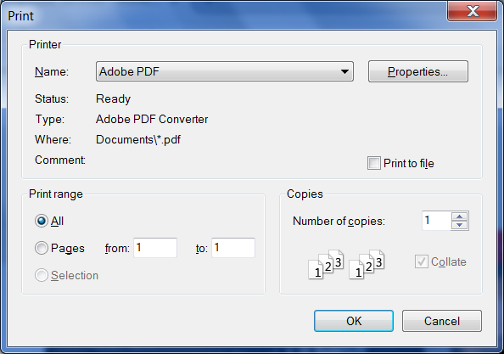

After clicking OK, the SAVE FILE AS Dialog box will open
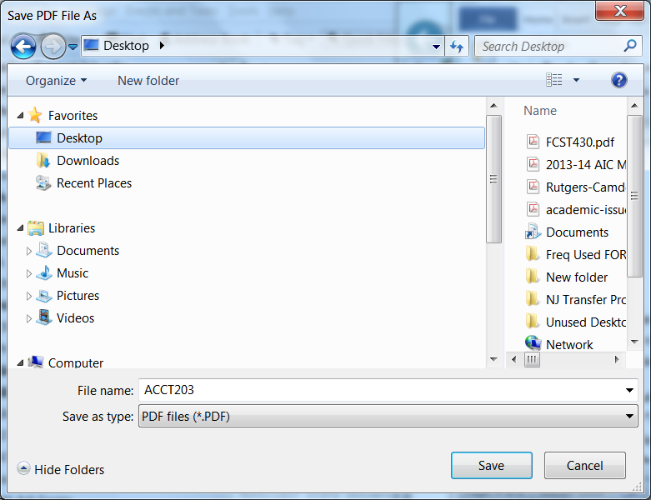
From this screen, name the file with the four digit alpha code and course number of the course you are proposing (e.g., ACCT203) and save it to a file or your desktop.

STEP 5 – VETTING YOUR COURSE BEFORE SUBMISSION
At this stage, proposers must have preliminary conversations with all entities to whom the course will be routed (e.g., dept. curriculum committee, dept. chair, coll/sch curr cmt chair, etc.). These preliminary conversations and discussions will ensure the course is not stopped/delayed/rejected during the routing process. NOTE: Courses which are denied approval during the signature routing process are required to be resubmitted from the beginning of the process so it is in the interest of the course proposer to communicate with all entities to ensure approval prior to the submission of the course.
STEP 6 – NEED TO MAKE EDITS PRIOR TO SUBMISSION?
In many instances, the vetting process will necessitate edits to be made to the course before actual submission. Following are the steps to edit a proposal prior to submission:
From the course Database home page, click on the Edit option for New Course Proposal (Undergrad or Grad)
You will be redirected to a new page to locate your existing course. In the field provided in the upper right, enter the course alpha and number of the course you wish to edit (e.g., ACCT202) and click on the magnifying glass to the right. Once your course appears, click on the pencil icon to begin editing your document as necessary.
NOTE: Once changes are completed, you must follow the same process listed above in STEP 4 to save your file to PDF (see above). It is recommended you overwrite your existing file, or, use a versioning indicator in the filename – (e.g., ACCT203v2). to be certain you are submitting the correct file.
STEP 7: SUBMIT YOUR COURSE FOR SIGNATURE ROUTING:
Once your course submission information has been vetted, edited where necessary, and saved to PDF you are now ready to submit your proposal for the signature routing process!
To submit your course for Signature routing:
From the Home Screen of the Course Submission/Course Action Database, click on the Course Submissions link at the bottom left hand side of the page. An email will open up, addressed to coursesubmissn@mail.montclair.edu. Attach your new course PDF and be sure to reference the course Alpha Code, number, and type of proposal (e.g., ACCT202NEW) in the Subject Field when submitting the file.

SO WE COMPLETED THE STEPS, NOW WHAT HAPPENS?
Once submitted to the Course Submissions email, your course will receive a technical review prior to being forwarded for approval to those entities listed in the Signature Workflow.
If all appears correct, your course will be forwarded via email for signature to those listed on the Signature Workflow in the order in which they appear.
Each person required to sign the form will receive an email from Adobe Sign (formerly Echosign); once the form is electronically signed, it will pass to each person on the Signature Workflow up to and through the level of the Dean.
Once signed by the Dean, the course will be placed on the Course Circulation List for circulation. This list is now located on the right hand side of the Course Submission/Course Action Database Home Screen.
Once the circulation period has passed, the course will be placed on the monthly Course Approval list. This list can also be found on the right hand side of the Course Submission/Course Action Database Home Screen.
For more information or to arrange a training session, please contact John Bonanno at x5412 or via email at bonnanojo@mail.montclair.edu.

