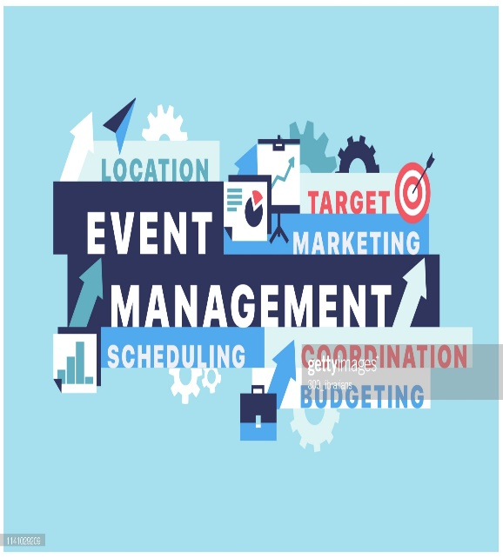
Event Planning Checklist

Planning a large conference? To guarantee a successful event, regardless of the event size, there are several important factors to consider.

Preparation
☐ Prepare a summary of your event and schedule a meeting with Associate Dean Amy Aiello
☐ Consider the budget
☐ Establish your needs (number of attendees, space requirements, key dates)
☐ Decide on special event

Logistics
☐ Secure the room [25 Live, Conference Center, Addy’s Lounge (Schedule with the Dean’s Executive Assistant)]
☐ Catering https://montclairstcatering.catertrax.com/
☐ Determine entry-level positions, salary scales, and industry qualifications.
☐ Consider the need for further training. This could be online courses, further education, certificates, training courses, self-study, or internships.
☐ Research and learn all you can about your desired new career.
☐ Special event parking

Marketing
☐ To submit a project request (flyer, posters, invites, postcards) contact Angie Aponte, Program Associate Deans Office apontea@montclair.edu.
☐

Website & social media content
☐ To advertise your event on social media or on the college website contact Web Content Manager Alex Thelin

