Lesson plan (# )
Adopted from:  Authors: (Your sub group’s name here) Grayson, iLearn, DeVoe | Grade: 9-12 | Lesson duration:
Topic/Title of lesson: Fundamentals of Data Storage

STANDARD(s) ADDRESSED  (Include the performance expectation number and text of each standard.) | 8.1.12.DA.3: Translate between decimal numbers and binary numbers.
CS PRACTICE(s) that students will engage in throughout the lesson. P 13-15 of NJSLS | Pattern recognition and algorithm thinking
CS CORE IDEA(s) or  SUB-CONCEPT(s) related to the performance expectation(s). P 20-34, includes core idea and performance expectations which are useful for designing general goals, specific objectives, and learning criteria down below | Choices individuals make about how and where data organized and stored affects cost, speed, reliability, accessibility, privacy, and integrity.
CENTRAL FOCUS (The central focus is an overarching goal of the lesson or big idea for student learning.) | TLWBAT apply their understanding of the translation of binary numbers to decimal numbers or vice versa by identifying patterns.
EU/EQ (The enduring understanding(s) and/or essential question(s) that guide the lesson.)  Here are some useful examples from math: https://jaymctighe.com/downloads/Essential-Questions-in-Mathematics.pdf | How do you think a device stores information?
PRIOR KNOWLEDGE AND CONCEPTIONS (What prior knowledge, skills and/or academic language do these students need to have that will help them be successful with this lesson? Any misconceptions you may anticipate?) | Vocabulary: Binary, Decimals, Computer Storage,

UDL/PLANNED SUPPORT
(Discuss the universally designed decisions guided by learner diversity and/or individualized adaptations for the variety of learners in your class/group who may require different strategies/support (e.g., children with IEPs or 504 plans, English language learners, children at different points in the developmental continuum, struggling readers, and/or gifted children).
UDL:  How are you universally designing your lesson with all your learners in mind? What other characteristics of diverse learners should be considered? | Multiple means of representation | Multiple means of action and expression | Multiple Means of engagement
Additional ADAPTATIONS, MODIFICATIONS, and SUPPORTS for individual learners (IEPs, 504s, ELLs) If you were not able to meet your focus learners needs through UDL, what individual adaptations will you use to meet your focus learners needs (especially ELLS) | Present information in audio or with video

ACADEMIC VOCABULARY/  LANGUAGE (including different coding languages)/  SYNTAX (rules of how to combine symbols to make “correct” statements) | Vocabulary: Binary, Decimal,  Language:  Syntax: | Describe the additional support for each language demand in this lesson. Address both the whole class and individual needs.
LEARNING OBJECTIVES | LEARNING CRITERIA (How will you know that students have met and/or are moving toward meeting that LO?)  SWBAT: Apply understanding to convert decimal numbers to binary and vice versa. Students will be able to explain that computers convert data into 1s and 0s and store data in binary. | ASSESSMENT (What will be the pre assessment, formative, or summative assessment(s) in this lesson?)  The teacher will evaluate the students' understanding of decimal numbers and binary code.  Pre-Assessment: Teacher will engage students on a demonstration/phenomena to evaluate the opening of the lesson and see where their understanding is.  Formative: Teacher will use think/pair/share. Teachers will use cold calling, teachers will have students use concept summaries to explain their understanding, use of apps like quizziz and or quizlet live.  Summative: Teacher will have an exit ticket and relate it back to the objective and/or utilize a real world problem.
Should include both core ideas and concepts, and practices

MATERIALS, RESOURCES, and INSTRUCTIONAL TECHNOLOGY
What resources and technology do you need to teach the lesson: | What materials, technology will students need?
Computer | Should reflect the UDL planned supports identified above

INSTRUCTIONAL STRATEGIES AND LEARNING ACTIVITIES
(Describe explicitly what the teacher and the students will do to meet learning outcomes. Use bulleted or numbered list)
 | What is the teacher doing? | What are students doing? (including adaptations)
LAUNCH/  Beginning ( mins)  How will you engage students and capture their interest? 3-7 minutes | Students will be shown this image of binary number  - What do you notice?  - How could this information be valuable?  - How can you connect binary and decimals to credit cards?  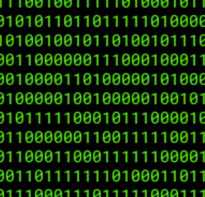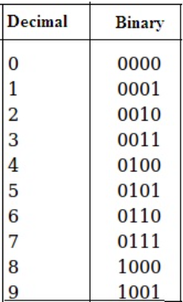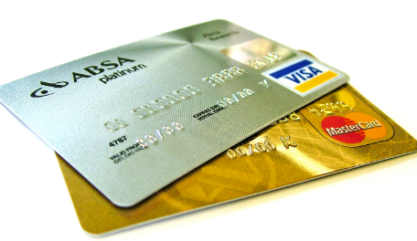 | Students are reviewing the image and answering the questions.  Students will work with a partner.  Students will do a think/pair/share.  Students are engaged and explore.  Students will watch a short video clip related to the topic.
LEARNING ACTIVITIES/  Middle ( mins)  “I do” “We do” “You do” How will you explain/ demonstrate knowledge /skills required of each objective? How will you ensure that students have multiple opportunities to practice? How will you address the academic language demands? | The teacher will evaluate the students' understanding of decimal numbers and binary code.  Example questions:  How many bits represent a binary number?  What is the smallest number in binary?  What is the decimal number 1 in binary? | - The students will be required to translate the information from binary to decimal or from decimal to binary in small groups (2-4)  - The goal will be to confirm the students come to the same resolution  - Limit the activity to two binary digits  - Count from the smallest number to the largest number?  - Ask what/if any patterns do they notice?  - Check for additional understanding  The teacher will provide the students with a set of binary numbers and a set of decimal numbers. The students will analyze the information, discuss in their groups, provide responses and compare with the rest of the class to see if they all came up with the same information.  Additional discussion can be had on the reliability of the information, how much time to it took to complete the task, and identify privacy, integrity issues that could come up during this process for a computer.
CLOSURE/
End ( mins)
How will students summarize and state the significance of what they learned? 3-7 minutes
Extension/Reinforcement/Homework:
Family/Community Engagement—

* Please attach copies of assessments and/or handouts to be used

