Student Workbook

Student Name:___________________________
Grade:_________________
Date:__________________

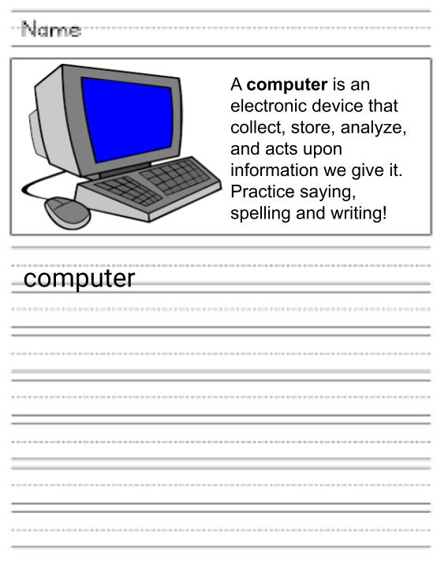

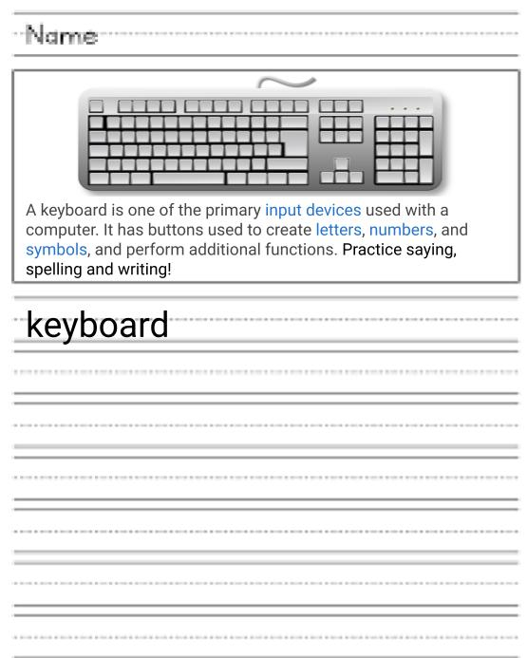

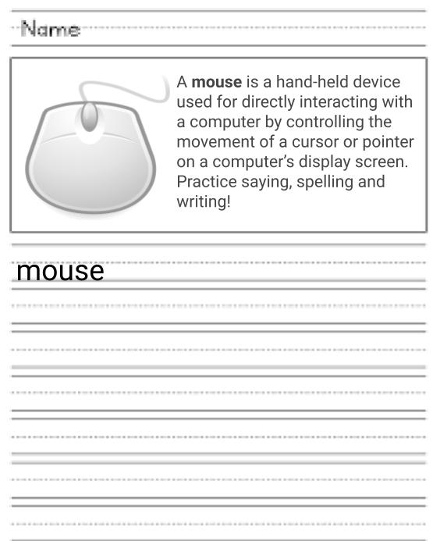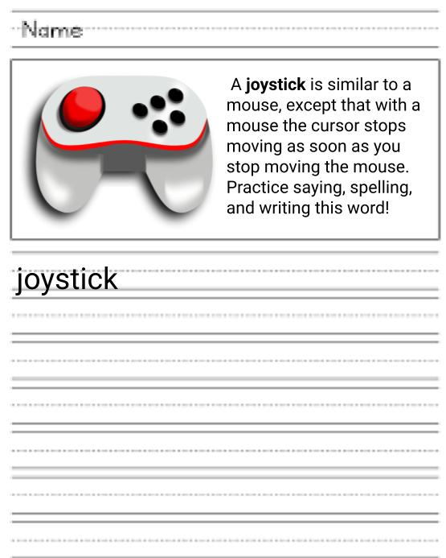

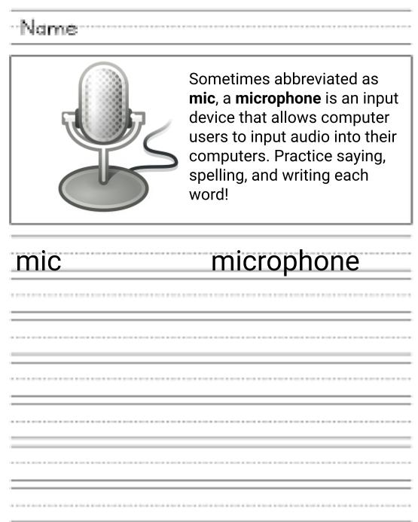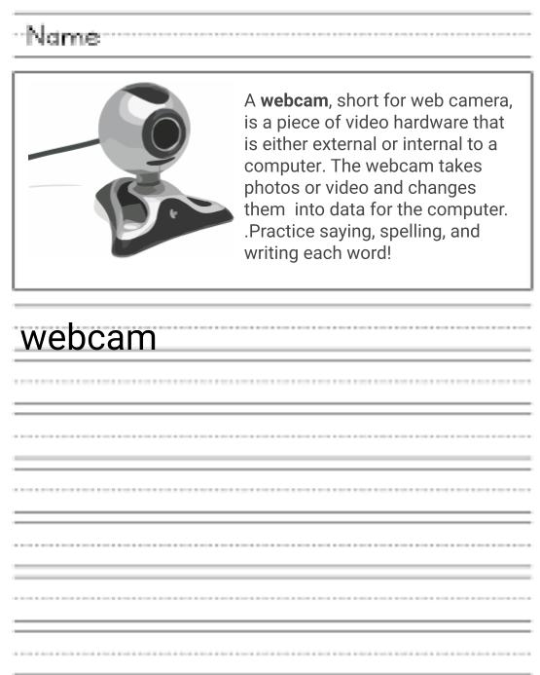
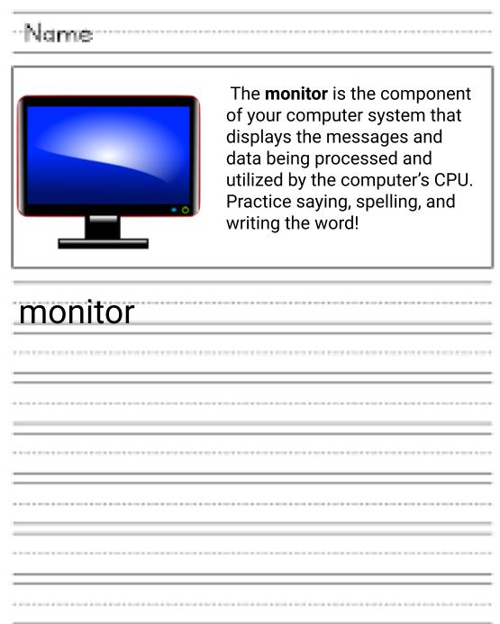

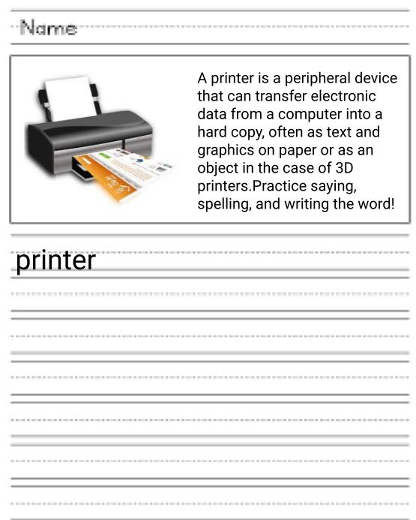
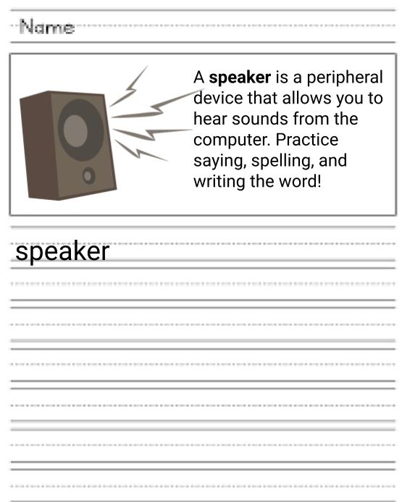
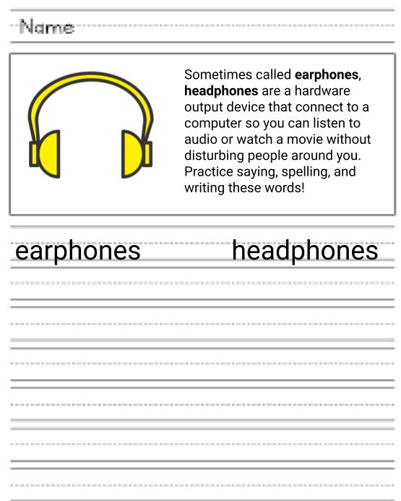

Name: Grade: HB: Date:________
Computer Basics Questions
Directions: Answer the following questions using information from this booklet.
- What is a computer?
- What is a keyboard used for?
- What type of data do we input to the computer from the keyboard?
- What is a computer mouse used for?
- What is a joystick?
- What is a microphone used for?
- What is a monitor used for?
- What are speakers used for?
- What are headphones used for?

