H-1B Invoice
Office of University Counsel

Please use the following sample invoice to request check(s) in Workday Finance. Please ask Finance to ship the check(s) directly to Elizabeth Gill’s home address, which Cheri Jefferson and Patricia Moyston have on file.

When completing the Supplier Invoice, your selections will appear as follows:

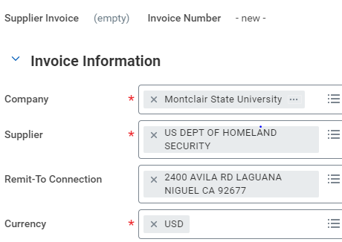

Today’s Date: ____/____/_________
MM DD YYYY

Checks to cover fees for H-1B processing to:

U.S. Department of Homeland Security
24000 Avila Road
USCIS California Service Center
Room 2312
Laguna Niguel, CA 92677

Petition for H-1B for _____________________________________
(Full name of H-1B applicant, department name)

Amount: $_________ (a separate check is required for each H-1B fee)

Check description (e.g., “I-129 petition processing fee,” “premium (expedited)
processing fee,” “Fraud Prevention and Detection fee”:

____________________________________________

Department: ____________________________________________

Name of Department Head: ________________________________

Cost Center Number: _____________________________________

Name of Department Fiscal Agent: __________________________

Signature of Department Fiscal Agent: ________________________

