O-1 Invoice
Office of University Counsel

Please use the following sample invoice to request check(s) in Workday Finance. When completing the Supplier Invoice, your selections will appear as follows:

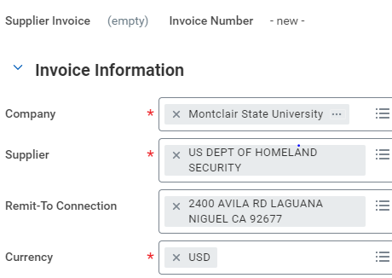

Today’s Date: ____/____/_________
MM DD YYYY

Checks to cover fees for O-1 processing to:

U.S. Department of Homeland Security
24000 Avila Road
USCIS California Service Center
Room 2312
Laguna Niguel, CA 92677

Petition for O-1 for _____________________________________
(Full name of O-1 applicant, department name)

Amount: $_________ (a separate check is required for each O-1 fee)

Check description (e.g., “I-129 petition processing fee,” “premium (expedited)
processing fee”:

____________________________________________

Department: ____________________________________________

Name of Department Head: ________________________________

Account #: _____________________________________________

Name of Department Fiscal Agent: __________________________

Signature of Department Fiscal Agent: ________________________

Note to Requesting Department: Please ask Finance to ship the checks directly to Elizabeth Gill’s home address, which Cheri Jefferson and Patricia Moyston have on file.

