Name:_______________________________________________________________________
Plastic Bots
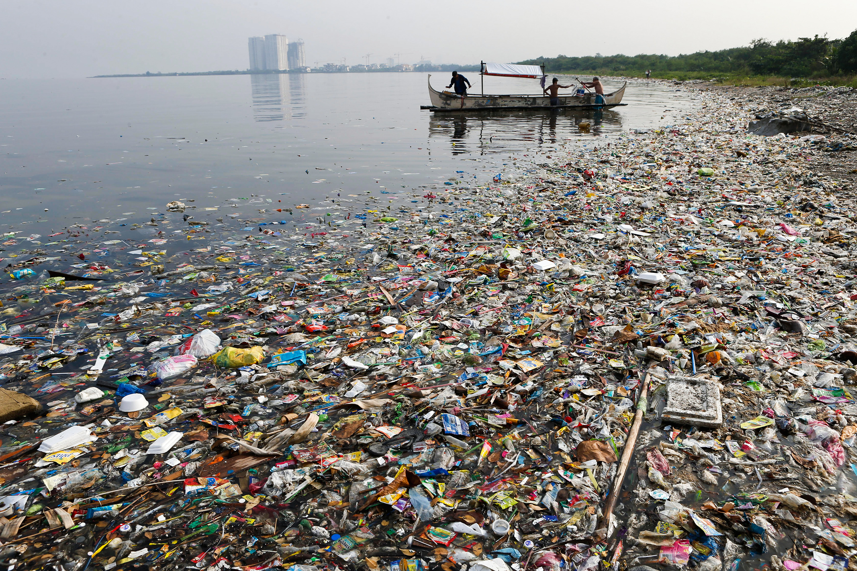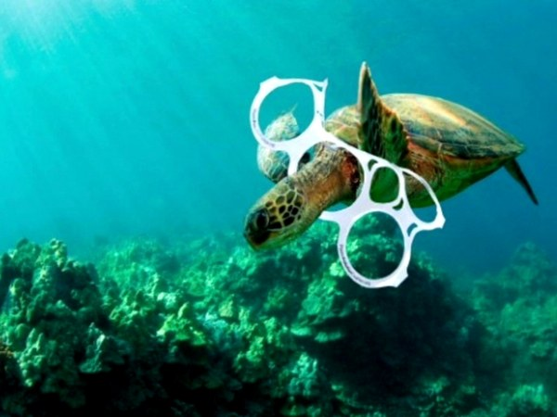

Problem
Useful Questions | Causes

Name:_______________________________________________________________________
Plastic Bots Solutions
Strategy | Explain how this will solve the problem | Sketch
The Ocean Clean Up

https://www.theoceancleanup.com/milestones/north-sea-prototype/

Floating Screens

Bucket (first solution in article)

Trash Eaters

Other: Find another solution

Source:
____________________

Name:_______________________________________________________________________

Plastic Bots

Design Brief: | The numbers are staggering: There are 5.25 trillion pieces of plastic debris in the ocean. Of that mass, 269,000 tons float on the surface, while some four billion plastic microfibers per square kilometer litter the deep sea.
Problem: | Plastic heavily pollutes the world’s oceans
Solution: | Humans can create devices to collect the plastic debris
Task: | Design a shell that will fit onto the sphero that will collect plastic debris from a model ocean

Initial Design: Draw an initial design of a solution to the problem.
Top View | Side View  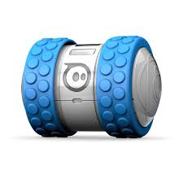

Bot’s Name:_______________________________________________________________________

Save the Oceans Project

Design Brief: | The numbers are staggering: There are 5.25 trillion pieces of plastic debris in the ocean. Of that mass, 269,000 tons float on the surface, while some four billion plastic microfibers per square kilometer litter the deep sea.
Problem: | Plastic heavily pollutes the world’s oceans
Solution: | Humans can create devices to collect the plastic debris
Task: | Design a shell that will fit onto the sphero that will collect plastic debris

Criteria/Constraints
1. The device must collect as much plastic as possible (pushing it to your goal)
2. Must be 9 cm in height *part of each side
3. Must use the provided top
4. Must use approved materials
5. 75 gram mass limit (the shell not the mounting unit)

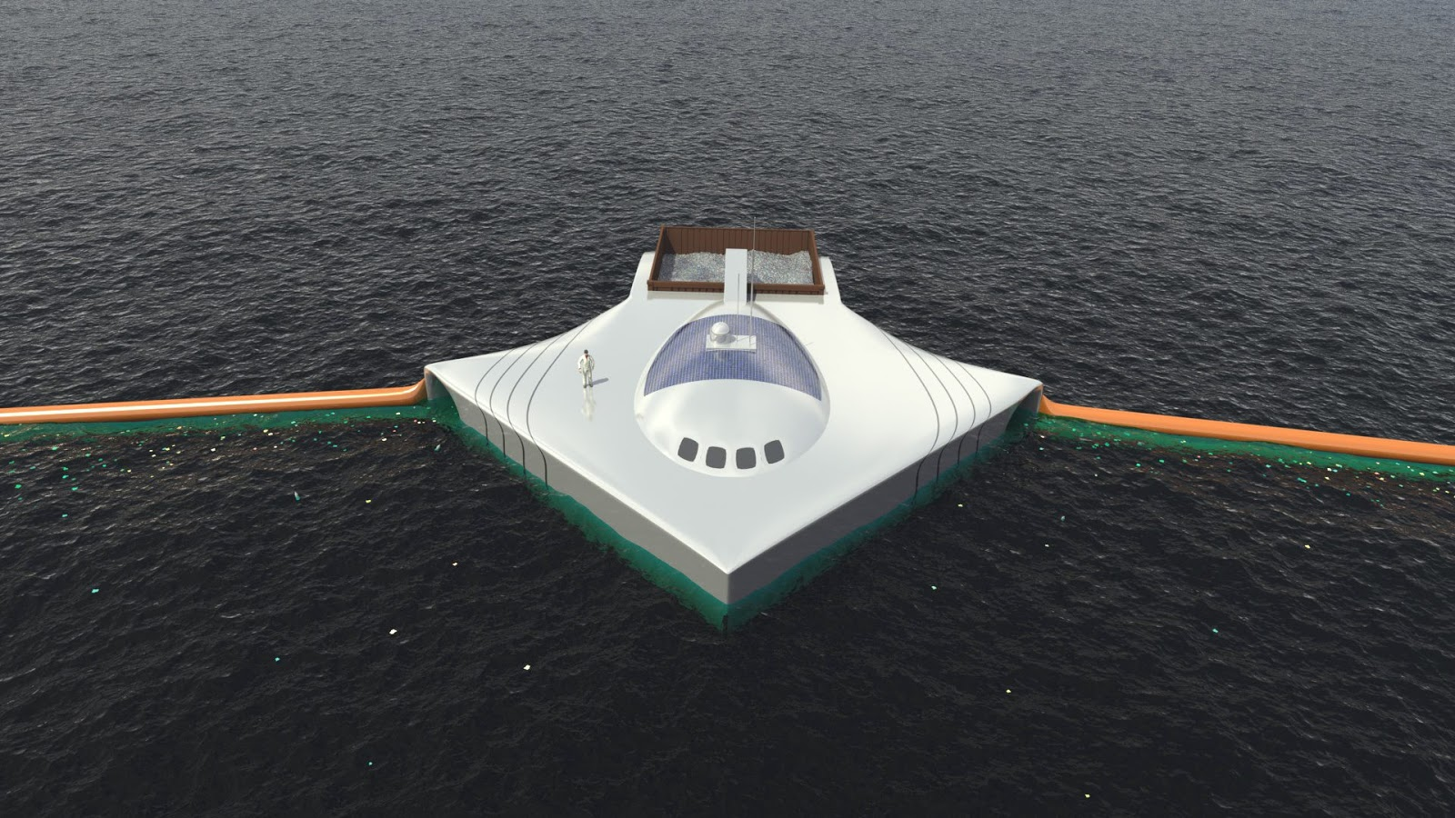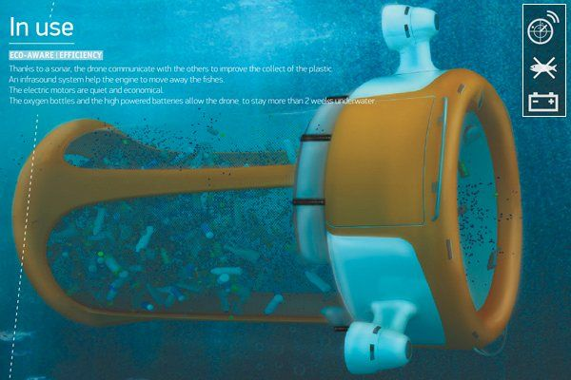

Bot’s Name:_________________________________________________________________________________________________

First Design
Design (top view) | Design (side view)
Useful Observations for improvement

- ______________________________________________________________________________________________

- ______________________________________________________________________________________________
How are you going to improve on this design? (2 changes)

- _____________________________________________________________________________________________________________________

- _____________________________________________________________________________________________________________________

Bot’s Name:_________________________________________________________________________________________________

Second Design
Design (top view) | Design (side view)
Useful Observations for improvement

- ______________________________________________________________________________________________

- ______________________________________________________________________________________________
How are you going to improve on this design? (2 changes)

- _____________________________________________________________________________________________________________________

- _____________________________________________________________________________________________________________________

Bot’s Name:_________________________________________________________________________________________________

Final Design
Design (top view) | Design (side view)
How are you going to improve on this design? (2 changes)

- _____________________________________________________________________________________________________________________

- _____________________________________________________________________________________________________________________

Name:______________________________________________________________________________________________________

Plastic Bots Investigation

Target Question: Which Solution is most effective?

Directions: Use this table to organize your testing evidence. Evidence
Bot Name | Useful Observations from Testing | Total Plastic Collected  Mass | RANKING | Reasoning *explain how you used the evidence to rank each solution

Generates and compare multiple solutions that solve a real world problem *evidence focus is on patterns and cause and effect relationships
1 | 2 | 3
Is unable to evaluate the merit a solution with evidence | Is able to evaluate the merit of one solution with one type of evidence to support their claim  Accuracy  Claim: Is accurate or logically connected to one type of evidence (observation)  *logically connected means the claim makes sense based on the students thinking but may not be accurate  *can be applied to content mastery evaluation | Is able to evaluate the merit of more than one solution using multiple types of evidence to support their claim  Accuracy  Claim: Is accurate and fully supported by their evidence  *can be applied to content mastery evaluation

