Foreign Affairs, May 26, 2015

Russia and China Go Sailing

Superpower on Display in the Eastern Mediterranean
By Elizabeth Wishnick

On May 21, Russia and China concluded ten days of joint naval exercises in the eastern Mediterranean, which included live-fire drills. Although the militaries of the two countries claimed that the naval exercise was meant only to improve interoperability, their presence in the sea has far broader political implications.
For some years, Russia and China have been participating in bilateral and multilateral exercises in Asia, mostly with other members of the Shanghai Cooperation Organisation—Kazakhstan, Kyrgyzstan, Tajikistan, and Uzbekistan. This is the first time that Russian and Chinese naval forces have conducted joint tactical exercises in Europe and the first major exercise for China in such distant waters.
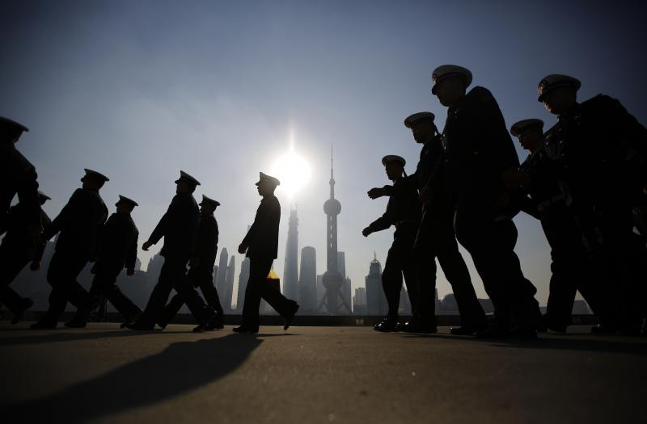Carlos Barria / Reuters
Chinese navy officers prepare for the arrival of the British Royal Navy destroyer HMS Daring to the north side of the bund at Huangpu River in Shanghai, December 10, 2013.
The exercise followed Chinese President Xi Jinping’s visit to Moscow for the May 9 commemoration of the Russian victory over the Nazis. To kick it off, three Chinese and six Russian ships departed from the Russian port of Novorossiysk on the Black Sea. The exercise culminated in the Joint Sea 2015 drills. According to Rear Admiral Viktor Kochemazov, who commanded the Russian ships, antisabotage, antiship, antisubmarine, and air defense maneuvers were conducted as a part of “Operations to Ensure the Safety of Shipping in Remote Areas of the World Ocean.”
Chinese and Russian officials reported that the Mediterranean exercises reflected their need to prepare for nontraditional security missions and improve navigation safety. It is true that Russian and Chinese vessels have participated, along with ships from the United States and other countries, in antipiracy such missions, particularly in the Gulf of Aden. The three Chinese ships involved have all joined in antipiracy missions, and one frigate (the Linyi) also took part in China’s second rescue mission in the region in March, this time to evacuate 600 Chinese citizens and several hundred foreign nationals from Yemen. China’s first rescue mission in the Mediterranean occurred in 2011 in response to unrest in Libya and involved a makeshift effort to evacuate 38,500 Chinese workers using rented cruise ships and cargo boats supervised by a Chinese naval vessel. Since then, the Chinese navy has been increasingly visible in the region, making ports of call in Cairo, Haifa, and Istanbul in 2012. At the same time, Russian ships sailed to Tartus in Syria, a seeming show of support for Russia’s interests there. Two years later, in January 2014, a Chinese frigate took part in the multinational force removing chemical weapons from Syria. After that mission, in late January 2014, two of the participating Russian and Chinese ships engaged in their first joint maneuvers in the eastern Mediterranean to improve coordination, and the two navies decided to hold more extensive exercises in 2015.
China and Russia both see opportunity in a weakened southern Europe. But the 2015 Sino-Russian exercise was also a timely counterpoint to NATO’s own in Europe (Operation Atlantic Resolve), as well as to some between the United States and Georgia and allies in Asia. As in previous exercises, the Chinese-Russian operation also served as a marketing opportunity for Russian weapons manufacturers seeking Chinese buyers. Russian arms sales to China have picked up again lately after a lull—China recently became the first foreign country to buy Russia’s S-400 antiaircraft missile defense system. This time, however, China also highlighted its own technologies for possible Russian purchase—two of the participating Chinese vessels are missile-guided Jiangkai II frigates, which China may be trying to sell to Russia. Russian defense analyst Alexander Mozgovoy has argued that the Chinese ships could help Russia fill gaps in its fleet until sufficient numbers of Sergei Gorshkov–class frigates have been produced.
Further, the exercise represented a show of global power and reflected growing Chinese economic interests beyond Asia. China and Russia both see opportunity in a weakened southern Europe. In 2008, the China Ocean Shipping Company (COSCO) invested 4.3 billion euros to operate one of the three terminals at the Greek port of Piraeus and rebuild a second terminal there, a venture that would give China’s Maritime Silk Road an important outlet in the Mediterranean and make the Greek port a key hub for Chinese trade. COSCO, a Chinese state–owned company, wants majority ownership in the port, assuming its privatization continues under the new leftist government in Greece. The Chinese government is also financing high-speed rail connections between Piraeus, Belgrade, and Budapest, to be completed in 2017.

Related Tweets
Meanwhile Gazprom, Russia’s state-owned gas company, is seeking to develop a new gas pipeline via Turkey and Greece, bypassing Ukraine. In December 2014, Russian President Vladimir Putin abruptly announced that he was scrapping South Stream, which would have exported Russian gas to Bulgaria, for Turkish Stream, a new export route via Turkey, which would connect to Greece. European Union officials opposed South Stream, which they argued would have maintained Russian dominance over European gas markets. Although the new Russian Turkish Stream proposal is a tantalizing opportunity to bring in needed investment to Greece, the United States has been urging the country to support an alternative Trans Adriatic Pipeline project that would bring Azerbaijani gas to Albania, Greece, and Turkey via a pipeline beneath the Adriatic Sea.
For Russia, the broader point of its new investment initiatives in Europe—as well as the Sino-Russian military exercises in the Mediterranean—is to remind the United States and Europe that, like it or not, Russia remains a global power. Russian Foreign Minister Sergey Lavrov noted, for example, that the main conclusion he drew from U.S. Secretary of State John Kerry’s May 12 visit to Sochi and meeting with the Russian president was that “the solution of numerous acute contemporary problems depends on our concerted joint efforts on the international scene.”
There are no doubts about China’s importance to Europe—China is the EU’s second-largest trading partner after the United States, and the European Union is China’s top trading partner. As COSCO’s plans for Piraeus’ port attest, China’s Maritime Silk Road is already having an impact on Europe, and the ongoing economic crisis there is providing new opportunities for Chinese investment. For this reason, Chinese officials have taken great pains to insist that the Sino-Russian military exercises were not directed at any third country. Nonetheless, while events in Ukraine, Iraq, and the South China Sea have grabbed headlines of late, it is important to keep an eye on southern Europe as well.

