CARES Lab Ph.D. Students & Alumni

MENTORSHIP MODEL
CARES Lab Ph.D. students are collaborators, not assistants. Trainees are supported in leading projects, publishing early, presenting at major conferences, and developing independent research identities across academic and applied career paths. To ensure close mentorship, the lab maintains a faculty-to-PhD student ratio of 4:1 or lower.
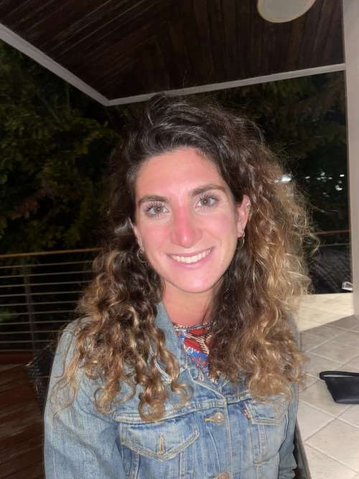
CURRENT STUDENTS
- Christina Christodoulou, M.A., A.B.D.
- Research interests: Exploring how constant connectivity (such as emails and messages outside of work) affects employee well-being, including strategies that help employees mentally disconnect from work during nonwork hours
- Job placement (begins Fall 2026): Assistant Professor of Industrial-Organizational Psychology (tenure-track), Fairleigh Dickinson University
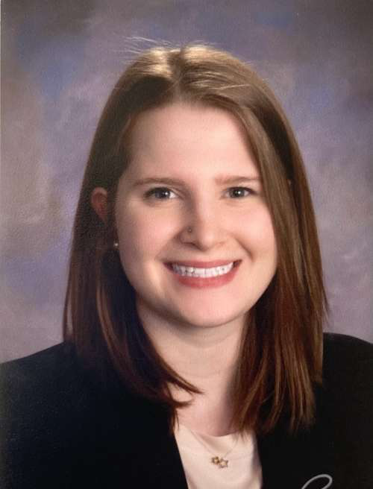
- Sara Stavely, M.A., A.B.D.
- Research interests: Understanding how employees experience and cope with bereavement in the workplace, including how organizational policies, supervisors, and coworkers can provide effective support during periods of grief
- Internship: Human Resources Compensation Intern, The Port Authority of New York & New Jersey
ALUMNI JOB PLACEMENTS
- Lauren Offermann, Ph.D. (2025) — Clinical Assistant Professor of Human Resource Management, New York University (NYU)
- Isabel (Izzy) Skovera, Ph.D. (2025) — Senior Equal Employment Opportunity (EEO) Analytics Specialist at The Port Authority of New York
STUDENT PEER REVIEWED PUBLICATIONS
This list includes only CARES Lab projects. CARES Lab students may also publish research conducted with other labs.
- Stavely, S. M., Gray, C. E., Bajwa, N. K., Hunt, L. N., & Johnson, W. N. (Under review). When grief comes to work: Examining employees’ perceptions of colleague support during bereavement. Journal of Organizational Behavior.
- Gray, C. E., Skovera, I., Hughes, I. M., Kellman, D., & Offermann, L. (2025). Help! We need a measure: Developing and evaluating a Multidimensional Coworker Support Scale (MCSS). Journal of Occupational Health Psychology, 30(4), 199-226
- Hughes, I. M., Gray, C. E., Bazzoli, A., & Stavely, S. M. (2024). Why your help is unhelpful: A multi-stage mediation model exploring mechanisms linking unhelpful workplace social support to work engagement. Journal of Occupational Health Psychology, 29(4), 238-257
- Offermann, L., Gray, C. E., Bragger, J., & Laguerre, R. A. (2023). It takes a [helpful] village: Recognizing and minimizing unhelpful help to better support female caregivers in academia. Industrial and Organizational Psychology: Perspectives on Science and Practice, 16, 233-236

STUDENT CONFERENCE PRESENTATIONS
This list includes only CARES Lab projects. CARES Lab students may also present research conducted with other labs.
- Christodoulou, C. Z. & Gray, C. E. (2026, June). Constant connectivity to work and health outcomes: What do employees want us to do about it? [Poster presentation]. Submitted for presentation at the European Academy of Occupational Health Psychology Annual Conference, Helsinki, Finland.
- Stavely, S. M. & Gray, C. E. (2026, April). Grief at work: A systematic review of bereavement and organizational support. In Gonzalez, M. F. (Co-Chair), Mohan, N. S.* (Co-Chair), Shah, A.* (Co-Chair), & Spector, P. E. (Discussant), Beyond the episode: Considering enduring forms of emotions at work [Symposium]. Society for Industrial and Organizational Psychology Annual Conference, New Orleans, LA, United States.
- Gray, C. E., Skovera, I. R., DiGiovanni, A. M., Spector, P. E., Wells, J. E., & Hughes, I. M. (2026, April). Just as harmful as abusive supervision? Outcomes of unhelpful supervisor support. In K. J. Black & J. Lamprecht (Co-Chairs), The personal and organizational costs of unhelpful and imbalanced support at work [Symposium]. Society for Industrial and Organizational Psychology Annual Conference, New Orleans, LA, United States.
- Christodoulou, C. Z. (2026, April). Carrying work in your back pocket: A systematic review of work-related smartphone use [Poster presentation]. Society for Industrial and Organizational Psychology Annual Conference, New Orleans, LA, United States.
- Offermann, L., Gray, C. E., & Spector, P. E. (2025, December). Supervisor Mental Health Awareness Training 2.0: Evaluating the utility of a self-paced web-based program. [Paper presentation]. Educational Research Center Annual Pilot Research Symposium (Virtual).
- Skovera, I. R. (Chair), Gray, C. E., Kessler, S. R., Newlin, A. B., Rosen, C. C. (2025, April). Turns out researchers are human: Experiences making and disclosing mistakes in I-O Psychology research [Panel]. Society for Industrial-Organizational Psychology Annual Conference, Denver, CO, United States.
- Stavely, S. M., Gray, C. E., & Bajwa, N. (2025, April). Examining employees’ perceptions of received support during bereavement. In C. E. Gray & I. M. Hughes (Co-Chairs), Support received: Exploring the nuanced effects of received social support at work [Symposium]. Society for Industrial-Organizational Psychology Annual Conference, Denver, CO, United States.
- Skovera, I. R. & Gray, C. E. (2025, April). Drinking the company kool-aid: A systematic literature review of organizational identification and employee well-being [Poster presentation]. Society for Industrial-Organizational Psychology Annual Conference, Denver, CO, United States.
- Ahmad, A. S. (Co-Chair), McCauley, R. (Co-Chair), Cheung, H. K., Fletcher, K., Hideg, I., Offermann, L., Reynolds-Kueny, C., Hatif, H. S. (2024, April). Caring for caregivers: Experiences and solutions to support caregivers in academia [Panel]. Society for Industrial and Organizational Psychology Annual Conference, Chicago, IL, United States.
- Skovera, I. R., Gray, C. E., Hughes, I. M., & Offermann, L. (2024, April). Help! We need a measure: Developing a multidimensional measure of coworker support. In I. M. Hughes & M. G. Keith (Co-Chairs), Helping revisited: Research on alternative workplace social support perspectives [Symposium]. Society for Industrial and Organizational Psychology Annual Conference, Chicago, IL, United States.
- Offermann, L. (2024, April). Supervisor support and employee mental health: A systematic literature review [Poster presentation]. Society for Industrial and Organizational Psychology Annual Conference, Chicago, IL, United States.
- Offermann, L., Gray, C. E., Hunt, L., Shelley, L., & Elhouar, W. (2023, November). How do supervisors support employees with mental health conditions? What works & what doesn’t [Poster presentation]. Work, Stress, & Health Biennial Conference (Virtual).

STUDENT GRANT FUNDING
- Offermann, L. (PI), Gray, C. E. (Co-PI), & Spector, P. E. (Co-PI). (2024–2025). Supervisor mental health awareness training 2.0: Evaluating the utility of a self-paced web-based program (Grant No. T42 OH008422). Pilot Projects Research Training Program of the NY/NJ (Region II) Education and Research Center, National Institute for Occupational Safety and Health (NIOSH). $11,934.00.

