

COMMUNICATION PLAN
Updated: December, 2012
Paula Maliandi
Table of Contents

- Introduction 2
- Guiding Principles of Communication 3
- Stakeholders 3
- Objectives of Communication 6
- Using the Communication Plan 6
- Style Guide 7
- Communication by Message 7
- Methods of Communication 8
- Project Documents 9
- Communicating Key Messages to Stakeholders 10
- Project Communication Calendar 11
- The Blackboard Repository 11
- Communications Announcing High-Impact Changes 12
- Document Naming Convention 12
- Version Control Flow Chart 14
- Feedback and Measurement 15

APPENDICES:
A. Process/Business Change Form 16
B. Communication Calendar Template 18

1. INTRODUCTION
OneMontclair is a university-wide initiative to re-engineer processes and implement supporting technologies for our core administrative areas to create a more operationally efficient and effective organization. The areas in scope for this effort include Budgeting and Planning, Finance, Human Resources, Student and Campus Services, University Advancement and Enterprise Research, Reporting and Analytics, and include the integration of new capabilities with locally developed and vendor provided third party applications. This will be a very complex, multi-year program and potentially involves hundreds of participants. As such, it will be critical that the team members are communicating effectively such that
- The Program Scope and Objectives are understood by all
- Roles and responsibilities are clear
- Issues are well articulated, highly visible and raised and resolved quickly
- Decisions are made quickly in light of the best information
- Those impacted by the changes are well informed and prepared.
This document describes the methodology for program and project communications for project participants, stakeholders and target audiences. In addition, the communication team will facilitate the development and dissemination of information about the initiative so that all audiences understand the project, are prepared for the changes it will bring, and are ready to embrace the changes.
The OneMontclair communication team will commit to:
• Ensuring that project team members are communicating to all relevant personnel so the goals and objectives of the project are met;
• Conveying a clear, consistent message about the program;
- Reaching the University community with the information needed to understand the project’s scope and impact
- Generating positive responses to and excitement and optimism about OneMontclair from stakeholders and target audiences;
- Addressing concerns of affected members of the University community while developing an understanding of the transition from legacy systems and procedures to the new system and procedures;
- Enabling knowledge and understanding of the project’s implementation phase and the University’s transition to the new applications;
- Demonstrating to all present and future members of the University community that OneMontclair benefits the University community and that the University community is enthusiastically utilizing the new applications.

2. GUIDING PRINCIPLES OF COMMUNICATION
The quality of information and communication vehicles must be consistent and clear across all modules. A template approach will be applied to each module and specific messages will be crafted as needed.
Open, candid, risk-free communication will be expected from all involved in OneMontclair. Transparent communication builds trust and should be modeled at every level of governance throughout the project.
Project Team Leads and Operational Team Leads will make the project a top priority. All members of the team must assume ownership of and accountability for the project’s success therefore attendance at meetings is critical. To properly communicate about the project to others, all team members must be engaged and participate fully in the project.
All stakeholders will receive and provide information in a timely and appropriate manner on key actions and decisions affecting them. This approach is critical to achieve confidence and support and minimize anxiety.
Communication will reflect the culture, language and spirit of the MSU community to earn credibility and trust among stakeholders. Communication leads will be an ongoing presence in stakeholder meetings, training sessions, and other key OneMontclair events to capture the proper tone and approach when engaging the MSU community. In addition, it is recommended that Communication Champions be designated within teams to facilitate communication to and from leadership.
3. STAKEHOLDERS
A significant number of individual stakeholders and stakeholder groups are involved in this project. These individuals will require information and be called upon to provide information. By effectively communicating with and among stakeholders, the project can accomplish its work with support and cooperation.
Primary stakeholders are defined as follows:
University President
Legal and Compliance Personnel
Project Executive Leadership Team
Divisional Leads (Vice Presidents)
Program Management Office
Team Leads
Operational Team Leaders
Faculty and Staff
Students and Families
Operational Champions
Technology Vendors
Deans Council
Process Owners
Subject Matter Experts
Database Administrators

Every stakeholder group requires project information and is required to provide information to other stakeholders, team members and the campus community. The following chart enumerates the types of information that are needed by each stakeholder group along with the information they are required to provide.

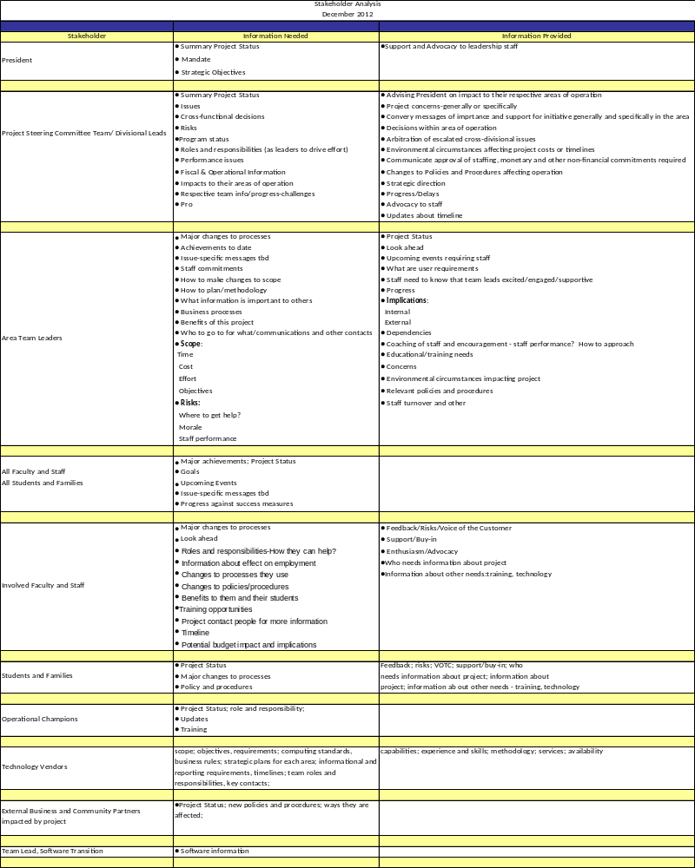
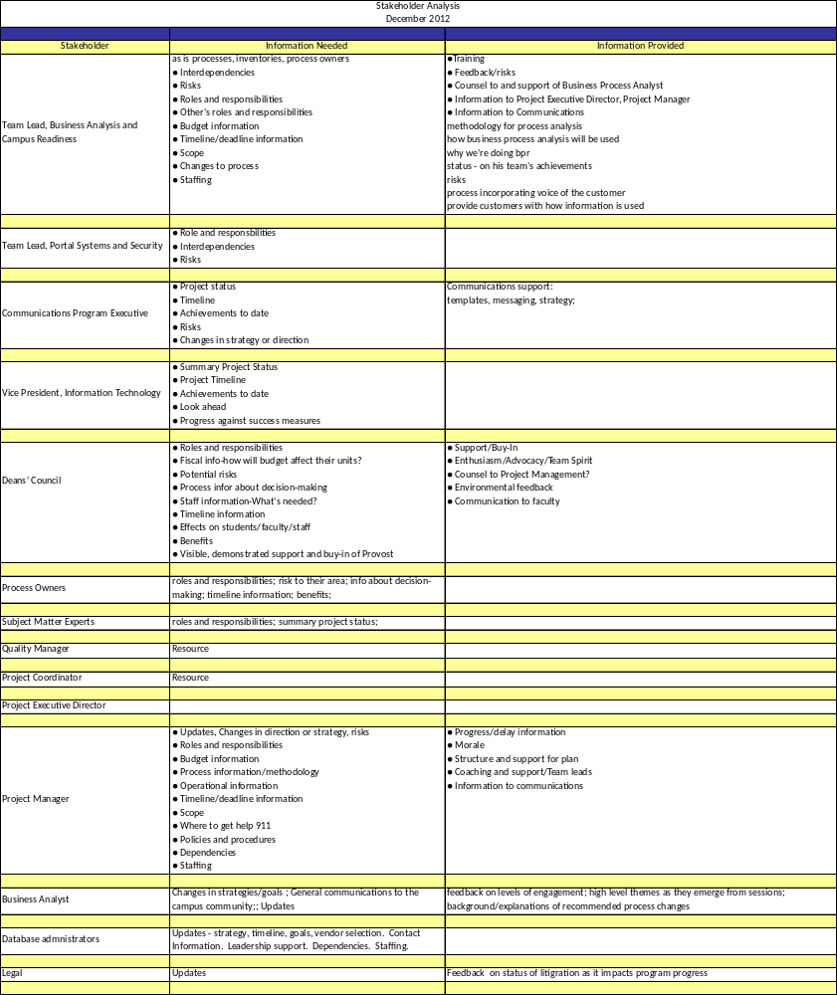

4. OBJECTIVES OF COMMUNICATION
The primary purpose of this communication plan is to ensure that all project participants are communicating in a clear, consistent and timely manner in order that the objectives of the OneMontclair program are met.
- Drive awareness for the OneMonclair Initiative and its impact on the University with timely, clear and engaging communication, mindful of responsibilities and policies accruing to our status as a public institution

- Build a positive image for OneMontclair, paving the way for a smooth transition and implementation
• Generate understanding for the OneMontclair initiative among key stakeholders
- Generate enthusiasm and excitement for the project by celebrating successes and milestone achievements
- Reinforce the project’s link to MSU strategic goals
- Provide continuous, accurate and timely information to promote a better understanding of why the University is engaging in the project and how the educational mission is furthered through its results
- Position MSU management as engaged and fully supportive leaders of OneMontclair
- Drive visibility and gain recognition for OneMontclair teams
- Create forums and vehicles for sharing ideas and listening to concerns
- Communicate project timeline
• Motivate staff by stressing importance of their involvement and leadership
- Build confidence throughout MSU community for a successful project outcome
- Encourage open communication among those involved in the OneMontclair implementation and those affected by it

5. USING THE COMMUNICATION PLAN
As you review this plan, you will be taken through the steps of how to communicate with your constituents and with other team members:
Step 1. Identifying stakeholders
Step 2: Creating messages/subjects of communication
Step 3: Selecting the best channels for communication from email to website to face to face communication
Step 4: Feedback and Measurement – evaluating the effectiveness of the communication

6. STYLEGUIDE
OneMontclair has its own distinct logo and banner. These should be used for all official OneMontclair documents and can be downloaded from Blackboard. All communications directed to external audiences, which are defined as anyone beyond the OneMontclair team, including the general campus community, must be vetted and approved by the Communication Program Executive. The OneMontclair PowerPoint template also is available on Blackboard.
One Montclair logo (color)

One Montclair logo (black and white)


One Montclair eblast template


7. COMMUNICATION BY MESSAGE
The following table provides a guide to the analysis of the various messages that will need to be disseminated to target audiences and the channels through which they will be sent. For example, status updates will be included in meeting minutes, risk and action logs, in informational sessions, on Blackboard and in Project/program scorecards, financial summaries and in P.R. object plans.
 | MEETINGS/MINUTES, RISK & ACTION LOGS | RISK LOGS/ACTION LOG/MEETING MINUTES | WEBSITE | E-COMM  (E-Blast, E-mail, E-Newsletter) | INFORMATIONAL SESSIONS  (May include PowerPoint) | TRAINING | BLACK  BOARD REPOSIT-ORY | PROJECT/  PROGRAM SCORECARDS/  FINANCIAL SUMMARIES/PROBJECT PLANS | PROJECT  TOOLS AND TEMPLATES
Status Update | ✓ | ✓ |  | ✓ | ✓ |  | ✓ | ✓ | ✓
Organizational Impacts such as process, technology &  personnel changes | ✓ | ✓ |  | ✓ | ✓ | ✓ | ✓ |  | ✓
Training Schedule |  |  | ✓ | ✓ | ✓ |  | ✓ |  | ✓
Project Plans, Goals, Scope | ✓ |  |  |  | ✓ |  | ✓ |  | ✓
Roles and Responsibilities | ✓ | ✓ |  |  | ✓ | ✓ | ✓ |  | ✓
Issues/Risks | ✓ | ✓ |  |  |  |  | ✓ | ✓ | ✓
Business Requirements |  |  |  |  |  |  | ✓ |  | ✓
Fiscal and Operational Info |  |  |  |  |  |  | ✓ | ✓ | ✓
8. METHODS OF COMMUNICATION
The following communication channels will be used, as appropriate for message and audience, to deliver OneMontclair information:
- OneMontclair Website (External communications)
• About One Montclair
• The Team
• Areas of Implementation
• Contact information
• News about the program

- Presentations/PowerPoint
• Broad information about the program

- Blackboard Repository (see Section 11)
• Templates
• Documents
• Reports
• Scorecards
- Eblast
• Status updates from all areas

- Project Scorecards
• Reflects progress, upcoming milestones, risks, budget plan vs. actual

- Program Scorecards
• Reflects program-level budget, risks, achievement of goals

- Financial Summaries
• Budget plan vs. actual, financial classifications, program cost performance, earned value

- Project Plans
• Schedules with roles, responsibilities, due dates

- Risk Logs
• Issues/risks raised and their current status

- Action Logs
• Project wide specific deliverables and status

- Meetings/Meeting minutes
• Key decisions, open issues, project status

- E-Newsletter
• Special topics of interest to the team and campus community

- Other media outlets. Specialized communication to:
  - The Montclarion
  - Campus TV
  - WMSU radio

- Information Sessions and Training
- Ongoing Communications Announcing Process and Business Changes
9. PROJECT DOCUMENTS
In addition to the above, much of the project decisions will be captured in project artifacts, documents and templates. For each of the OneMontclair projects, documents to be stored in the Blackboard are as follows:
- Charter, Project Definition Document – Objectives and Scope
- User Requirements - Business Requirements
- Technical Architecture Design - Systems Design, Data Flows, Systems Configurations Specification
- Quality Management Plans – Test Strategy, Scope and Methodology
- Risk Management Plan – Risk Analysis, Mitigation and Status
- Test Scripts – Unit, Integration User and Test Scripts
- Traceability Matrix – Requirements to Test Results Tracing
- Test Summary Reports - Test Results, Variance Reports, Remediation Activities
- Project Plans – Project Schedules, Roles and Responsibilities
- Workflow Documents – As Is and To Be process diagrams
- Training Records – Administrator and User training records
- Operational Handover Documents – Supports Agreements, Hours of Operation, Contact Points, Ongoing Roles and Responsibilities
- User and Administrator Procedures – Processes for correct usage, Ongoing Administrations and Data Stewardship
- Training Materials
- Quotes, Contracts, POs and Invoices
- Lessons Learned
10. COMMUNICATING KEY MESSAGES TO STAKEHOLDERS
The following table provides a guideline for the dissemination of key messages to key stakeholders. Communication is designed to be a constant and ongoing element of the project. The absence of communication should be noted and all team members are responsible to provide information when needed.
MESSAGE | TO WHAT STAKEHOLDERS | METHOD OF COMMUNICATION | FREQUENCY | PERSON(S) RESPONSIBLE
Goals/Scope | Internal Team Members | Kick off meetings | One time then as needed | Project Executive Steering Committee
Goals/Scope | Internal Team Members | Storage: Blackboard |  | Project Executive Steering Committee
Goals/Scope | Internal Team Members | Web site (excluding budget info.) |  | Project Executive Steering Committee
Business Requirements | Project Team | User and Functional Requirements Document | During Planning Phase | Team Leads
Technical Standards | Project Team | Technical Architecture Design Documents | As needed
Roles/Responsibilities | Internal Team Members | Kick off meeting | At project onset; during planning phase; as changes occur to personnel | Project Executive
 |  |  |  | Team Leads
Roles/Responsibilities | Internal Team Members | Project Meeting/Minutes |  | Operational Leads
Roles/Responsibilities | Internal Team Members | Team RACI
Roles/Responsibilities | Internal Team Members | Action Logs
Roles/Responsibilities | Internal Team Members | Storage: Blackboard
Status Reports | Internal Team Members | E-mail | Monthly | Communications Team
Status Reports | Internal Team Members | Meeting Minutes | As Needed | Communications Team
Status Reports | Internal Team Members | Program Scorecards |  | Communications Team
Status Reports | Internal Team Members | Project Scorecards |  | Communications Team
Status Reports | Internal Team Members | Financial Summary |  | Communications Team
Status Reports | Internal Team Members | Storage: Blackboard and website |  | Communications Team
Impact to other areas including process, business and organizational changes | Division and Team Leads | Project Meetings | As detected | Everyone
 | Relevant Team Members | As outlined in Change Management and Communications Process | As needed | Team Leads
Issues/Risks | Team Members | Project Meetings/Risk Management Plan | Immediate upon event | Everyone
Issues/Risks | Team Members | Storage: Issue Log on Blackboard | Immediate upon event
Fiscal and Operational Info | Leadership Team | Project Meetings | Weekly | Project Executive and Project Coordinator (program level)
Fiscal and Operational Info | Leadership Team | Storage: Blackboard | Weekly | Project Managers and Team Leads (project level)

11. PROJECT COMMUNICATION CALENDAR
For each area of implementation it is the team lead and project managers’ joint responsibility to create a communication calendar that outlines the communication needs, tools, and delivery methods. Communication activity dates will be based on the project timeline and work plan. Communication calendars for each area will be available on the Blackboard repository and will be updated as needed throughout the project.
See Appendix B: Communication Calendar Template
12. THE BLACKBOARD REPOSITORY
Blackboard will serve as OneMontclair’s repository for much of the information and tools that we will use throughout the project. The following illustration is a guide to how you can access OneMontclair information and tools:
Blackboard Structure
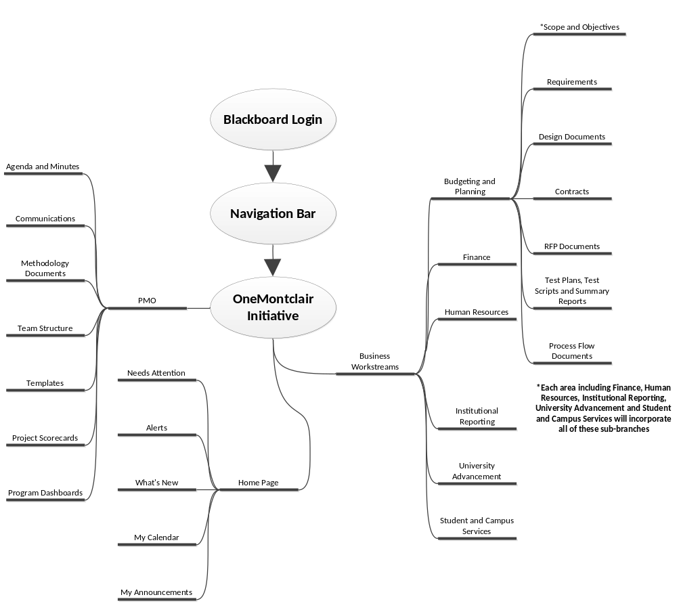
13. COMMUNICATIONS ANNOUNCING HIGH-IMPACT CHANGES
Communications regarding high-impact business and processes changes will be initiated with a Process/Business Change Communication Management Form. (See Appendix A: Process Change Form.)

Once a change has been approved, the form is submitted to the Communication Team which will work in consult with the process or business owner to develop a plan for communicating the change and how that communication will be executed. 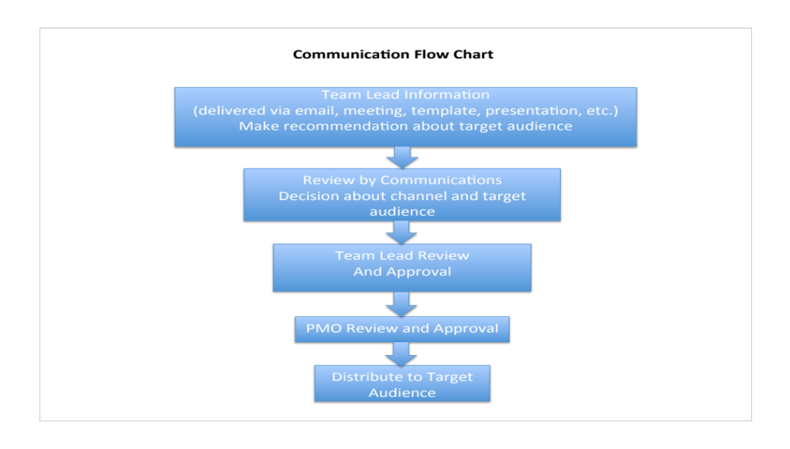

14. DOCUMENT NAMING CONVENTION
When saving a document to any file including blackboard, please use the following convention to name and version all documents. This critical naming system will enable all team members to save and access the most up to date version of documents in the Blackboard repository.
All final documents designated to reside on Blackboard will be forwarded to the OneMontclair administrative assistant where they will be reviewed, renamed according to the document naming convention, and uploaded to the repository. Only the newest versions of documents should be stored on Blackboard.
General format guidelines
Use the below as a guideline for naming documents so that they can be easily found and the content type, author, date and status are easily understood.

< document type > <Workstream> < date MM-DD-YYYY> <Author> <Version Version Number> <file type>
Separate each data element with the underscore character: _

Example:
UserRequirements_Finance_05-15-2012_John Doe_Version 1.1.doc
Project Scorecard_Student Services_5-14-2013_Jeff Jones_Version 1.0.xls

Document Type:
For the document type describe the document type and use the template category wherever possible (i.e. meeting minutes, user requirements, etc.)

Workstream:
Describe which program workstream this is in regard to. Possible choices are as follows:

OneMontclair Program, Finance, Budgeting and Planning, Human Resources, Student Services, Institutional Reporting, Data Warehouse, Portal, Single Sign On, etc.
Date:
Use the month, day year format as follows with the numbers separated MM-DD-YYYY

Author:
List the author’s first and last name.

File type:
Be sure to keep the file type intact so that the document can be opened by the appropriate applications.

Version Control Guidelines
Refer to the Version Control Flow Chart following the guidelines.
- Document dates
- The author of the document will ensure the date the document is created or revised is identified on the first page and, when possible, is incorporated into the header or footer of the document and appears on every succeeding page.
- Version numbers
- The author of the document will ensure the current version number is identified on the first page and, when possible, is incorporated into the header or footer of the document and appears on every succeeding page.
- Draft document version number
- The first draft of a document will be Version 0.1.
- Subsequent drafts will have an increase of “0.1” in the version number, e.g., 0.2, 0.3, 0.4, …0.9, 0.10, 0.11.

- Final document version number and date
- The author will deem a protocol or other document (requirements, technical design document, test scrip, manual of procedures) final after all reviewers have provided final comments and the comments have been addressed.
- The first final (APPROVED) version of a document will be Version 1.0. Include the date when the document becomes final.
- Subsequent final documents will have an increase of “1.0” in the version number (1.0, 2.0, etc.).
- Final documents undergoing revisions
- Final documents undergoing revisions will be Version X.1 for the first version of the revisions. While the document is under review, subsequent draft versions will increase by “0.1”, e.g., 1.1, 1.2, 1.3, etc. When the revised document is deemed final, the version will increase by “1.0” over the version being revised, e.g., the draft 1.3 will become a final 2.0.
- Documenting substantive changes
- A list of changes from the previous draft or final documents will be kept. The list will be cumulative and identify the changes from the preceding document versions. The list of changes made to a protocol and consent/assent should be submitted to the IRB with the final protocol and consent/assent documents.

15. VERSION CONTROL FLOW CHART
The following chart illustrates the workflow for the document naming convention:

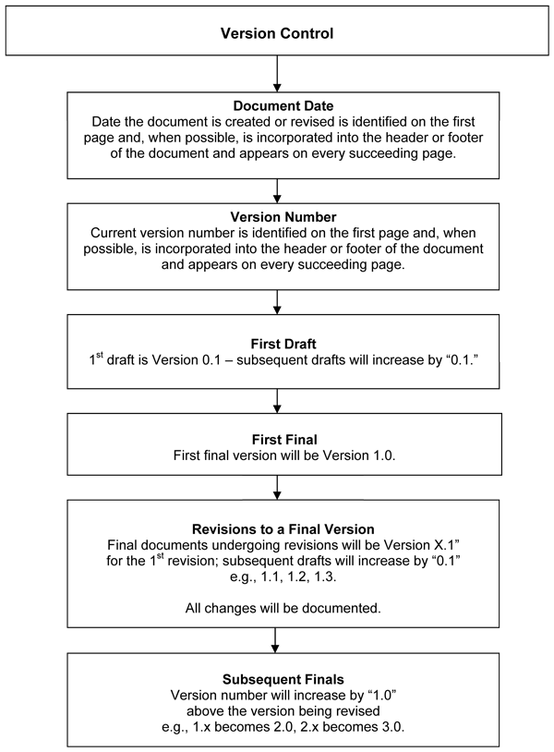
16. FEEDBACK AND MEASUREMENT
Feedback and gauging message saturation is critical to ensuring the ongoing effectiveness of communication. Feedback and measurement will focus on validating:
- Comprehension and need for more information
- Relevancy and credibility
- Timeliness
- Communication channels
- Spirit and morale of teams
By evaluating feedback we will be able to adapt the Communication Plan to meet the needs of the audience and stakeholders, enabling continuous improvement for future communication.
Face-to-face communication events (e.g., review sessions, workshops, focus groups) will provide an opportunity for the stakeholders to provide direct feedback. Other channels will include physical feedback forms. The OneMontclair email box, to which staff and students can email feedback or questions, will be featured in all materials. Any concerns regarding communications or the information outlined in this plan should be directed to Paula Maliandi, communications program executive for OneMontclair, via email at maliandip@mail.montclair.edu or by telephone at 973-655-7900.
Routine communications will seek feedback through the mechanisms noted in the following table.
Communications Vehicle | Feedback Mechanisms
E- Newsletter | Promote Email box to encourage feedback.  Random Surveys and contest
Website | Website Page to submit comments & questions  Place Random Surveys  Track visits to site
Workshops; Meet & Greets. | Face-to-face comments; Survey; attendance numbers.
Project updates and other ongoing Communications | Include contact info; promote email box
Focus Groups and Surveys | Specially designed around new communications or issues
APPENDIX A: Process/Business Change Form
PROCESS/BUSINESS CHANGE
COMMUNICATION MANAGEMENT FORM

Once a process change has been approved, please submit this form to Paula Maliandi, executive director of Communications for OneMontclair. Paula will then contact you to discuss the plan for communicating the change to the appropriate audiences.

DIVISION: ____________________________________________________________________________________

DEPARTMENT: ______________________________________________________________________________

TODAY’S DATE: ____________________ SUBMITTED BY: ______________________________________

NAME OF CHANGE (if applicable):_______________________________________________________________________

EXPLANATION OF CHANGE (Please include description of current and new scenario): _________________________________________________________________________________________________
_________________________________________________________________________________________________
_________________________________________________________________________________________________
_________________________________________________________________________________________________

DATE CHANGE IS EFFECTIVE: ____________ CHANGE OWNER: __________________________

PROCESS/BUSINESS CHANGE
COMMUNICATION MANAGEMENT FORM, page 2

WHO THE CHANGE BENEFITS: HOW:

1.

2.

3.

WHO NEEDS TO BE NOTIFIED OF THE CHANGE: RECOMMENDED METHOD:
1.

2.

3.

APPENDIX B: Communication Calendar Template
For each area of implementation the team lead and project managers will work together to create a communication calendar that outlines the communication needs, tools and delivery methods. An example of this calendar (below) offers some sample input that might populate such a calendar. Communication activity dates will be based on the project timeline and work plan. Communication calendars for each area will be available on the Blackboard repository and will be updated as needed throughout the project.

Communication Calendar Template
 | Month 1 | Month 2 | Month 3 | Month 4 | Month 5 | Month 6 | and so on ...
Goals/Scope | Published on website Uploaded to blackboard delivered at kick-off meetings communicated to leadership team |  | Communicated to leadership team |  | Communicated to leadership team
Business Requirements | Communicated at meetings Uploaded to blackboard
Technical Standards | Uploaded to blackboard |  | Uploaded to blackboard
Roles and Responsibilities | Delivered at kick-off meeting
Status Reports | blackboard  website  email | email  website  meetings | email  website  meetings | email  website  meetings
Impact to other areas including process, business, and organizational changes | blackboard | blackboard | blackboard meetings | blackboard | blackboard
Issues/Risks | meetings
Fiscal and Operational Info | meetings

