Conference Presentations

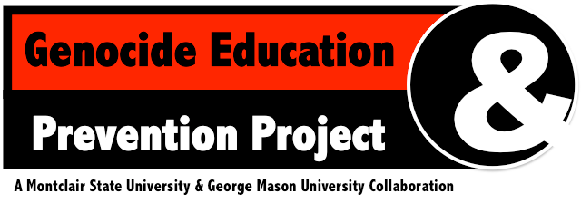July 24-26, 2017

Open to the Public

Montclair State University
Machuga Heights Multipurpose Room Webster Road, Little Falls, NJ 07424

MONDAY, JULY 24
9:00am—9:15am | Welcome
9:15am—10:15am | Jocelyen Getgen Kestenbaum, Benjamin N. Cardozo School of Law | Teaching Atrocity Prevention: Opportunities for Innovation and Challenges in Implementation
10:15am—10:30am | Break
10:30am—12:00pm | Borislava Manojlovic, Seton Hall University | Education, Historical Narratives and Conflict Resilient Communities
 | Keith Singleton, George Mason University | Black Genocide: A Lost Conversation on Human Rights in America
12:00pm—1:30pm | Lunch
1:45pm—3:15pm | Sarah Federman, University of Baltimore | The Role of Corporations in Mass Atrocity
 | Douglas Irvin-Erickson, George Mason University | Conflict Resolution Education for Genocide Prevention: Case Studies and Directions
3:15pm—3:30pm | Break
3:30pm—4:30pm | Nela Navarro-Lapointe, Rutgers University | Tentative
TUESDAY, JULY 25
9:00am—9:45am | Khatchig Mouradian, Columbia University | The Three "Dives" of Genocide Education
9:45am—10:55am | Peppy Margolis, Raritan Valley Community College | Can we Co-exist with THE OTHER?
10:55am—11:10am | Break
WEDNESDAY, JULY 26
9:00am—10:30am | J.J. Buckley, Bowdoin College | The Situation of the Mandaeans
 | Arnaud Kurze, Montclair State University | Memory Politics and Sexual Minorities in Post- Authoritarian Tunisia and Lebanon: Mapping Youth, Art and Violence Prevention
10:30am—10:45am | Break
10:45am—12:15pm | Steven L. Jacobs, University of Alabama | The Religion/Genocide Nexus:  Under-examined, Under-explored, Under-reported
 | Kate E. Temoney, Montclair State University | Religion and Genocide Prevention
12:15pm—12:30pm | Closing
12:30pm—1:30pm | Lunch and the future of GEAPP discussion

Supported by MSU Department of Religion | MSU Residence Life
MSU Holocaust, Genocide, and Human Rights Education Project | NJ Commission on Holocaust Education

