Here’s
How We
Can Help

Information About Title IX, Sexual Violence, Options and Resources, 2024 Brochure
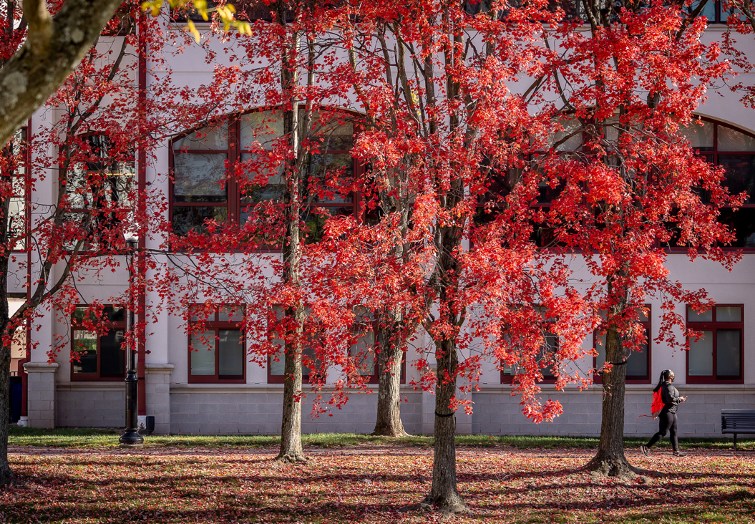
WHAT IS TITLE IX?

Title IX is a federal law which prohibits discrimination on the basis of gender or sex. Sexual harassment and sexual violence are forms of discrimination under Title IX. Along with several other federal and state laws, Title IX Montclair State University’s policies and procedures in preventing and addressing these forms of misconduct. Gender-Based Misconduct is the term Montclair State University uses to describe the range of behaviors that are prohibited under our policies relating to gender, sex, and relationships. It includes non-consensual sex and sexual contact, sexual harassment, sexual exploitation, dating and domestic violence, and stalking.

OUR TEAM IS HERE FOR YOU

We encourage students to report and get the support they need.

Cases involving staff, faculty and others, report to:
Paul Apicella, JD
Director of Institutional Compliance and Title IX Coordinator
Equal Employment Opportunity and Affirmative Action Officer
Phone: 973-655-2041 Email: apicellap@montclair.edu
Michelle Affinito
Executive Assistant, Office of University Counsel
Phone: 973-655-5225 Email: affinitom@montclair.edu
Cases involving only students, report to:

Report to: Yolanda Alvarez, Ed.D.
Associate Dean of Students, Deputy Title IX Coordinator
Student Center, Suite 400, 4th Floor
Phone: 973-655-4118 Email: alvarezyo@montclair.edu

FIRST STEPS: ARE YOU IN DANGER?

If yes, contact University police at 973-655-5222 on-campus or 911 off-campus.

DO YOU NEED MEDICAL ATTENTION?

You can receive medical attention at any medical facility, and the University Health Center has trained staff to work with survivors of sexual assault.

If you choose, you can request a Sexual Assault Nurse Examiner (SANE) to perform a confidential forensic examination for evidence collection, receive access to medical care for the prevention of infections and pregnancy, evaluation and treatment of possible injuries. Completing a medical exam does not require you to file a police report or report to the institution.

It is important to preserve physical evidence that may include tissue and fluid samples, evidence of violence, sheets, towels, clothing, etc. You may choose to avoid washing, bathing, urinating, etc., until after being examined at the hospital, if possible. Evidence of a sexual assault can deteriorate quickly. You may choose to seek a medical exam as soon as possible. Evidence collection should be completed within 120 hours of an assault, but fluids, hair samples, and DNA can be collected for a long time thereafter. Even if you have washed, evidence can often still be obtained. After 120 hours, it may still be helpful to have medical attention, even if you are not trying to obtain evidence of an assault. Save items you were wearing, sheets, or towels in a paper bag. Evidence collection should be completed within 5 days of an assault. Sexual assault nurse examiners (SANE) are trained in the collection of forensic evidence and can check for injuries and exposure to infections. If you are still wearing any clothes worn during the assault, wear them to the hospital, but bring a change of clothes, as the hospital will keep the clothes you are wearing as evidence. If you have changed clothes, bring the ones you were wearing during the assault to the hospital in a clean paper (not plastic) bag or a wrapped in a clean sheet. Leave sheets/towels at the scene. You can bring clothing to anywhere you seek treatment and where evidence is collected.
UNSURE OF WHERE TO START
You may want to talk to someone confidentially as you decide what to do. You can speak to any of the designated University confidential resources to help you consider options.
Try a designated confidential resource: Counseling and Psychological Services (CAPS), Campus Victim Advocate in the Office for Social Justice and Diversity, The Multicultural Center, The University Health Center, Campus Clergy and/or Center for Faith and Spirituality.

CAPS – COUNSELING AND PSYCHOLOGICAL SERVICES

You may pursue services or a referral based on your needs.
Located in Russ Hall, Side Entrance, 1-973-655-5211. https://www.montclair.edu/counseling-and-psychological-services/

CAMPUS VICTIM ADVOCATE

Located in the Office for Social Justice and Diversity, which includes, the Women’s Center, LGBTQ+ Center, and Center for Faith and Spirituality, Student Center, Room 113C, 973-655-5114.
https://www.montclair.edu/social-justice-diversity/

UNIVERSITY HEALTH CENTER

Located in Blanton Hall, Ground Floor, 973-655-4361
https://www.montclair.edu/university-health-center/
NEED TIME TO THINK ABOUT OPTIONS?
Although at this time you may choose not to pursue nor participate in an investigation, it is important you know you may request further action at any future time, consistent with the University’s policy on Title IX Sexual Harassment/Sexual Assault Policy and Procedures.
https://www.montclair.edu/policies/all-policies/gender-based-conduct/
Please know that the more time that elapses from the time of the incident you reported, the more difficult it will be to obtain information as individuals graduate or leave school or physical evidence is not obtainable. This does not mean that a successful resolution is impossible. You are encouraged to call or meet at any time, and you may be accompanied by an advisor of your choice.
ACADEMIC, HOUSING & SUPPORT
-Any of the Title IX Coordinators can help you pursue services.
-You may pursue a University No Contact Order (UNCO) between students at Montclair State enforceable through the Office of Student Conduct. If you experience immediate threat to your safety. University police at 973-655-5222 on-campus or 911 off-campus.
-Academic Supportive Measures: At your request, a general letter can be sent to your faculty requesting consideration for additional time to submit assignments, exams, and projects.
-Housing: You may pursue alternative housing if living on-campus.
-You may be connected to the Disability Resource Center, Financial Aid, International Services, or other office to discuss options.
National, Community and Technology Resources
- RAINN National Sexual Assault Hotline (offering nationwide support and virtual chat options) 1-800-656-HOPE (4673) https://www.rainn.org/about-national-sexual-assault-telephone-hotline
- National Domestic Violence Hotline (national support for domestic violence) 1-800-799-7233 https://www.thehotline.org
- Essex County Family Justice Center (offering counseling support, legal assistance, and other services to victims of domestic violence) 1-973-230-7229 https://www.essexcountyfjc.org
- Essex County SAVE (Women’s Center) (offering counseling support, legal assistance, and other services, you must work with an intake officer to determine eligibility) 1-877-733-2273 – 24 hour hotline https://familyserviceleague.org/save-of-essex-county
- NJ CASA – Find help in any county. Request a Confidential Sexual Violence Advocate. 1-800-601-7200 – 24 hour hotline https://njcasa.org/find-help/
- New Jersey Specific 24-Hour Hotlines and Resources: (Domestic Violence and Sexual Violence) 1-800-572-SAFE (7233) https://www.nj.gov/dcf/women/hotlines/
- New Jersey Coalition to End Domestic Violence – 1-800-572-7233 https://njcedv.org/services/
- Partners for Women and Justice (offering legal assistance) 1-973-233-0111, 60 South Fullerton Ave. #106, Montclair, NJ https://pfwj.org
- Passaic County Women’s Center (counseling support, legal assistance) 1-973-881-1450, http://www.passaiccountywomenscenter.org
- WAFA House Passaic (offering counseling support, legal assistance, and other services, you must work with intake on eligibility) 1-800-930-WAFA (9232) or 862-295-3525 https://www.wafahouse.org
- RAVE Guardian App - You contact University Police when walking on campus with your arrival time. If they don’t hear from you, they come looking. https://www.montclair.edu/emergency/rave-mobile-safety
Note: This information is not a substitute for professional, legal or medical advice; it is not considered an endorsement. You are encouraged to independently evaluate options.
OPTIONS FOR RECOURSE
Filing a Report and/or Filing a Formal Complaint Choices
1-You may choose to file a police report and request a criminal investigation
2-You may choose to file with civil court to pursue a temporary restraining order
3-You may choose to file a formal complaint through our Deputy Title IX Coordinator on-campus for an on-campus student conduct process.
**Note: these options are independent of one another, which means if you file in one office it does not mean you automatically filed a report in another office. You can choose to report to one of the offices, all of the offices or none of the offices.
The University encourages reporting, and we know that only you can determine if doing so is the right decision. You can report now or anytime in the future.
A-How Police Can Help:
You can work with University police to understand how-to file a police report and how-to file a restraining order. University Police are trained in trauma informed victim care and available to answer your questions regarding the police process. University Police are available 24 hours a day, 7 days a week. You may call or visit the police at 973-655-5222. They are located adjacent to the Red Hawk Deck.
B-How the University Can Help:
You may also file a formal complaint with the University where an independent investigation under Title IX will be conducted once a signed formal complaint with the Title IX officer has been received. You can do this now or at any time in the future. Please advise if you wish to file a formal complaint in a Title IX investigation. A criminal investigation does not automatically start a University procedure; you must file a complaint with the University.
-You can participate in both the University Title IX process, civil process and criminal process simultaneously. You can also choose not to file reports with any office.
-Participation in an investigation may include in-person or video meeting and scheduled phone calls.
-A meeting with an advisor of your choice can be coordinated to discuss resources, options, investigation process and campus disciplinary process. An advisor can be anyone you wish that can support you (friend, faculty, attorney, parent, etc.).
New Jersey Sexual Assault Victim’s, Bill of Rights. N.J. Stat. Ann. § 52:4B-60.1 et seq.

In New Jersey, victims of sexual violence are afforded the following rights:

(1) To have any allegation of sexual assault treated seriously; to be treated with dignity and compassion; and to be notified of existing medical, counseling, mental health, or other services available for victims of sexual assault, whether or not the crime is reported to law enforcement;
(2) To be free, to the extent consistent with the New Jersey or United States Constitution, from any suggestion that victims are responsible for the commission of crimes against them or any suggestion that victims were contributorily negligent or assumed the risk of being assaulted;
(3) To be free from any suggestion that victims are to report the crimes to be assured of any other guaranteed right and that victims should refrain from reporting crimes in order to avoid unwanted personal publicity;
(4) When applicable, to no-cost access to the services of a sexual assault response team comprised of: a certified forensic nurse examiner, a confidential sexual violence advocate, and a law enforcement official as provided in accordance with the Attorney General’s Standards for Providing Services to Victims of Sexual Assault, and the choice to opt into or out of any of the team’s services;
(5) To be informed of, and assisted in exercising, the right to be confidentially or anonymously tested for acquired immune deficiency syndrome (AIDS) or infection with the human immunodeficiency virus (HIV) or any other related virus identified as a probable causative agent of AIDS; and to be informed of, and assisted in exercising, any rights that may be provided by law to compel and disclose the results of testing of a sexual assault suspect for communicable diseases;
(6) To have forensic medical evidence, if collected, retained for a minimum of five years, and to receive information about the status of the evidence upon request;
(7) To choose whether to participate in any investigation of the assault;
(8) To reasonable efforts to provide treatment and interviews in a language in which the victim is fluent and the right to be given access to appropriate assistive devices to accommodate disabilities that the victim may have, whether temporary or long term;
(9) To information and assistance in accessing specialized mental health services; protection from further violence; other appropriate community or governmental services, including services provided by the Victims of Crime Compensation Office; and all other assistance available to crime victims under current law;
(10) To be apprised of the availability and process by which a court may order the taking of testimony from a victim via closed circuit television in accordance with section 1 of P.L.1985, c.126 (C.2A:84A-32.4); and(11) To be apprised of the availability and process by which to seek protections through a temporary or final protective order under the “Sexual Assault Survivor Protection Act of 2015,” P.L.2015, c.147 (C.2C:14-13 et seq.), if the victim believes that the victim is at risk for re-victimization or further harm by the perpetrator.

