First Year Writing Annual Report AY 21/22

Mission Statement
The mission of the First-Year Writing (FYW) program is to provide all undergraduate students with process-based instruction in academic writing that will support their continued growth and development as writers and thinkers throughout their undergraduate education and beyond. Our two courses—College Writing I and College Writing II—are designed to connect writing, intellectual inquiry, and learning across the contexts of school, work, relationships, and community. The mission of the program is supported by standardized criteria for assessment of student writing, written collaboratively by full-time faculty.

Program Leadership
Caroline Dadas is in her fourth year of directing the program. In Fall 2021, Jennifer Holly-Wells left the university and Christine Giancatarino (Specialist faculty) assumed the role of Associate Director for the full academic year. We have hired Jazmine Thompson as the new permanent Associate Director, beginning in June. Liz Martin (Specialist faculty) assumed the role of Assistant Director. The administrative team meets on a weekly basis to collaboratively move the work of the program forward. Caroline Dadas also meets with the department chair regularly to discuss FYW matters, a routine that proves especially important in a department where all faculty regularly teach WRIT 105 and 106.

Enrollment
A key highlight of our program is its size: the FYW program instructs nearly every undergraduate at the University. This academic year, the university welcomed Montclair State’s largest incoming First Year class to date; the First Year Writing program adjusted to accommodate the increase in students. Student needs continue to be diverse and significant across our demographic and drive program events, professional development, curricular initiatives, and staffing. Table 1 below outlines enrollment numbers for AY 21-22:

 | 105 sections | 105 seats | 105 used | % capacity used | 106 sections | 106 seats | 106 used | % capacity used | Total sections | Total seats | Total used | Total Capacity Used
Summer 2021 | 41 | 776 | 444 | 57.22% | 5 | 95 | 81 | 85.26% | 46 | 871 | 525 | 60.28%
Fall 2021 | 154 | 2916 | 2640 | 90.53% | 18 | 342 | 342 | 100.00% | 172 | 3258 | 2982 | 91.53%
Winter 2022 | 0 | 0 | 0 | 0 | 0 | 0 | 0 | 0 | 0 | 0 | 0 | 0
Spring 2022 | 23 | 437 | 433 | 99.08% | 129 | 2451 | 2446 | 99.80% | 152 | 2888 | 2879 | 99.69%
Spring 2022 2nd term 105 class | 1 | 19 | 20 | 105.26% | (this 2nd term course not factored into stats above)
Table 1: AY 21-22 enrollment across First Year Writing courses

A few key notes about the table above:
- The calculations (specifically for Fall, Winter, and Spring) were calculated after the drop/add deadline. Former Associate Director, Jennifer Holly Wells shared that the timing of this calculation is more an art than science; some calculate the number during the first week of classes before drop/add; others calculate after drop/add. Christine Giancatarino calculated after the drop/add deadline for the AY 21-22 academic year so that enrollment numbers matched the grade data. Moving forward, Jazmine Thompson might choose to time the calculations differently.
- For the Fall 2021 WRIT “105 Seats” calculation, two of our fully online sections were capped at 14 instead of 19. The reasons for this are unclear and might have been a carryover by the registrar. In any case, the WRIT “105 Seats” number calculates these two classes at a 14 cap.
- Of note for Spring 2022: 6 sections of 105 were added late; 33 sections of 106 were canceled, including many of the evening sections; 1 2nd-term (8 week) WRIT class was added late to accommodate the demand.

Curriculum
The FYW program offers two courses:
- WRIT 105, College Writing I: The first of two required general education writing
courses, WRIT 105 takes a broad, interdisciplinary focus on academic argument and analytical writing.
- WRIT 106, College Writing II: The second of two required general education writing courses, ENWR 106 currently engages students in critical reading of texts while continuing the emphasis on academic argument and analytical writing. This past year, we ran a pilot program for faculty interested in teaching a research-oriented focused WRIT 106; we will use the results of this pilot to determine if this is a viable option for the future.

We take a process-based approach to writing instruction, with an emphasis on multiple drafts, peer review, and one-on-one conferencing. All courses end
with students’ submission of cumulative portfolios to demonstrate improvement over
time. Students produce three major essays in each course, and all essays in each course undergo a three-draft process that includes peer and instructor feedback. Instructors[1] choose among textbooks approved by the program, and they have the option of drawing on materials outside of the recommended texts (including increasingly the design of textbook-free, open-access courses) in consultation with the program director. In the Spring semester, Liz Martin began developing an OER collection for the program, including student essays. We plan to build on this collection in future semesters.

During AY 21-22, the program piloted a new approach to assessment called labor-based contract grading. Popularized in the field of Writing Studies by Asao Inoue (2015), this approach to assessment rewards students for completing drafts, discussion boards, and other assignments. In a process-oriented class such as First Year Writing, this approach encourages students to participate in the kinds of scaffolding activities that we know will help them become better writers. It requires, however, a fairly extensive reorientation around grades for both faculty and students. For this reason, the FYW program began experimenting with this approach via a voluntary pilot in Fall 2021; participating faculty were then surveyed about their experiences. Data from that survey is included below.

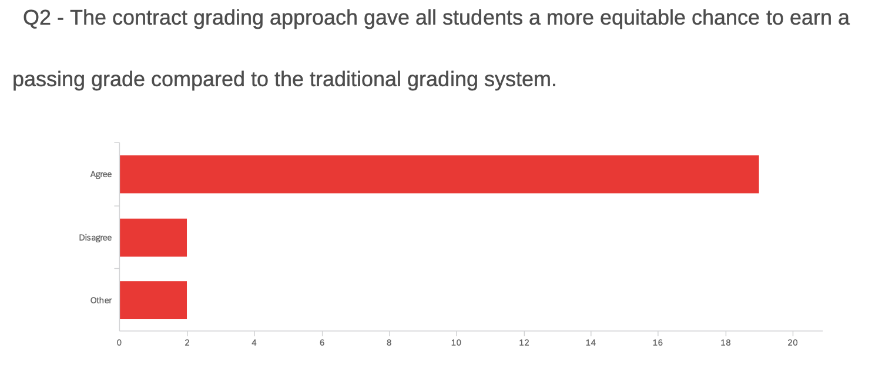

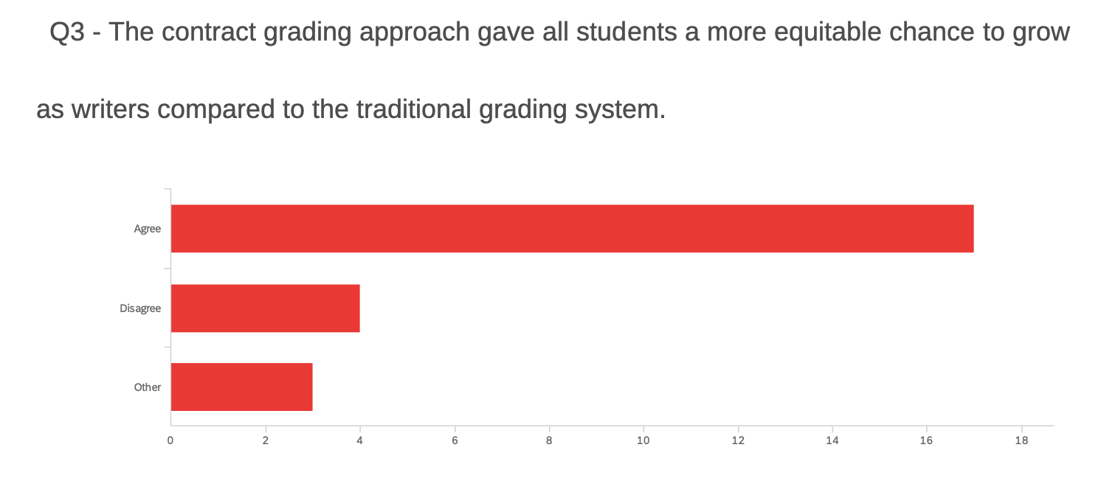

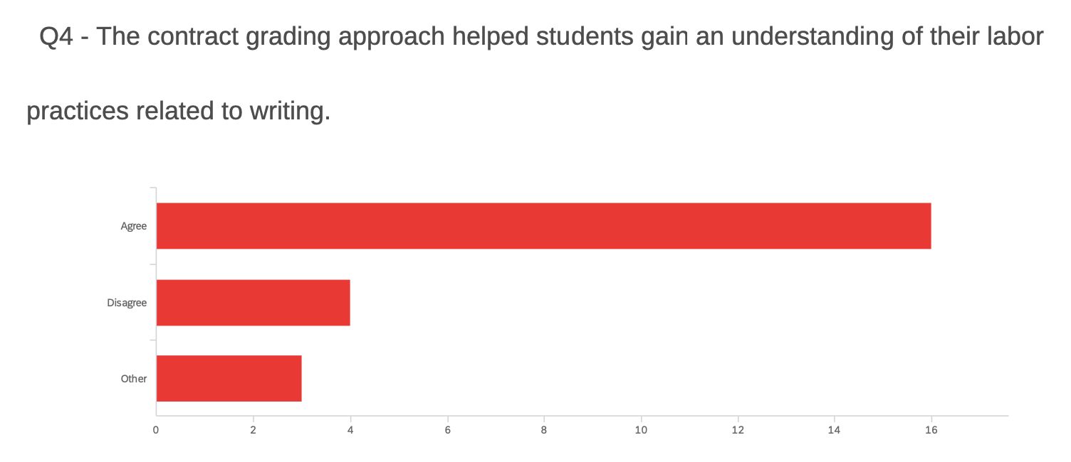

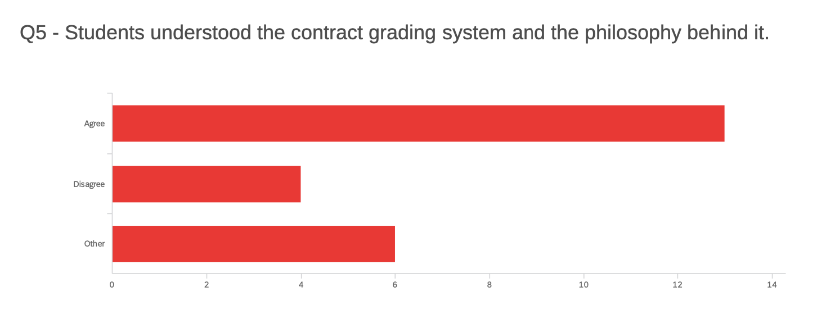

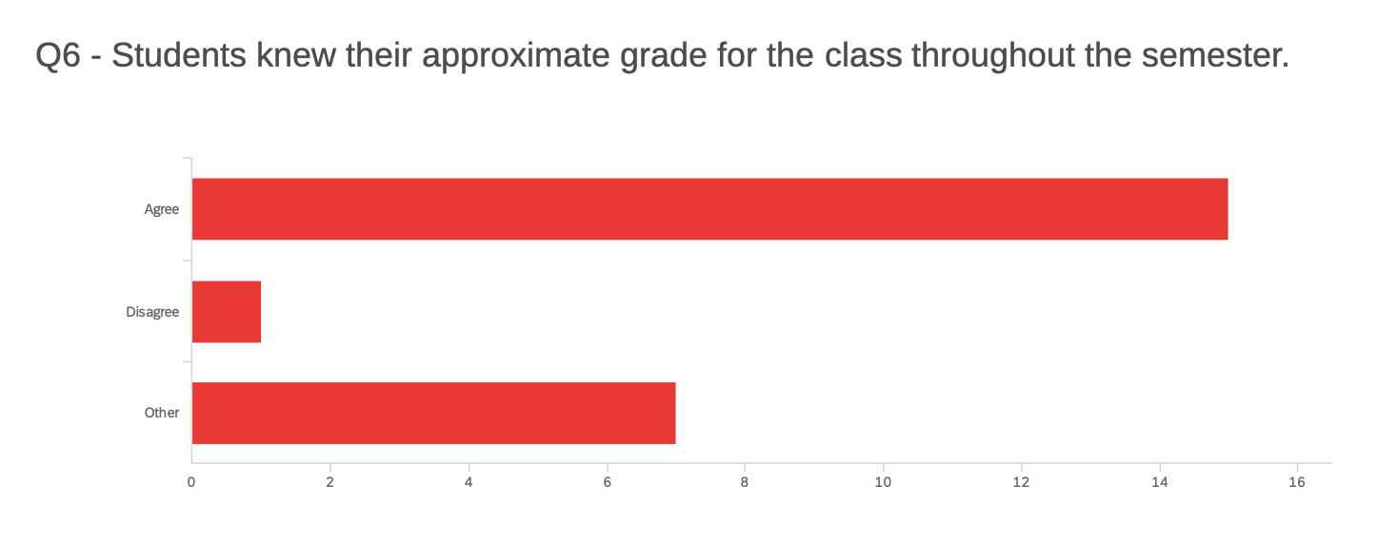

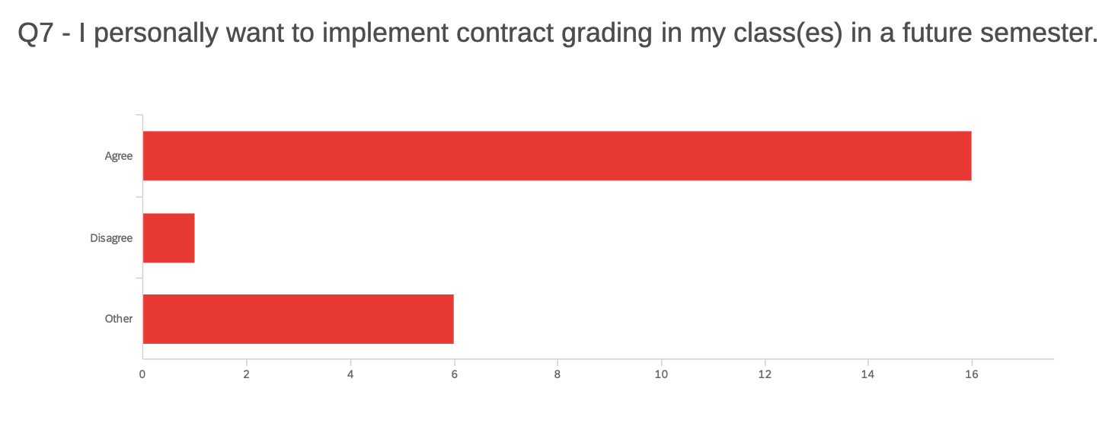
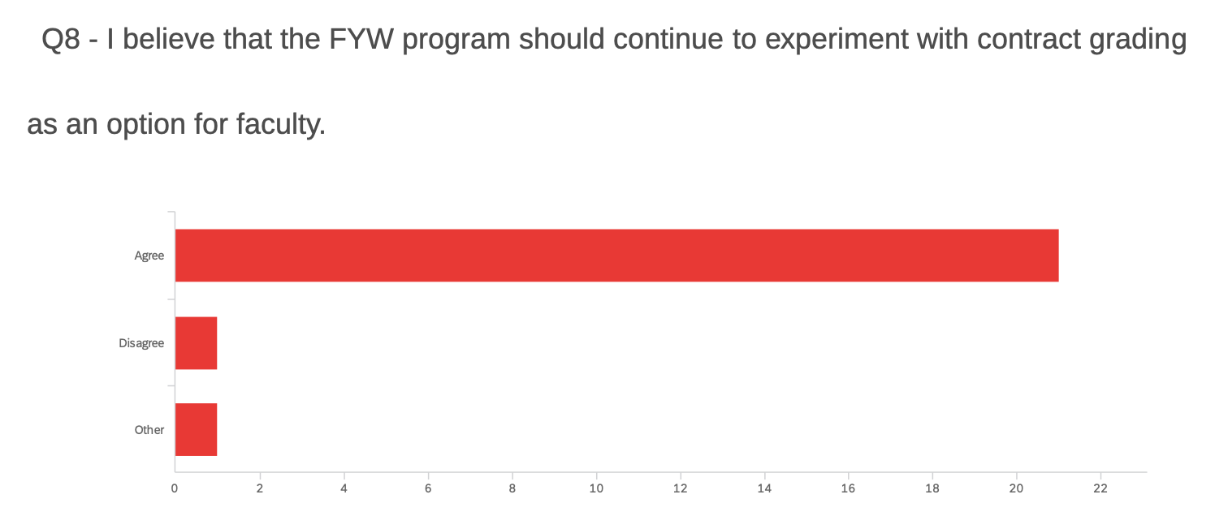

Moving forward, the program will continue to assess faculty and students’ experiences with this approach to assessment. We will also continue to offer professional development opportunities oriented around labor-based contract grading. Our offerings from AY 2021-2022 covered this topic extensively and are detailed below.

New Versions of 106
Two new approaches to WRIT 106 were piloted in Spring 2022, Writing & Research and College Writing for Business Majors.

We view “Writing and Research” as an opportunity for students to gain a strong foundation in research skills at the beginning of their college experience. This course built on the basic writing strategies taught in College Writing I and extended the goal of helping students to become effective writers of intellectual arguments through a semester-long individual research project. Students wrote a proposal, conducted primary and secondary research, created an annotated bibliography, learned to synthesize sources, analyzed data, and wrote multiple drafts of a 3000 word (or more) research paper. Some faculty teaching these sections allowed students to craft their own topics based on their interests. Others focused the course around a central theme such as food subcultures or Covid-19 (among others) and allowed students to choose individual topics within the broader focus.

We also offered two special sections of WRIT 106 titled “Writing for Business Majors,” specifically designed for students from SBUS, and taught by Neiha Bhandari and Jazmine Thompson. In these sections, students worked on a variety of business writing tasks including crafting a professional identity through a self-profile, elevator pitch, and responses to interview questions; writing a comparative analysis mini-report; and writing a proposal, annotated bibliography, and recommendation report. Students left the course with a digital portfolio of their work. Throughout, students were asked to use data to tell stories, develop audience awareness in their writing, compose multimodally, work collaboratively, conduct methodically-sound research, and summarize information concisely.

4-credit Sections of FYW
Our 4-credit sections of FYW follow a “stretch” co-requisite model, which is a nationally-recognized method of writing instruction. This model dictates that with more time in class and with increased one-on-one instruction, struggling writers can make significant gains. In regular meetings during the year, 4-credit faculty meet and discuss pedagogy, troubleshoot issues, compare experiences, and share best practices.

Students will be placed into the 4-credit sections in Fall 2022 according to GPA, in conjunction with the Office of Admissions. Previously, we had used the Freshman Index Score for this placement, but Admissions has found GPA alone to be an equally reliable indicator. We anticipate having the same number of students qualify for the 4-credit classes as in years past.

For Spring 2023 courses, all WRIT105 students will complete a self-assessment survey and a reflection assignment. The self-assessment encourages students to reflect on their writing experiences before registering for a spring semester class. Instructors will review the reflections and make decisions about students who might benefit from additional instruction in a 4-credit course. Instructors will then submit student names to the Assistant Director, Liz Martin, and the students will be notified about their instructor’s recommendation and directed to register for the 4-credit course. Along with notification from the program and individual instructors, FYW will also collaborate with the advising centers in each college by sharing a 4-credit course description, schedule, and the recommended/placed student names. Outreach from the program to the students will continue through the registration period.

Best Practices Document
Over the summer of 2021, an ad hoc committee consisting of Shil Sen, Tavya Jackson, Jackie Regan, and Liz Martin convened to create a best-practices document for leaving effective feedback on student writing. This project grew out of a charge from the FYW Director to develop an easy-to-read document for veteran and new faculty members alike. The document aimed to provide instructors with suggestions to help them leave meaningful, concise, and timely feedback on student work.

The document is divided into four sections. The first provides overall best-practices guidelines applicable to all feedback modalities, while the other three focus on specific feedback types, written, audio/screencast, and student conferences. Each specific section includes guidelines for best practices as well as timesaving tips. In creating this document, FYW instructors and students were surveyed in the Spring of 2021 by the ad hoc committee. Recommendations were also developed from data gathered at MSU for Jackie Regan’s dissertation project and the committee members' own expertise.

DFW Rate
With a particular eye to active reduction of the program’s DFW rate, we’ve continued to adjust the curriculum including the introduction of labor-based contract grading (see above). Given the ongoing pandemic, an increase in the DFW rate for the Fall 2021 semester was experienced university-wide, posting the highest DFW rate on record in the last nine years at 12.2% (see Figure A below and the Office of Faculty Advancement’s Grade Analysis, Fall 2021).

For the FYW program, the DFW rate for WRIT 105 in Fall 2021 saw an increase, up to 17.16%, a more than 3.5% increase from the previous Fall (see Figure B). The reason for this number is multi-layered and appears to primarily stem from the ongoing pandemic and the co-occuring challenges that students faced during the semester. Currently, the department’s transition towards labor-based contract grading is an intentional approach to better support students and help reduce the DFW rate.
FIGURE A: COMPARISON OF FALL WRIT DFW RATES vs UNIVERSITY-WIDE DFW
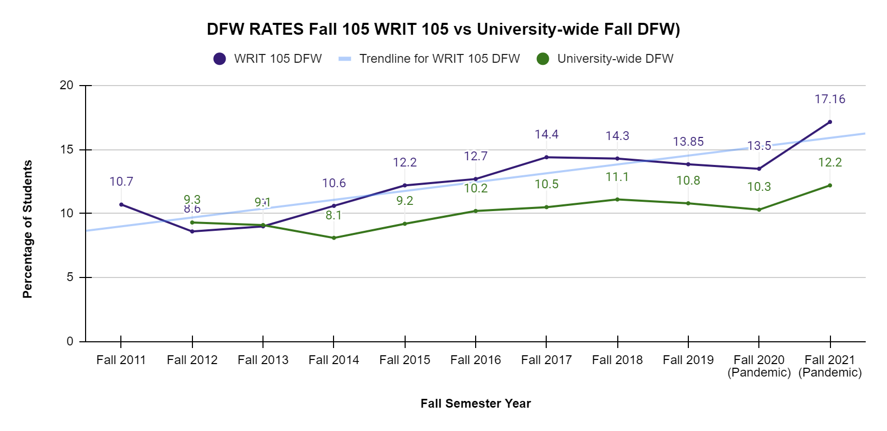
FIGURE B: FALL WRIT 105 DFW RATES
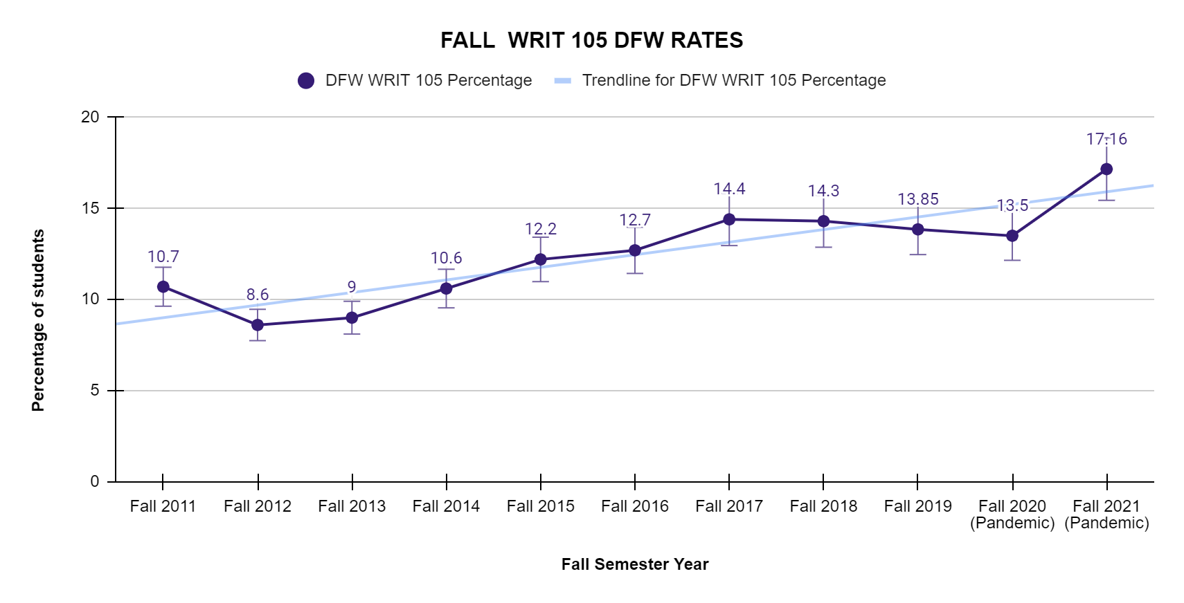

In addition to tracking the overall DFW numbers, Tableau was used to revisit the demographic breakdown of race and gender for Fall 2021. For males, a comparison chart from Fall 2020 and Fall 2021 (Figure A) is included below. A chart for females is also included below for Fall 2021 (Figure B). Note: according to Dr. Emily Issacs, OFA, the demographic of “Not Known” is increasingly being used, and those percentages have been added to the charts

Figure A:
Demographics | WRIT 105 Fall 2020 DFW Rate | WRIT 105 Fall 2021 DFW Rate
Black-African American Males | 26.20% | 26.00%
Hispanic-Latino Males | 23.60% | 18.10%
White Males | 11.50% | 13.40%
Not Known Males |  | 21.30%
OVERALL | 13.50% | 17.16%

Figure B:
Demographics | WRIT 105 Fall 2021 DFW Rate
Black-African American Females | 23.80%
Hispanic-Latino Females | 18.30%
White Females | 10.00%
Not Known Females | 16.10%
OVERALL | 17.61%

The FYW program is continuing to adjust curriculum, rework grading practices (including labor-based contract grading) and revisit pedagogy to find ways to better support FYW students of color, as mentioned above.

Delivery Formats
Traditional First Year Writing courses offer a mixture of small group discussion, peer review, workshops, conferences, and in-class reading and writing. Traditional course models make up the bulk of the program's offerings. Like all first year writing courses, they are designed to advance the standard learning goals of the program.

Likewise, hybrid and online courses are oriented around the program’s learning goals. Approaches to hybrid and online instruction are informed by the work of a faculty hybrid/online committee. This past year the committee came up with a plan for how to increase student participation and attendance in these sections. The committee will then pilot these approaches in the fall.

4-credit sections of WRIT 105/106 offer an additional 50 minutes of instruction per week. Known as the “stretch” model of co-requisite writing instruction, this approach to teaching students who need additional practice with writing is nationally recognized as being effective with this student population. This model dictates that the curriculum remains the same as the 3-credit sections, and that the additional classroom time is spent by having students work on their ongoing writing projects while the instructor conferences with students and answers their questions. This added workshop time helps students keep pace with their peers in the 3-credit sections.

Advising
First-year students seek advisement for several issues, including: evaluation of courses
taken at other universities; concern about an instructor; appeal of a plagiarism charge;
grade grievances; and placement in writing courses. The FYW administration maintains
office hours each week: the associate director is available on a standard professional staff schedule and the faculty director keeps weekly office hours and appointments by request of students and faculty. Both correspond with students via email to meet the demand. The program partners with the Dean of Students’ office on academic honesty and grade appeal issues as needed. The program asks that students follow a process that involves meeting with the instructor before progressing through administrative appeals; most issues are resolved on the programmatic level and do not require Dean level involvement. The faculty director also works regularly with Counseling and Psychological Services (CAPS), and the Director of the Disability Resource Center to address student needs.

The director meets frequently with faculty who ask for consultation on a variety of issues including curricular choices, responses to student drafts, student attendance issues, and other concerns.

Professional Development
The program held a professional development session devoted to contract grading, facilitated by adjunct faculty member Susan Wright, in September 2021. Additionally, the program devoted a day at the end of the school year devoted to several topics, contract grading among them:
- Struggles from the academic year and how we might move forward
- Decolonizing our assessment criteria
- Drafting new questions for our student course surveys
- Research-based approaches to WRIT 106
- Labor based grading contracts

University Outreach/Initiatives
The First Year Writing program always seeks to be good partners with other units and initiatives around campus. Representatives from the program participated in a variety of collaborations this past academic year.
- Adjunct faculty member Susan Wright and Caroline Dadas collaborated on a presentation for OFA over the winter term, talking about their experiences incorporating labor-based contract grading in the classroom.
- In February 2022, Liz Martin and Caroline Dadas sat on an ITDS panel devoted to academic honesty as part of their Practices and Engaging Instructional Technologies Virtual Conference. This presentation focused on ways to prevent dishonesty by focusing on assignment prompts, reflective writing, and other strategies.
- Caroline Dadas sat on two committees tasked with reimagining two new Gen Ed core requirements oriented around writing: Written Communication and Interactive Communication.
- In Spring 2022, Liz Martin worked with Sprague Librarian Justin Savage to find an Open-Educational Resource (OER) textbook to replace The Norton Field Guide to Writing as the recommended textbook for College Writing I on the common syllabus given to newly hired adjunct faculty. Liz will be running a pilot of the OER textbook, Writing Guide with Handbook, in Fall 2022 with existing faculty.

Program Assessment
The FYW program maintains a rigorous agenda of program assessment. These assessments include routine faculty class observations, student evaluations, program grade data reports by semester, and periodic surveys of faculty opinion on topics related to program materials (i.e. textbooks) and their own classroom experiences (new teaching approaches, professional development needs, assessment of students’ strengths and weaknesses outside of grade performance). The program also conducts assessments of any new curricular or programmatic initiatives as needed. This year, we piloted a new approach to adjunct faculty observations where adjuncts established the agenda for a conversation between them and their observer. This approach will be refined in the coming year.

On the student level, as a program we track performance of our EOF (Educational
Opportunity Fund) as well as Summer Bridge students (see below), and periodically conduct performance assessments in relation to courses, our placement process, and other relevant needs as they arise. To meet with the unique demands of this academic year, an 8-week half-term WRIT 105 class was added in Spring 2022.

Ongoing program initiatives
To promote a culture of writing, the FYW program maintains several ongoing initiatives that provide support and community for faculty:

- Deep Down in the Classroom blog: Started and maintained by Shil Sen, this project offers a way for instructors to share pedagogical ideas in a more informal setting. This year the blog has added interviews with faculty as well as a monthly FYW newsletter. The blog can be found at: https://msufywblog.wordpress.com/
- Mentoring program: All new instructors in the program are paired with a more experienced teacher at the beginning of the year. Pairs are encouraged to meet during the course of the semester and problem-solve any issues that the new faculty member may be facing in the classroom.
- Summer Bridge Program: Added by the university in Summer 2021 and running again in Summer 2022, the Summer Bridge program gives eligible incoming first year students the opportunity to take up to 7 degree credits for free. In Summer 2021 the department staffed 31 Sections of WRIT 105; for Summer 2022, there are currently 18 sections of WRIT 105 being offered. Like EOF, Summer Bridge includes embedded tutors, and this summer, Summer Bridge students will be required to meet with tutors for a tutoring session after every class meeting.

Moving forward:

- Newark Bridge Program: This new initiative is a collaboration between the Provost's Office/Special Programs and the Newark Board of Education. This program will include a cohort of high achieving High School Seniors who will take WRIT 105 in the Fall. Currently, the department will run 3 sections of WRIT 105 for Newark Bridge Students. All sections are SON (synchronous online) classes. For the inaugural classes, one section will be taught by Dr. Jackie Regan (Instructional Specialist); the other two sections will be taught by Dr. Shelagh Patterson (Instructional Specialist).
- We will continue to assess the efficacy of the labor based contract grading approach.

*Report compiled by Christine Giancatarino, Liz Martin, and Caroline Dadas

